16.04 Outliers
Year 7 Maths · Worksheet · Level 3 · Challenge
Name: ____________________ Date: ______________
This worksheet practises finding outliers, measuring their effect on the mean, median, mode and range, and deciding how to report data that contains them. Tip: total = mean × number of values. Use it whenever a value is added, removed or corrected.

 Understanding
- These are the weekly rainfall totals (in mm) at a Queensland farm for eight weeks. A cyclone crossed the coast in one of the weeks.
- 12.5, 8.0, 15.5, 0.0, 10.5, 210.0, 9.5, 14.0
  - Which value is an outlier? ______________
  - Leah says 0.0 is also an outlier. Do you agree? Explain.

  - Find the mean and median with the outlier. ______________
  - Find the mean and median without the outlier. ______________
- The dot plot shows how long 17 students spent on homework last night.
- 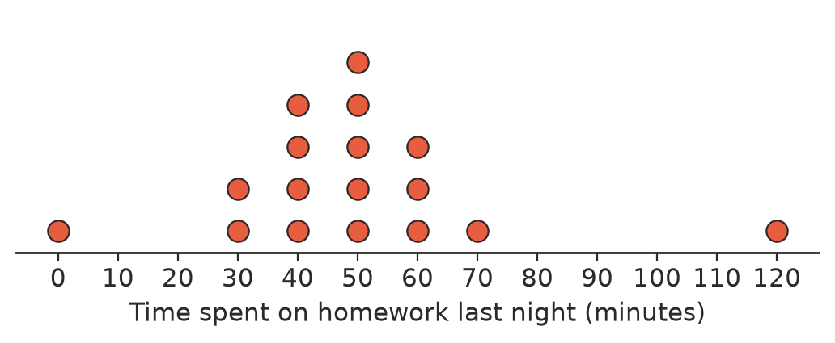
  - Which two values are outliers? ______________
  - Find the median and the range with the outliers. ______________
  - Find the median and the range without the outliers. ______________
  - Find the mean with the outliers, correct to 1 decimal place, and the mean without them. ______________
  - Why did removing both outliers change the mean only a little?

 Fluency
- A data set is 5, 7, 8, 8, 9, 11. The value 50 is added.
  - Find the mean, median, mode and range before 50 is added. ______________
  - Find the mean, median, mode and range after 50 is added. ______________
- What number must be added to 6, 8, 10, 12 to make the mean 13? Is it an outlier?

- Five numbers have a mean of 12. When one outlier is removed, the mean of the other four is 8. Find the outlier.

 Reasoning
- A value is removed from a data set and the mean goes up. What can you say about the value that was removed? Explain.

- Explain why removing an outlier usually does not change the mode.

- News reports about house prices usually give the median price, not the mean price. Explain why.

 Problem solving
- Seven test scores have a mean of 70. One of the scores is an outlier of 10. Find the mean of the other six scores.

- A scientist recorded the masses of 10 rock wallabies. The mean was 87.5 kg, which seemed far too heavy. She found that one mass had been written as 450 kg instead of 45.0 kg. Find the correct mean mass.

- Write a data set of six whole numbers with exactly one outlier where:
  - the mean is bigger than every value except the outlier ______________
  - the median does not change when the outlier is removed ______________
- A business has nine workers. Eight earn $1000 a week and the manager earns $5500 a week.
  - Find the mean and median weekly wage. ______________
  - The manager gets a pay rise to $10 000 a week. Find the new mean and median. ______________
  - A job advertisement says, “Our workers earn an average of $1500 a week.” Explain why this could be misleading.

