16.04 Outliers
Year 7 Maths · Worksheet · Level 2 · Core
Name: ____________________ Date: ______________
This worksheet practises identifying outliers, working out how they change the mean, median, mode and range, and deciding what to do with them. An outlier is a value that is much bigger or much smaller than the rest of the data. Tip: an outlier pulls the mean and the range a long way, but it hardly changes the median, and usually doesn’t change the mode.

 Understanding
- Write down the outlier in each data set.
  - 31, 28, 30, 29, 3, 32 ______________
  - 0.5, 0.6, 0.4, 0.5, 4.5 ______________
  - 1200, 1350, 1280, 9900, 1310 ______________
- Write true or false.
  - An outlier changes the median more than the mean. ______________
  - Removing a very large outlier makes the mean smaller. ______________
  - The mode is usually not affected by an outlier. ______________
  - An outlier always changes the range. ______________

 Fluency
- These are the times (in minutes) six students took to get to school: 14, 16, 15, 13, 16, 52
 | Mean | Median | Mode | Range
With the outlier
Without the outlier

  - Complete the table.
  - Which measures changed the most? ______________
- The dot plot shows the masses of 15 eggs from a farm.
- 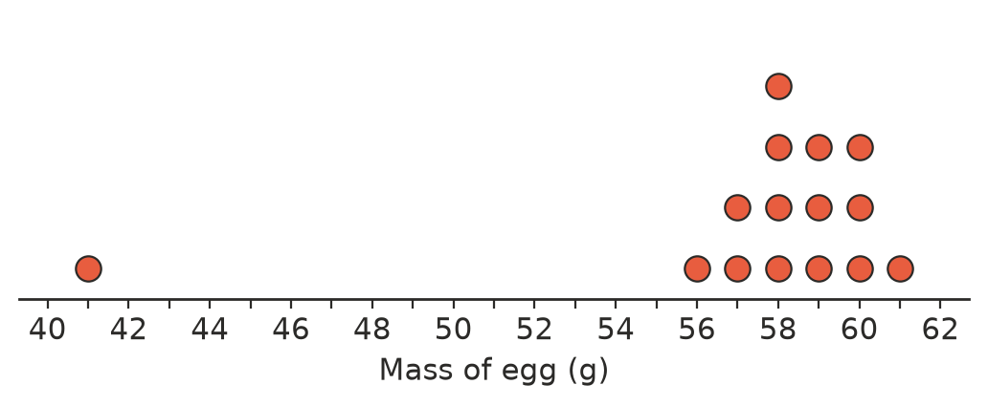
  - Which egg is an outlier? ______________
  - Find the median and range with the outlier. ______________
  - Find the median and range without the outlier. ______________
  - The total mass of all 15 eggs is 861 g. Find the mean mass. ______________

 Reasoning
- Explain why the median is often a better measure of centre than the mean when the data has an outlier.

- Decide what to do with each outlier: remove it (it is a mistake), correct it, or keep it (it is real data). Give a reason.
  - In a list of reaction times in seconds, one student recorded 0.01 s because they started before the signal.

  - In the house prices for a suburb, one house is a mansion that sold for $6 000 000.

  - In a list of students’ ages, one is written as 113 instead of 13.

- Zara’s test scores were 78, 82, 80, 85, 81 and 14. She scored 14 on a test she started late.
  - Find the mean and median with all six scores. ______________
  - Find the mean and median without the 14. ______________
  - Zara’s report says her average is 70. Do you think this is fair? Explain.

 Problem solving
- Six numbers have a mean of 15. Five of them are 10, 12, 11, 13 and 12. Find the sixth number. Is it an outlier?

- A data set of six values has a mean of 20. When an outlier is removed, the mean of the other five values is 15. What was the outlier? Show your working.

- The ages of the people at a family picnic are 34, 36, 8, 10, 12, 11, 9 and 82.
  - Are there any outliers? Explain. ______________

  - Find the mean and median age. ______________
  - Which measure best describes the age of a typical person at the picnic? Explain.

- Write a data set of five numbers with an outlier, where the median is 10 and the mean is 20.

- In a game, Ava’s scores were 45, 50, 48, 52, 47 and one more score. Her median is 49 and her mean is 59. Find the missing score and explain whether it is an outlier.

