16.04 Outliers
Year 7 Maths · A5 question sheet · Level 1 · Warm-up
This worksheet practises spotting outliers and seeing how they change the mean, median and range. An outlier is a value that is much bigger or much smaller than the rest of the data. Tip: an outlier pulls the mean towards it, but it hardly moves the median.

 Understanding
- Write down the outlier in each data set and write it down.
  - 5, 6, 4, 7, 25, 6
  - 42, 45, 3, 44, 41
  - 110, 115, 112, 180, 108
- The dot plot shows how many pets each student in a group has.
- 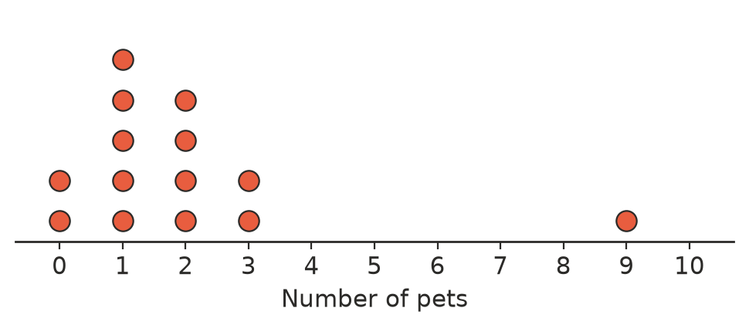
  - How many students are in the group?
  - Which value is an outlier?
  - Find the range with the outlier.
  - Find the range without the outlier.

 Fluency
- Here is a data set: 8, 9, 7, 10, 6, 32
  - Which value is the outlier?
  - Find the mean with the outlier.
  - Find the mean without the outlier.
  - Find the median with the outlier.
  - Find the median without the outlier.
- Use your answers to Question 3. Which changed more when the outlier was removed: the mean or the median?
- Use the dot plot in Question 2. Find the median number of pets with the outlier and without the outlier.
  - With the outlier:
  - Without the outlier:

 Reasoning
- A class recorded their heights in centimetres: 152, 148, 1.55, 150, 157, 149. Which value is the outlier? What do you think happened?
- Write a number that would be an outlier for this data set: 20, 22, 21, 23, 24. Explain your choice.

 Problem solving
- Bella’s spelling scores (out of 20) were 16, 17, 15, 18, 4 and 14. She scored 4 on a day she was sick.
  - Find her mean score with all six tests.
  - Find her mean score without the test she did when she was sick.
  - Which mean better describes how Bella usually goes?
- A cricketer made these scores in five innings: 12, 8, 15, 10, 105
  - Find the mean score.
  - Find the median score.
  - Which measure better describes a typical score for this cricketer? Explain.
- The range of a data set without its outlier is 6. With the outlier it is 40. The smallest value is 12 and the outlier is the largest value. What is the outlier?

