16.02 Frequency tables
Year 7 Maths · Worksheet · Level 1 · Warm-up
Name: ____________________ Date: ______________
This worksheet practises organising data in a frequency table. The frequency is how many times something happens. Tip: cross off each piece of data as you tally it, and draw every fifth tally mark across the four before it. When you finish, check that the frequencies add up to the number of pieces of data.

 Understanding
- Write the number shown by each set of tally marks.
- 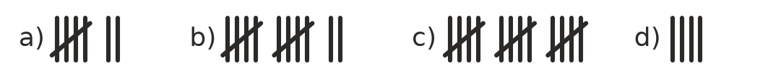
  - ______________
  - ______________
  - ______________
  - ______________
- Draw tally marks to show each number.
  - 9 ______________
  - 13 ______________

 Fluency
- The canteen recorded the drinks it sold in the first ten minutes of lunch.
- juice, water, smoothie, smoothie, juice, water, smoothie, water, milk, water, juice, juice, milk, juice, water, water, juice, water, smoothie, water
Drink | Tally | Frequency
water
juice
milk
smoothie
Total

  - Complete the frequency table.
  - Which drink was the most popular? ______________
  - How many more waters than smoothies were sold? ______________
- These are the numbers of tries a rugby league team scored in each of its 16 games.
- 3, 3, 2, 4, 2, 0, 2, 1, 2, 1, 3, 1, 2, 4, 5, 0
Number of tries | Tally | Frequency
0
1
2
3
4
5
Total

  - Complete the frequency table.
  - What was the most common number of tries? ______________
  - In how many games did the team score 3 or more tries? ______________
- The table shows the number of people in each car that arrived at school one morning.
Number of people in the car | Frequency
1 | 6
2 | 9
3 | 5
4 | 3
5 | 2

  - How many cars arrived? ______________
  - How many cars had exactly 3 people in them? ______________
  - How many cars had more than 2 people in them? ______________
  - What fraction of the cars had only 1 person in them? ______________
- Thirty students were asked about their pets. Find the missing frequency.
Pet | Frequency
dog | 11
cat | 7
fish
bird | 3
no pet | 5
Total | 30

- Fish: ______________

 Reasoning
- Jayden asked 25 students for their favourite subject. When he added up his frequency column, the total was 27. What could have gone wrong?

- Write the 10 data values that make this frequency table, in order from smallest to largest.
Score | Frequency
1 | 2
2 | 3
3 | 4
4 | 1

 Problem solving
- Use the car table from Question 5. How many people arrived by car altogether? Complete the last column to help you.
Number of people in the car | Frequency | Number of people
1 | 6 | 1 × 6 = 6
2 | 9
3 | 5
4 | 3
5 | 2
Total

- Total number of people: ______________
- Lucy rolled a dice 20 times. She got a 1 three times, a 2 four times, a 3 twice, a 5 five times and a 6 three times. She forgot to write down how many times she rolled a 4.
  - How many times did she roll a 4? ______________
  - Which number did she roll most often? ______________
  - Which number did she roll least often? ______________

