Solids and volume: Practice test 3
Year 7 Maths · Test · Test 3
Name: ____________________ Date: ______________
Time: 45 minutes
Total: 40 marks
Show your working in the boxes. Then write each final answer on the answer sheet on the last page.

 Section A: No calculator
- Name the solid that each net folds up to make.
- 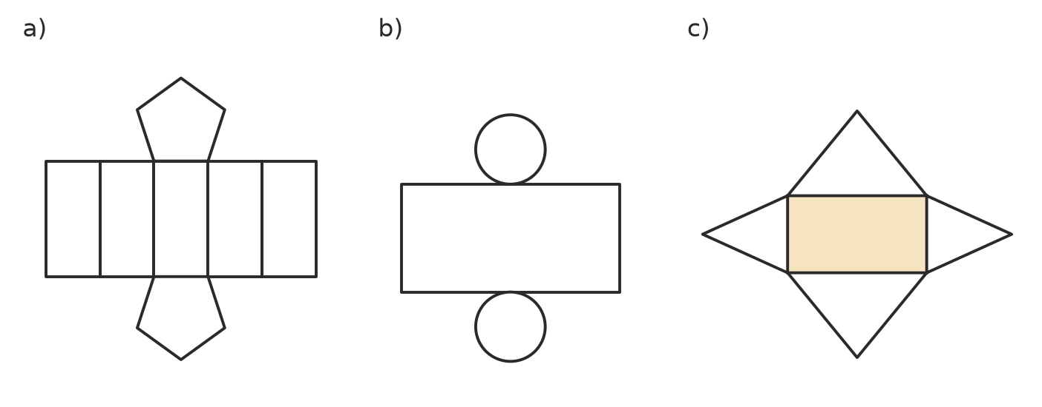
  - Net a) (1 mark)

  - Net b) (1 mark)

  - Net c) (1 mark)

- Think about a pentagonal pyramid.
  - How many faces does it have? (1 mark)

  - How many vertices does it have? (1 mark)

  - How many edges does it have? (1 mark)

- This net of a cube is missing one square. The dashed squares A, B, C and D show where the last square could go. Which position makes a net that folds up into a cube? (1 mark) Answer: ______________
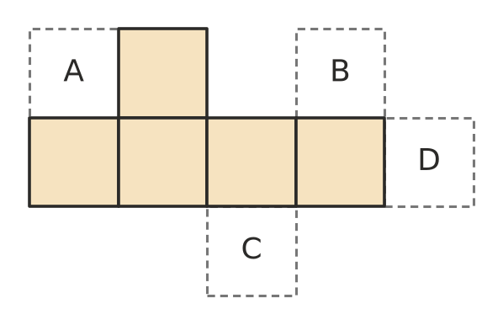
- This stack is made of 1 cm cubes. Every cube sits on the table or on another cube.
- 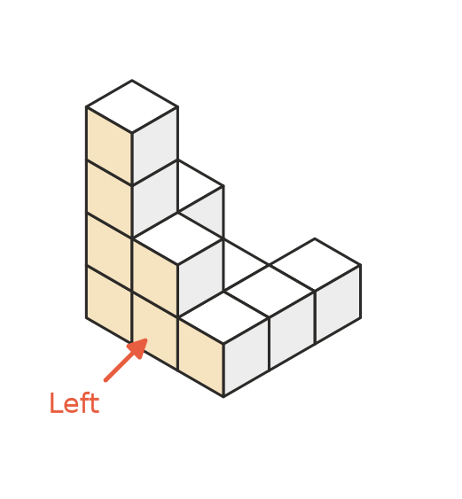
  - How many cubes are in the stack? (1 mark)

  - Which drawing below shows the view of the stack from the left (in the direction of the arrow)? (1 mark) Answer: ______________
- 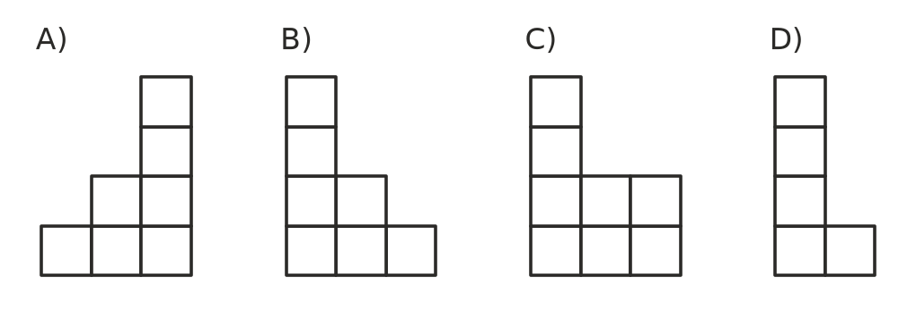
  - How many of the cubes are touching the table? (1 mark)

- A cardboard box is 8 cm long, 5 cm wide and 4 cm high.
  - How many 1 cm cubes will fit in the box? (1 mark)

  - How many 2 cm cubes (2 cm long, 2 cm wide and 2 cm high) will fit in the box? (1 mark)

- Convert each volume to the unit shown.
  - 0.6 cm³ to mm³ (1 mark)

  - 4 200 000 cm³ to m³ (1 mark)

  - 3.5 L to cm³ (1 mark)

- Find the volume of each solid.
- 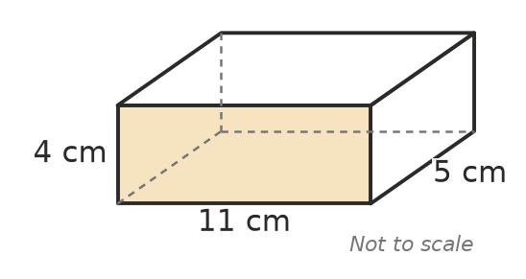
  - The rectangular prism above. (1 mark)

  - A cube with edges 10 m long. (1 mark)

- Find the volume of this triangular prism. (2 marks)
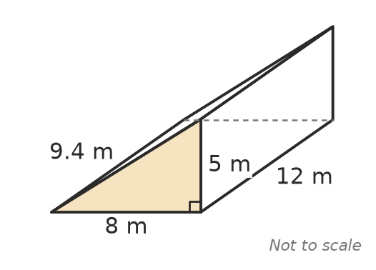

- Use V = A × h, where A is the area of the cross-section and h is the length (height) of the prism.
  - A prism has a cross-section with an area of 18 cm² and is 15 cm long. Find its volume. (1 mark)

  - A prism has a volume of 500 m³ and is 20 m long. What is the area of its cross-section? (1 mark)

- The volume of a rectangular prism is V = l × w × h. A box has a volume of 480 cm³. It is 6 cm wide and 8 cm high. How long is it? (2 marks)

- Jack says, “1 m = 100 cm, so 1 m³ = 100 cm³.” Explain why Jack is wrong, and give the correct number of cm³ in 1 m³. (2 marks)

- A large cube is made from 27 small cubes (3 long, 3 wide and 3 high). The outside of the large cube is painted red. How many of the small cubes have red paint on exactly two of their faces? (2 marks)

- These are the front, side and top views of a solid. Name the solid. (1 mark)
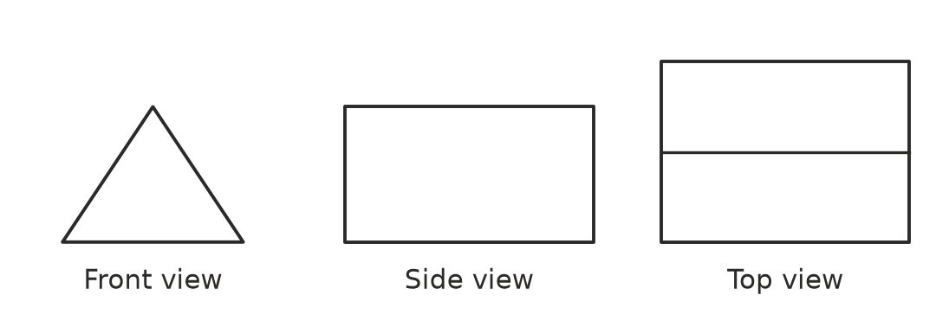

 Section B: Calculator allowed
- A wooden door wedge is shaped like a triangular prism. Find its volume. (2 marks)
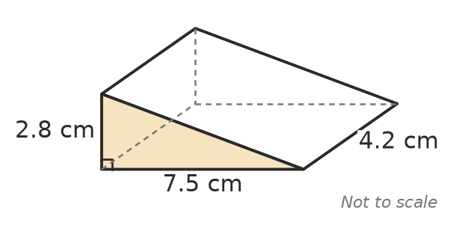

- A hay shed is a prism. Its end is a rectangle with a triangle on top. Find the volume of the shed. (3 marks)
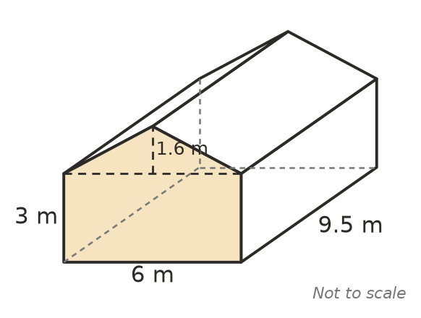

- A swimming pool is a rectangular prism 12.5 m long, 5 m wide and 1.4 m deep.
  - Find the volume of the pool in m³. (1 mark)

  - How many litres of water does the pool hold when it is full? (1 mark)

- A box has a square base with sides s cm long and a height of 10 cm. Its volume is V = 10 × $s^{2}$.
  - Find the volume when s = 3.5 cm. (1 mark)

  - Find s when V = 640 cm³. (1 mark)

  - The side length s is doubled and the height stays at 10 cm. How many times bigger does the volume become? (1 mark)

- In a storm, 15 mm of rain falls on a flat shed roof that is 8 m long and 6 m wide. All the rain runs into a tank. How many litres of water go into the tank? (Hint: change 15 mm to metres first.) (2 marks)

 Answer sheet
Name: ____________________
Write your final answer for each question in the table.
Question | Answer | Marks | Question | Answer | Marks
1a |  | /1 | 7b |  | /1
1b |  | /1 | 8 |  | /2
1c |  | /1 | 9a |  | /1
2a |  | /1 | 9b |  | /1
2b |  | /1 | 10 |  | /2
2c |  | /1 | 11 |  | /2
3 |  | /1 | 12 |  | /2
4a |  | /1 | 13 |  | /1
4b |  | /1 | 14 |  | /2
4c |  | /1 | 15 |  | /3
5a |  | /1 | 16a |  | /1
5b |  | /1 | 16b |  | /1
6a |  | /1 | 17a |  | /1
6b |  | /1 | 17b |  | /1
6c |  | /1 | 17c |  | /1
7a |  | /1 | 18 |  | /2
 |  |  |  | Total | /40

