Solids and volume: Practice test 2
Year 7 Maths · Test · Test 2
Name: ____________________ Date: ______________
Time: 45 minutes
Total: 40 marks
Show your working in the boxes. Then write each final answer on the answer sheet on the last page.

 Section A: No calculator
- Name the solid that each net folds up to make.
- 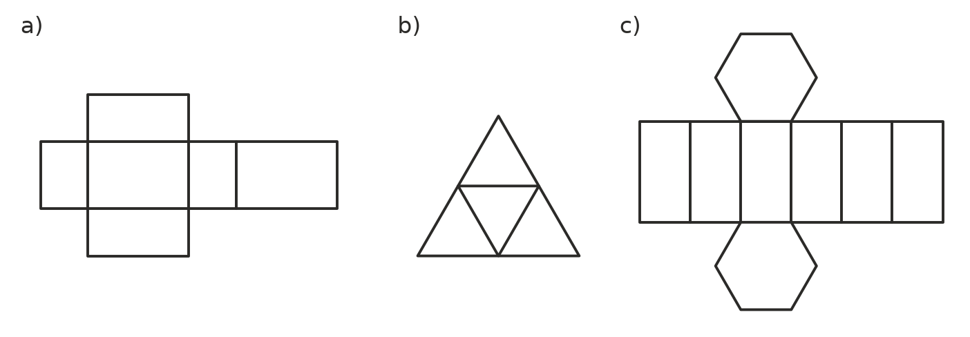
  - Net a) (1 mark)

  - Net b) (1 mark)

  - Net c) (1 mark)

- Think about a square-based pyramid.
  - How many faces does it have? (1 mark)

  - How many vertices does it have? (1 mark)

  - How many edges does it have? (1 mark)

- Only one of these nets will fold up to make a cube. Which one? (1 mark) Answer: ______________
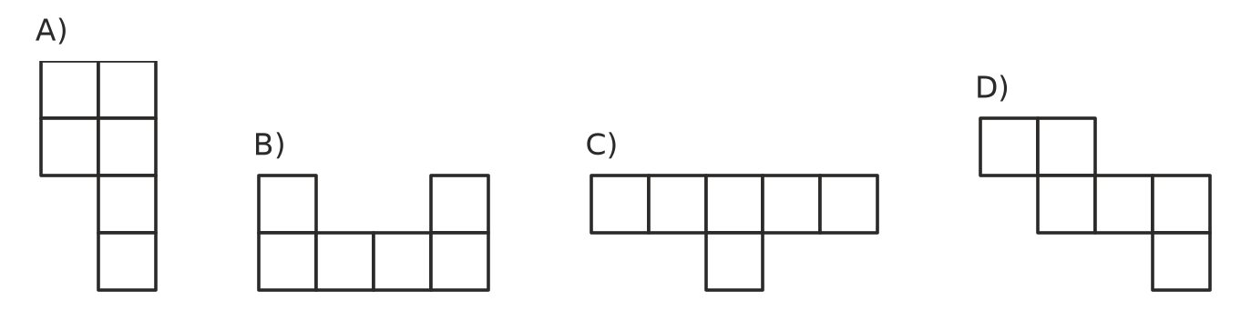
- This stack is made of cubes. Every cube sits on the table or on another cube.
- 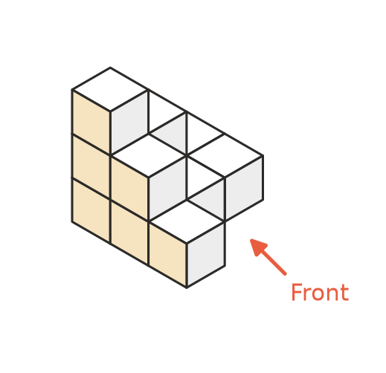
  - How many cubes are in the stack? (1 mark)

  - Which drawing below shows the top view of the stack? (The front is at the bottom of each drawing.) (1 mark) Answer: ______________
- 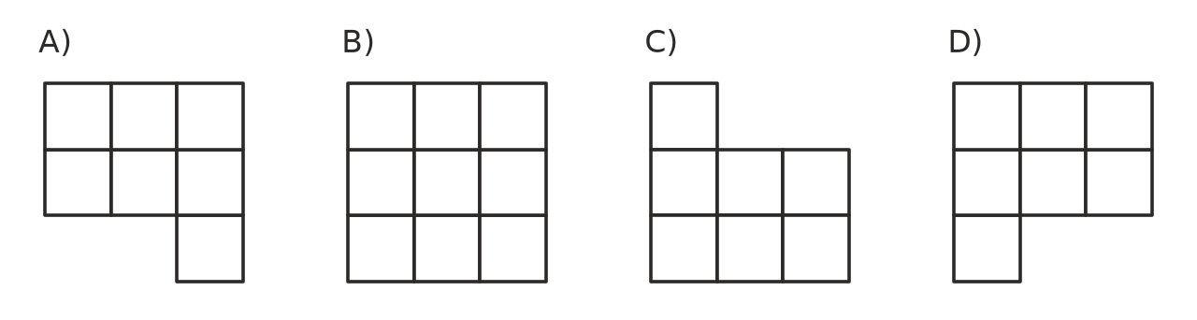
  - Each cube is 2 cm long, 2 cm wide and 2 cm high. What is the volume of the whole stack in cm³? (1 mark)

- A rectangular prism is built from 1 cm cubes. It is 7 cubes long, 3 cubes wide and 4 cubes high.
  - How many cubes are in the bottom layer? (1 mark)

  - What is the volume of the prism in cm³? (1 mark)

- Convert each volume to the unit shown.
  - 5 m³ to litres (1 mark)

  - 9000 mm³ to cm³ (1 mark)

  - 0.75 L to cm³ (1 mark)

- Find the volume of each solid.
- 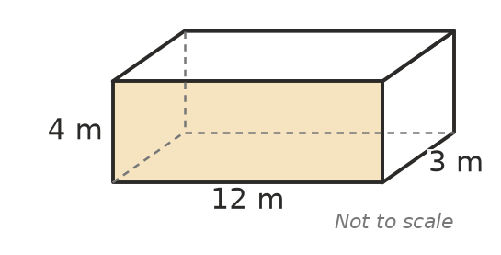
  - The rectangular prism above. (1 mark)

  - A cube with edges 9 cm long. (1 mark)

- Find the volume of this triangular prism. The dashed line is the perpendicular height of the triangle. (2 marks)
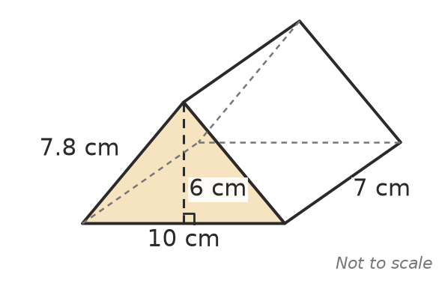

- Use V = A × h, where A is the area of the cross-section and h is the length (height) of the prism.
  - A prism has a cross-section with an area of 24 m² and is 11 m long. Find its volume. (1 mark)

  - A prism has a volume of 96 cm³ and is 8 cm long. What is the area of its cross-section? (1 mark)

- The volume of a rectangular prism is V = l × w × h. A box has a volume of 360 cm³. It is 10 cm long and 4 cm high. How wide is it? (2 marks)

- Ella says, “A box 10 cm long, 2 cm wide and 3 cm high holds more than a cube with 4 cm edges, because 10 is bigger than 4.” Is Ella right? Explain. (2 marks)

- A rectangular prism has a volume of 36 cm³. Its length, width and height are whole numbers of centimetres. They are all different and none of them is 1 cm. Find the length, width and height. (2 marks)

- These are the front, side and top views of a solid. Name the solid. (1 mark)
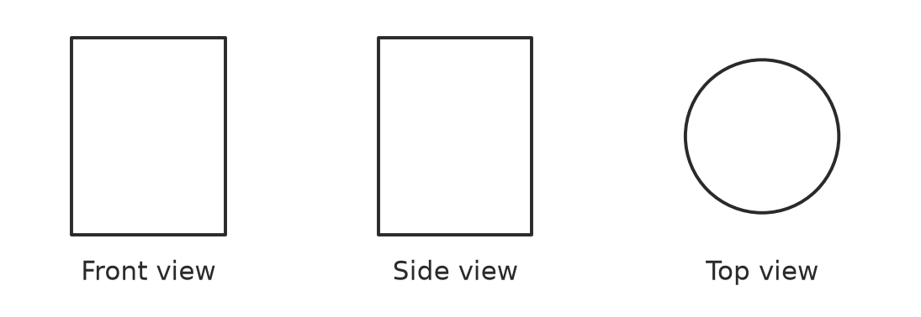

 Section B: Calculator allowed
- A chocolate bar comes in a box shaped like a triangular prism. Find the volume of the box. (2 marks)
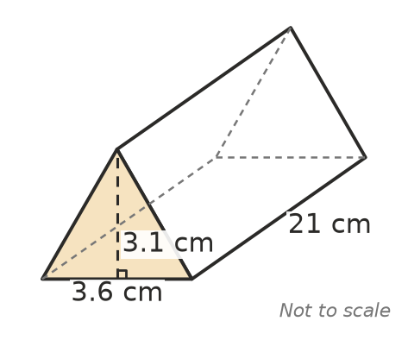

- Two concrete steps are made for the back door of a hall. The steps are a prism with the cross-section shown. Find the volume of concrete in cm³. (3 marks)
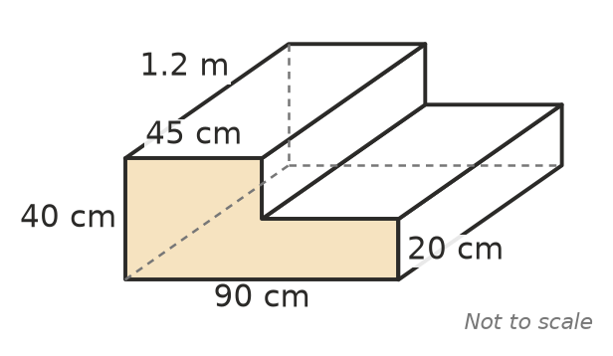

- A fish tank is a rectangular prism 60 cm long, 30 cm wide and 35 cm high.
  - Find the volume of the tank in cm³. (1 mark)

  - How many litres of water does the tank hold when it is full? (1 mark)

- The volume of a cube with edges s cm long is V = $s^{3}$.
  - Find the volume of a cube with edges 2.5 cm long. (1 mark)

  - The edge length of a cube doubles from 3 cm to 6 cm. How many times bigger does the volume become? (1 mark)

  - A cube has a volume of 343 cm³. How long is each edge? (1 mark)

- A sandpit at a kindy is a rectangle 2.4 m long and 1.5 m wide. It is filled with sand to a depth of 0.25 m. Sand costs $45 per cubic metre. How much does the sand cost? (2 marks)

 Answer sheet
Name: ____________________
Write your final answer for each question in the table.
Question | Answer | Marks | Question | Answer | Marks
1a |  | /1 | 7b |  | /1
1b |  | /1 | 8 |  | /2
1c |  | /1 | 9a |  | /1
2a |  | /1 | 9b |  | /1
2b |  | /1 | 10 |  | /2
2c |  | /1 | 11 |  | /2
3 |  | /1 | 12 |  | /2
4a |  | /1 | 13 |  | /1
4b |  | /1 | 14 |  | /2
4c |  | /1 | 15 |  | /3
5a |  | /1 | 16a |  | /1
5b |  | /1 | 16b |  | /1
6a |  | /1 | 17a |  | /1
6b |  | /1 | 17b |  | /1
6c |  | /1 | 17c |  | /1
7a |  | /1 | 18 |  | /2
 |  |  |  | Total | /40

