Solids and volume: Practice test 1
Year 7 Maths · Test · Test 1
Name: ____________________ Date: ______________
Time: 45 minutes
Total: 40 marks
Show your working in the boxes. Then write each final answer on the answer sheet on the last page.

 Section A: No calculator
- Name the solid that each net folds up to make.
- 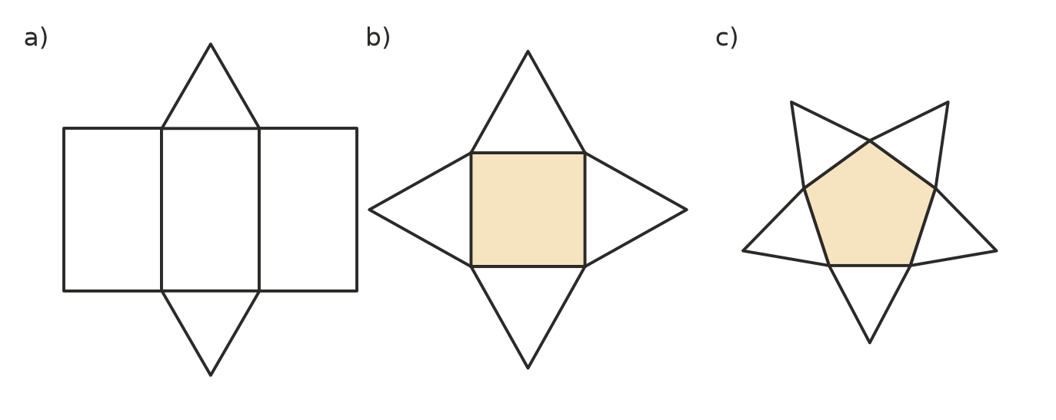
  - Net a) (1 mark)

  - Net b) (1 mark)

  - Net c) (1 mark)

- A new pencil (before it is sharpened) is shaped like a hexagonal prism.
  - How many faces does a hexagonal prism have? (1 mark)

  - How many vertices does it have? (1 mark)

  - How many edges does it have? (1 mark)

- Which of these nets will NOT fold up to make a cube? (1 mark) Answer: ______________
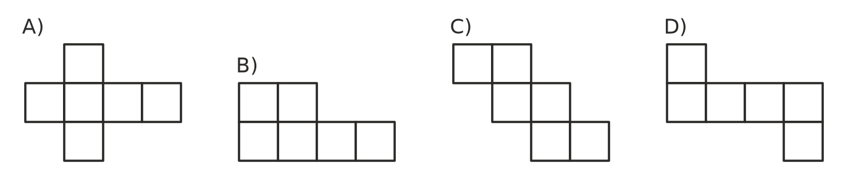
- This stack is made of 1 cm cubes. Every cube sits on the table or on another cube.
- 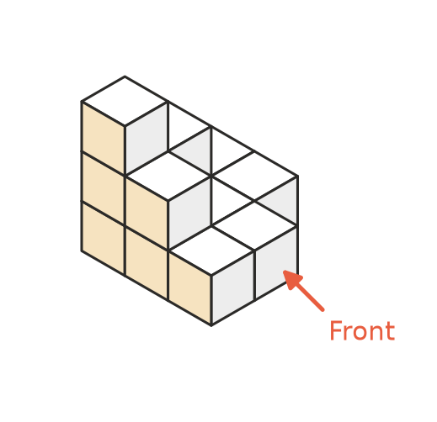
  - How many cubes are in the stack? (1 mark)

  - Which drawing below shows the front view of the stack? (1 mark) Answer: ______________
- 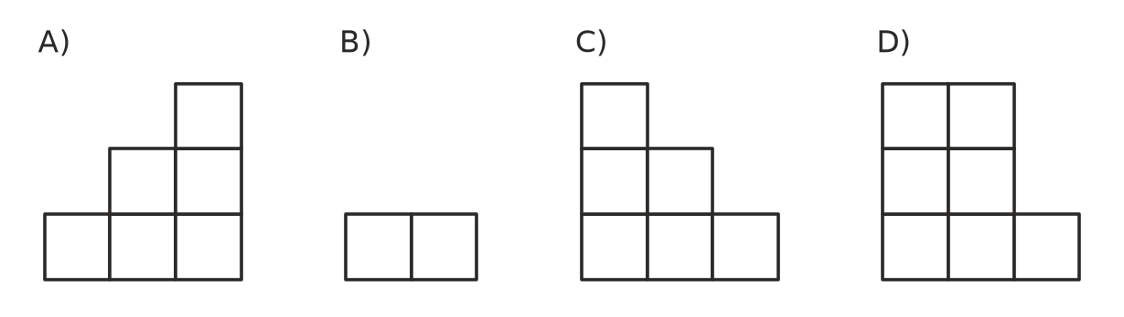
  - How many more cubes would you need to turn the stack into a large cube that is 3 cubes long, 3 cubes wide and 3 cubes high? (1 mark)

- A box is packed with 1 cm cubes. The bottom layer has 4 rows of 6 cubes, and the box holds 5 of these layers. What is the volume of the box in cm³? (2 marks)

- Convert each volume to the unit shown.
  - 7 cm³ to mm³ (1 mark)

  - 3 m³ to cm³ (1 mark)

  - 2500 cm³ to litres (1 mark)

- Find the volume of each solid.
- 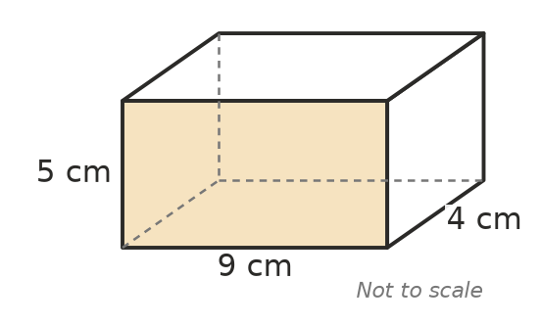
  - The rectangular prism above. (1 mark)

  - A cube with edges 6 m long. (1 mark)

- Find the volume of this triangular prism. (2 marks)
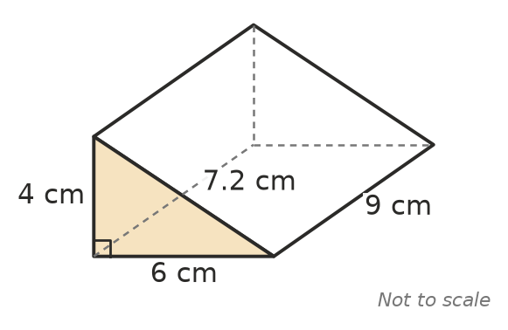

- Use V = A × h, where A is the area of the cross-section and h is the length (height) of the prism.
  - A prism has a cross-section with an area of 35 cm² and is 8 cm long. Find its volume. (1 mark)

  - Another prism has a volume of 240 cm³ and a cross-section with an area of 30 cm². How long is it? (1 mark)

- The volume of a rectangular prism is V = l × w × h. A box has a volume of 300 cm³. It is 12 cm long and 5 cm wide. How high is it? (2 marks)

- Sam says, “If you double the length of a rectangular prism, its volume doubles.” Lily says, “If you double the length, the width and the height, the volume also just doubles.” Who is right? Use an example to explain. (2 marks)

- You have exactly 12 unit cubes and must use all of them to build a rectangular prism. How many different rectangular prisms can you build? (A prism that is the same shape turned around counts only once.) List them. (2 marks)

- These are the front, side and top views of a solid. Name the solid. (1 mark)
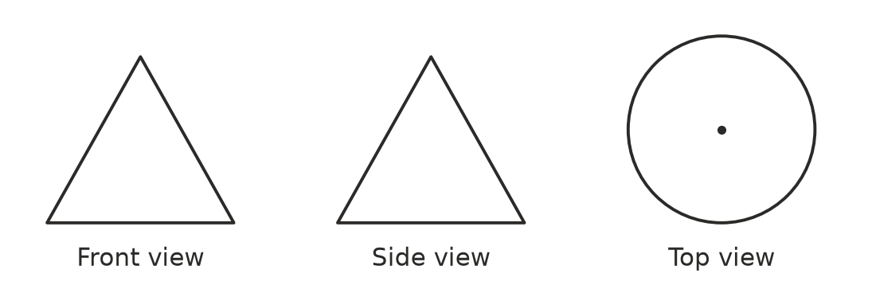

 Section B: Calculator allowed
- A camping tent is shaped like a triangular prism. Find the volume of air inside the tent. (2 marks)
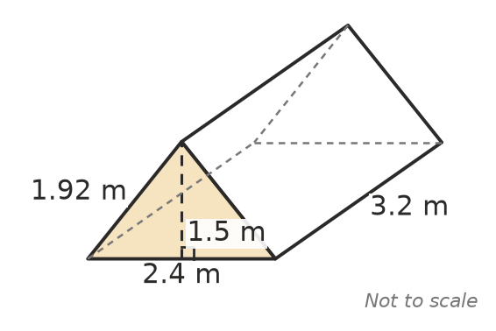

- Find the volume of this prism. All the corners of the L-shaped end are right angles. (3 marks)
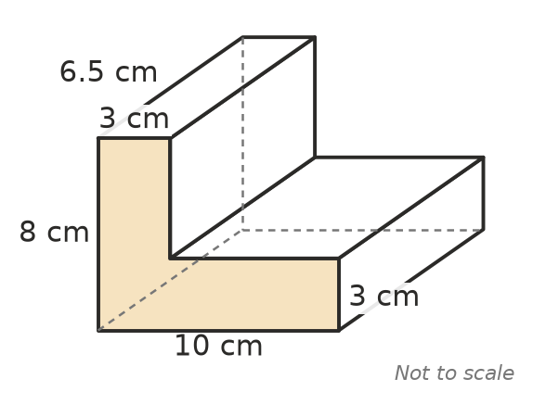

- A water tank on a farm is a rectangular prism 1.2 m long, 0.8 m wide and 0.9 m high.
  - Find the volume of the tank in m³. (1 mark)

  - How many litres of water does the tank hold when it is full? (1 mark)

- A box is 10 cm long and 4 cm wide. Its volume is given by the formula V = 40 × h, where h is its height in centimetres.
  - Find the volume when h = 2.5 cm. (1 mark)

  - Find the height when V = 180 cm³. (1 mark)

  - What happens to the volume each time the height increases by 1 cm? (1 mark)

- The concrete floor of a new shed is a rectangular prism 4.5 m long, 3 m wide and 0.1 m thick. Concrete costs $240 per cubic metre. How much does the concrete for the floor cost? (2 marks)

 Answer sheet
Name: ____________________
Write your final answer for each question in the table.
Question | Answer | Marks | Question | Answer | Marks
1a |  | /1 | 8 |  | /2
1b |  | /1 | 9a |  | /1
1c |  | /1 | 9b |  | /1
2a |  | /1 | 10 |  | /2
2b |  | /1 | 11 |  | /2
2c |  | /1 | 12 |  | /2
3 |  | /1 | 13 |  | /1
4a |  | /1 | 14 |  | /2
4b |  | /1 | 15 |  | /3
4c |  | /1 | 16a |  | /1
5 |  | /2 | 16b |  | /1
6a |  | /1 | 17a |  | /1
6b |  | /1 | 17b |  | /1
6c |  | /1 | 17c |  | /1
7a |  | /1 | 18 |  | /2
7b |  | /1
 |  |  |  | Total | /40

