13.06 Attributes in measurement formula
Year 7 Maths · Worksheet · Level 3 · Challenge
Name: ____________________ Date: ______________
This worksheet uses tables of values, like a spreadsheet, to investigate how changing the measurements in a formula changes the result, and to search for the best design. In a spreadsheet, =0.5*A2*B2*C2 means 0.5 × A2 × B2 × C2. Tip: change one value at a time, look for a pattern, then explain why the pattern happens. If you have a computer, build each table in a spreadsheet.

 Understanding
- This spreadsheet finds the volume of triangular prisms with V = $\frac{1}{2}$ × b × h × l. Cell D2 holds =0.5*A2*B2*C2, filled down to the rows below.
 | A | B | C | D
1 | Base b (cm) | Height h (cm) | Length l (cm) | Volume (cm³)
2 | 6 | 4 | 10
3 | 12 | 4 | 10
4 | 6 | 8 | 10
5 | 12 | 8 | 10
6 | 12 | 8 | 20

  - Fill in column D.
  - Compare row 5 with row 2. Which measurements changed, and by what factor did the volume change? ______________
  - Compare row 6 with row 2. By what factor did the volume change? Explain. ______________
- A cube has edges 2 cm long. Each edge is multiplied by a scale factor k. Complete the table.
Scale factor k | Edge (cm) | Volume (cm³) | Volume is multiplied by
1 | 2 | 8 | 1
2
3
10
$\frac{1}{2}$

What is the rule for the last column? ______________

 Fluency
- An open box (no lid) is made from a square of card 20 cm by 20 cm. A square with sides of x cm is cut from each corner and the sides are folded up.
- 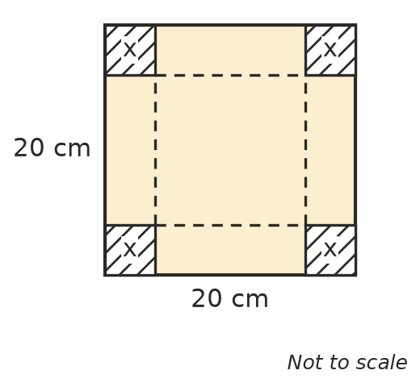
  - Explain why the base of the box is (20 − 2x) cm long and the height is x cm.

  - Complete the table. V = (20 − 2x) × (20 − 2x) × x.
x (cm) | 1 | 2 | 3 | 4 | 5 | 6 | 7 | 8 | 9
Base length (cm)
Volume (cm³)

  - In a spreadsheet, x is in column A, the base length in column B and the volume in column C. Write the formulas for cells B2 and C2. ______________
- Plot the volumes from Question 3 on the grid.
- 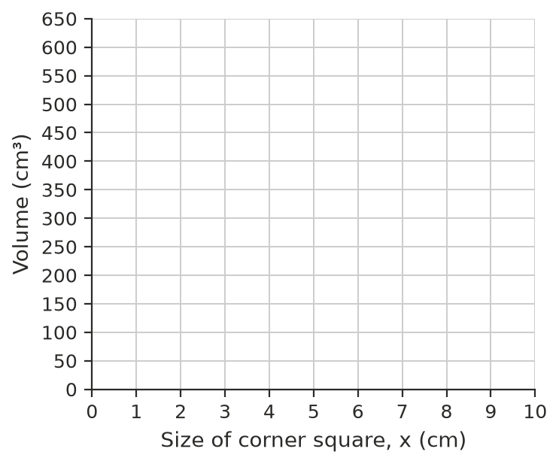
  - Which whole-number value of x gives the biggest volume? ______________
  - Explain why the volume goes up and then comes down again.

- Use a calculator to find the volume of the box in Question 3 for x = 3.1, 3.2, 3.3, 3.4 and 3.5. Round to 1 decimal place. Which of these gives the biggest volume? ______________

 Reasoning
- A box with a square base (length = width) must have a volume of 36 cm³, so h = 36 ÷ (l × l).
Length l (cm) | 1 | 2 | 3 | 6
Height h (cm)

  - Complete the table.
  - What happens to the height when the length doubles? Explain why. ______________
- A box has a volume of 40 cm³. Its length is doubled, its width is halved and its height is tripled. What is its new volume? Explain. ______________
- For a cube with edges of s cm, the volume is V = s × s × s and the surface area is SA = 6 × s × s.
Edge s (cm) | 1 | 2 | 3 | 4 | 5 | 6
Surface area (cm²)
Volume (cm³)

  - Complete the table.
  - For which edge length are the two numbers the same? ______________
  - Which grows faster as s gets bigger, the surface area or the volume? Explain. ______________

 Problem solving
- A box must have l + w + h = 15, using whole numbers of centimetres. Use a table to search for the box with the greatest volume. Write its measurements and volume.

- A rectangular garden bed will use 24 m of edging for its perimeter. Find the length and width (whole numbers of metres) that give the biggest area. Show a table of your results.

