13.06 Attributes in measurement formula
Year 7 Maths · Worksheet · Level 2 · Core
Name: ____________________ Date: ______________
This worksheet explores how changing one measurement in a formula, while keeping the others fixed, changes the result. You’ll use tables of values like a spreadsheet, where a cell such as D2 can hold the formula =A2*B2*C2 (* means multiply). Tip: change one thing at a time and look for a pattern. If you have a computer, try each table in a spreadsheet.

 Understanding
- This spreadsheet uses V = l × w × h. Cell D2 holds the formula =A2*B2*C2, and the formula is filled down to the rows below.
 | A | B | C | D
1 | Length (cm) | Width (cm) | Height (cm) | Volume (cm³)
2 | 5 | 1 | 3
3 | 5 | 2 | 3
4 | 5 | 3 | 3
5 | 5 | 4 | 3

  - Fill in column D.
  - What formula is in cell D5? ______________
  - Describe how the volume changes as the width changes. ______________
- In the spreadsheet in Question 1, the 3 in cell C2 is changed to 6. What happens to the value in D2? Explain. ______________

 Fluency
- A box is 2 cm long, 3 cm wide and 4 cm high. Complete the table.
Change | Length | Width | Height | Volume | Volume is multiplied by
Original box | 2 | 3 | 4 |  | 1
Double the length
Double the length and width
Double all three

- A box has a width of 2 cm and a height of 3 cm. Its length can change.
Length (cm) | 1 | 2 | 3 | 4 | 5 | 6
Volume (cm³)

  - Complete the table.
  - Plot the points on the grid.
- 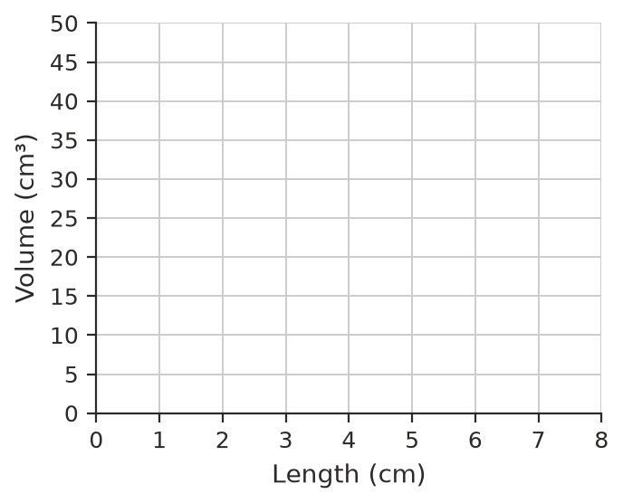
  - Use the pattern to find the volume when the length is 7.5 cm. ______________
  - What length gives a volume of 42 cm³? ______________
- The volume of a triangular prism is V = $\frac{1}{2}$ × b × h × l, where b and h are the base and height of the triangle and l is the length. Here h = 4 cm and l = 10 cm.
Base b (cm) | 2 | 4 | 6 | 8
Volume (cm³)

  - Complete the table.
  - When b doubles from 2 cm to 4 cm, what happens to the volume? ______________

 Reasoning
- Explain why doubling all three measurements of a box multiplies its volume by 8, not by 2.

- A box has a volume of 50 cm³. Find the new volume when:
  - the length is tripled ______________
  - the length, width and height are all tripled ______________
  - the length is doubled and the height is halved ______________

 Problem solving
- Jack has 12 cm of ribbon to mark out the length, width and height of a box, so l + w + h = 12. He uses whole numbers of centimetres.
  - Complete the table.
l (cm) | w (cm) | h (cm) | V (cm³)
1 | 1 | 10
2 | 4 | 6
3 | 3 | 6
3 | 4 | 5
4 | 4 | 4

  - Which box has the greatest volume? What do you notice about its measurements? ______________
- A rectangle has a perimeter of 20 cm, so l + w = 10.
  - Complete the table.
Length (cm) | 1 | 2 | 3 | 4 | 5 | 6 | 7
Width (cm)
Area (cm²)

  - Which rectangle has the largest area? ______________
- Tom is setting up the spreadsheet for Question 9. He types 1 in cell A2 and wants each cell below it to be 1 more than the cell above.
  - What formula should he type in cell A3? ______________
  - The width is 10 minus the length. What formula should go in cell B2? ______________
  - What formula should go in cell C2 for the area? ______________
- The area of a triangle is A = $\frac{1}{2}$ × b × h. A triangle has an area of 12 cm². What is the new area if:
  - the base is doubled? ______________
  - the base and the height are both doubled? ______________
  - the base is doubled and the height is halved? ______________

