13.06 Attributes in measurement formula
Year 7 Maths · Worksheet · Level 1 · Warm-up
Name: ____________________ Date: ______________
A formula such as V = l × w × h links the length, width and height of a box to its volume. This worksheet explores what happens to the result when you change just one of the measurements. Spreadsheets are a quick way to do this: a cell can hold a formula, such as =A2*B2*C2, where * means multiply. Tip: if you have a computer, build the tables in a spreadsheet to check your answers.

 Understanding
- A box has a length of 5 cm and a width of 2 cm. Its height can change.
- 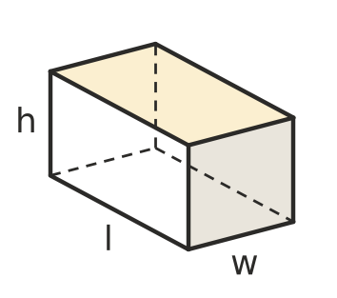
  - Complete the table using V = l × w × h.
Height (cm) | 1 | 2 | 3 | 4 | 5
Volume (cm³)

  - Each time the height goes up by 1 cm, what happens to the volume? ______________
- This spreadsheet works out the volume of boxes. Cell D2 holds the formula =A2*B2*C2, which multiplies the numbers in A2, B2 and C2.
 | A | B | C | D
1 | Length (cm) | Width (cm) | Height (cm) | Volume (cm³)
2 | 4 | 3 | 2
3 | 4 | 3 | 4
4 | 4 | 3 | 6
5 | 4 | 3 | 8

  - Fill in column D.
  - Which measurement is changing? ______________
  - What formula would go in cell D3? ______________

 Fluency
- Use the table in Question 2.
  - The height doubles from 2 cm to 4 cm. What happens to the volume? ______________
  - The height doubles from 4 cm to 8 cm. What happens to the volume? ______________
- The area of a rectangle is A = l × w. The width stays at 3 cm.
Length (cm) | 1 | 2 | 3 | 4 | 5 | 10
Area (cm²)

  - Complete the table.
  - Describe the pattern. ______________
- Plot the points from your table in Question 1 on the grid.
- 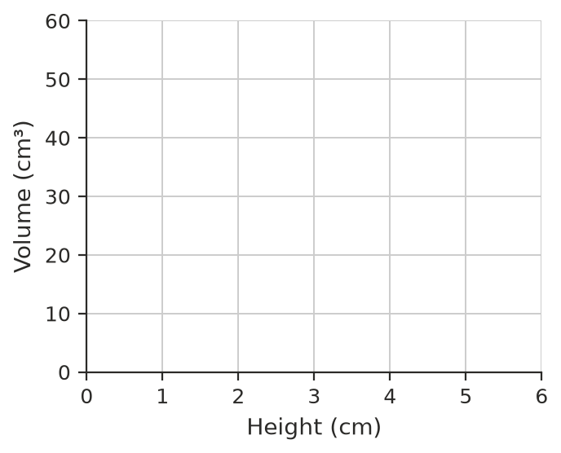
  - What do you notice about the points? ______________
  - Use the pattern to find the volume when the height is 6 cm. ______________

 Reasoning
- A box has V = l × w × h. Complete each sentence.
  - If the height is doubled and the length and width stay the same, the volume is ______________
  - If the length is halved and the width and height stay the same, the volume is ______________
  - If the width is multiplied by 3 and the others stay the same, the volume is ______________
- A box is 10 cm long, 2 cm wide and 3 cm high.
  - What is its volume? ______________
  - Find the new volume if you add 1 cm to the length only. ______________
  - Find the new volume if you add 1 cm to the width only. ______________
  - Find the new volume if you add 1 cm to the height only. ______________
  - Which change made the biggest difference? Why do you think that is?

 Problem solving
- Ella wants to make boxes that are 2 cm high with a volume of 24 cm³. Find all the whole-number lengths and widths she could use (count 3 by 4 and 4 by 3 as the same). Complete the table.
Length (cm) | Width (cm) | Height (cm) | Volume (cm³)
 |  | 2 | 24
 |  | 2 | 24
 |  | 2 | 24

- The perimeter of a rectangle is P = 2 × (l + w). The width stays at 4 cm.
  - Complete the table.
Length (cm) | 1 | 2 | 3 | 4 | 5
Perimeter (cm)

  - Each time the length goes up by 1 cm, how much does the perimeter go up? Explain why. ______________
- A cube has edges 3 cm long. Each edge is doubled to 6 cm.
  - What is the volume of the first cube? ______________
  - What is the volume of the new cube? ______________
  - How many times bigger is the new volume? ______________

