13.05 Volume of right prisms
Year 7 Maths · Worksheet · Level 3 · Challenge
Name: ____________________ Date: ______________
This worksheet practises finding the volume of prisms with composite cross-sections, working backwards to find missing lengths, and solving practical problems. For any right prism, V = A × l, where A is the area of the cross-section and l is the length. Tip: check that every length is in the same unit before you multiply.

 Understanding
- Find the volume of each prism. The cross-sections are shaded.
- 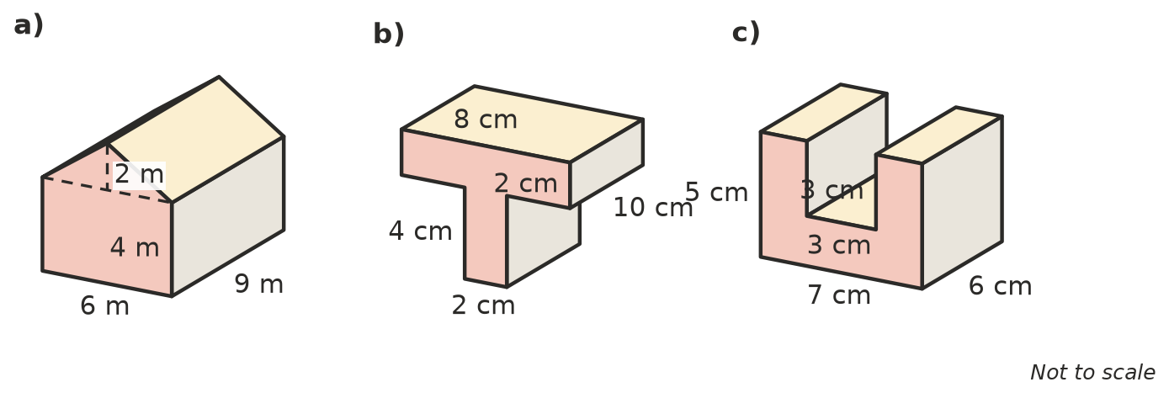
  - ______________
  - ______________
  - ______________
- Complete the table for these right prisms. Find each □ and each missing volume.
Cross-section | Length of prism | Volume
rectangle 12 cm by 5 cm | 0.4 m
triangle, base 3 m, height 2.4 m | 15 m
triangle, base 8 cm, height □ | 10 cm | 240 cm³
square, side □ | 20 cm | 1280 cm³

 Fluency
- A cube has a volume of 343 cm³. How long is each edge? ______________
- A rectangular prism has a square end with sides of 6 cm and a volume of 900 cm³. How long is it? ______________
- This hollow square tube is 50 cm long. It is 10 cm by 10 cm on the outside, with a square hole 6 cm by 6 cm.
- 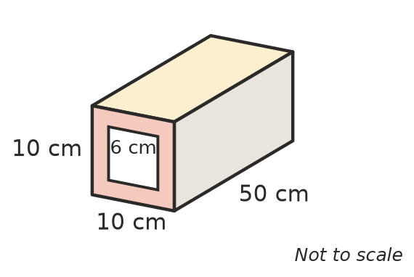
  - Find the area of the shaded cross-section. ______________
  - Find the volume of material in the tube. ______________
- Sam worked out the volume of the tube in Question 5 as 10 × 10 × 50 − 6 × 6 = 4964 cm³. Explain his mistake.

 Reasoning
- A triangular prism has a volume of 150 cm³.
  - If its length is tripled and the triangle stays the same, what is the new volume? ______________
  - If the base of the triangle is doubled and everything else stays the same, what is the new volume? ______________
  - If both changes happen, what is the new volume? ______________
- A tent is a triangular prism. Its triangle ends are 2.4 m wide at the base and 1.5 m high, and it is 3 m long.
- 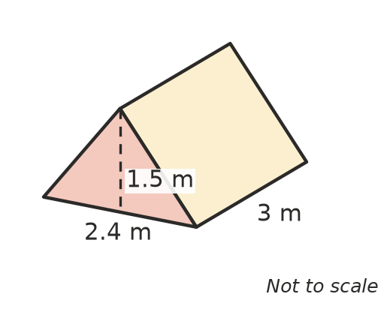
  - What is the volume of air inside the tent? ______________
  - A bigger tent has the same triangle ends but holds 9 m³ of air. How long is it? ______________
- Prism P has a cross-section of 18 cm² and is 10 cm long. Prism Q is a cube. Both prisms have the same volume. Is the edge of the cube a whole number of centimetres? Explain.

 Problem solving
- A rectangular water tank is 1.2 m long, 0.8 m wide and 1 m high. A hose fills it at 12 L per minute. How long does it take to fill the empty tank? Show your working.

- A set of concrete steps is 1 m wide. Seen from the side, there are three steps. Each step is 30 cm deep and 20 cm high, so the side view is a staircase that is 90 cm long at the bottom and 60 cm high at the back. Find the volume of concrete in cubic metres.

- A backyard pool is 8 m long, 4 m wide and 1.5 m deep. Water costs $2.50 per kilolitre. How much does it cost to fill the pool? Show your working.

