13.05 Volume of right prisms
Year 7 Maths · Worksheet · Level 2 · Core
Name: ____________________ Date: ______________
This worksheet practises finding the volume of right prisms with V = A × l, where A is the area of the cross-section and l is the length of the prism. For a rectangular prism, A = length × width. For a triangular prism, A = $\frac{1}{2}$ × base × height of the triangle. Tip: for a composite cross-section, split it into rectangles and triangles first.

 Understanding
- Find the volume of each prism.
- 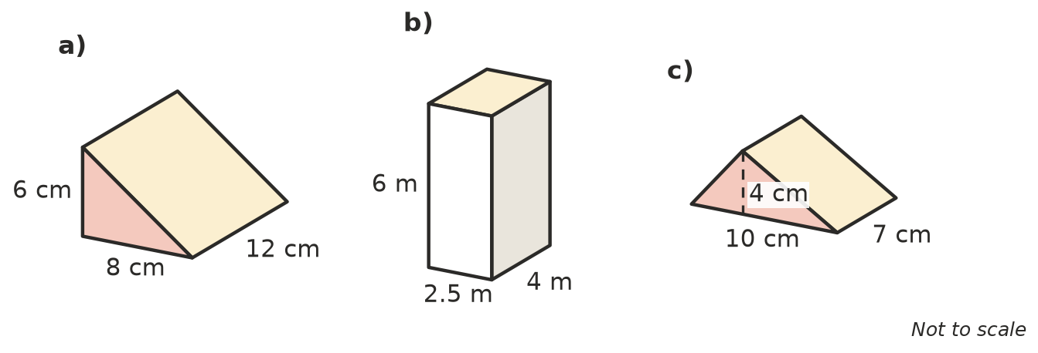
  - ______________
  - ______________
  - ______________
- Complete the table for these right prisms.
Area of cross-section | Length of prism | Volume
35 cm² | 8 cm
4.5 m² | 12 m
25 cm² |  | 400 cm³
 | 6 m | 90 m³

 Fluency
- Find the volume of each rectangular prism.
  - 1.5 m long, 4 m wide, 2 m high ______________
  - 2.5 cm long, 2.5 cm wide, 10 cm high ______________
  - 40 cm long, 15 cm wide, 0.5 cm high ______________
- Find the volume of each triangular prism. The dashed lines show the perpendicular heights of the triangles.
- 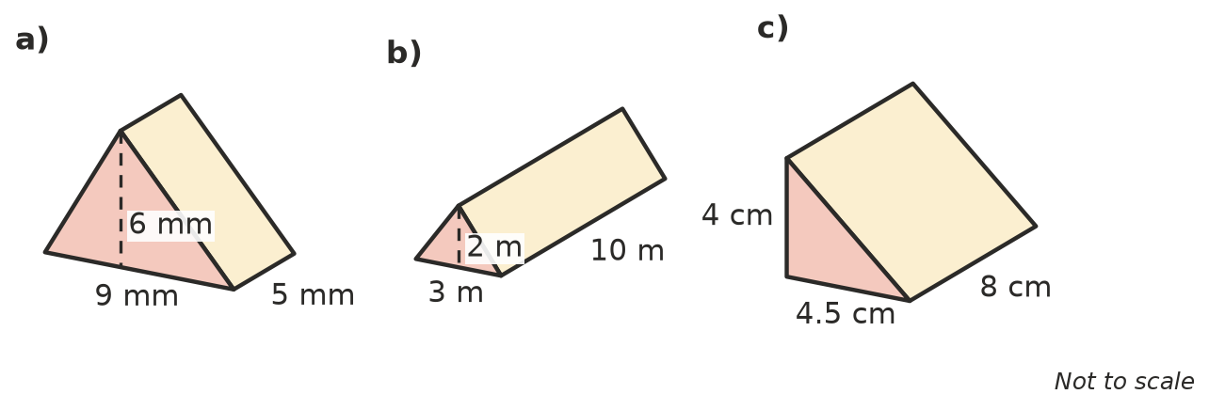
  - ______________
  - ______________
  - ______________
- A triangular prism has a volume of 60 cm³. Its triangle has a base of 5 cm and a height of 4 cm. How long is the prism? ______________
- Find the volume of this prism. Split the shaded cross-section into two rectangles first.
- 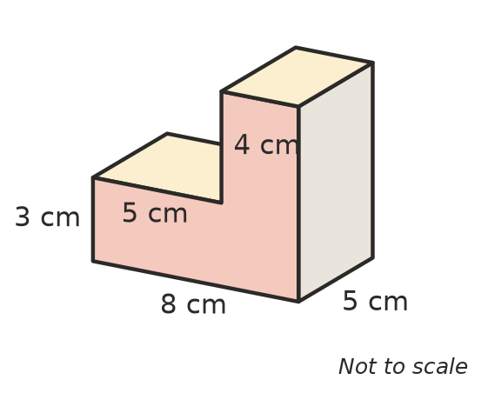

 Reasoning
- A rectangular prism is 6 cm long, 4 cm wide and 3 cm high. A triangular prism has a triangle with base 6 cm and height 4 cm, and it is 3 cm long. Ava says the triangular prism has exactly half the volume of the rectangular prism. Is she right? Explain.

- Two prisms have the same cross-section. Prism A is 9 cm long and prism B is 18 cm long. Prism A has a volume of 120 cm³. What is the volume of prism B? Explain how you know without measuring the cross-section. ______________

 Problem solving
- A concrete slab for a shed is 6 m long, 4 m wide and 0.1 m thick. Concrete costs $250 per cubic metre.
  - What volume of concrete is needed? ______________
  - What does the concrete cost? ______________
- A water trough for cattle is a triangular prism 2 m long. Its triangle end is 40 cm wide across the top and 30 cm deep. How many litres does it hold when full? Show your working. Remember 1000 cm³ = 1 L.

- A swimming pool is 25 m long and 10 m wide. It is 1 m deep at the shallow end and 2 m deep at the deep end, with a sloping floor. This side view shows the shape of the water.
- 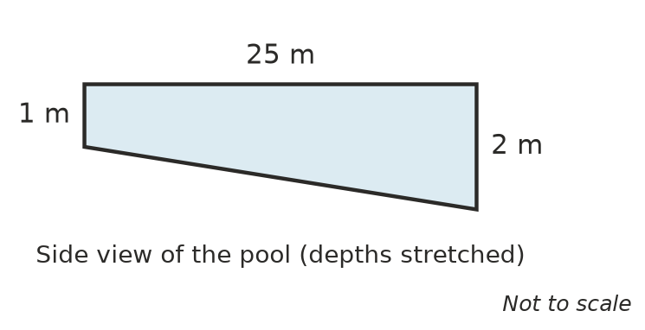
  - Find the area of the side view. Split it into a rectangle and a triangle. ______________
  - Find the volume of water in the pool. ______________
  - How many kilolitres is this? ______________

