13.05 Volume of right prisms
Year 7 Maths · A5 question sheet · Level 1 · Warm-up
A right prism has the same cross-section all the way along its length, and its sides stand at right angles to its ends. Its volume is the area of the cross-section multiplied by the length: V = A × l. For a rectangular prism this is V = length × width × height. This worksheet practises finding the volume of rectangular and triangular prisms. Tip: always write the cubic units, such as cm³ or m³.

 Understanding
- Find the volume of each rectangular prism.
  - 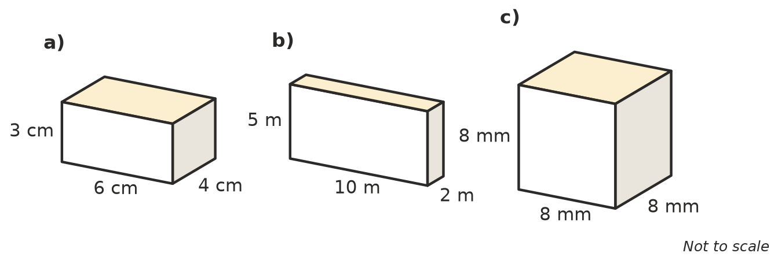

- The shaded end of this prism has an area of 12 cm². The prism is 10 cm long. What is its volume?
- 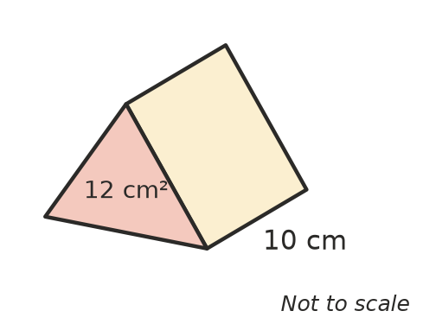
- Volume =
- Use V = A × l to find the volume of each prism.
  - cross-section area 20 cm², length 6 cm
  - cross-section area 14 m², length 5 m
  - cross-section area 9 mm², length 11 mm

 Fluency
- Find the volume of each rectangular prism.
  - length 12 cm, width 5 cm, height 2 cm
  - length 7 m, width 3 m, height 4 m
  - length 20 mm, width 10 mm, height 6 mm
- For each triangular prism, first find the area of the shaded triangle, then find the volume.
- 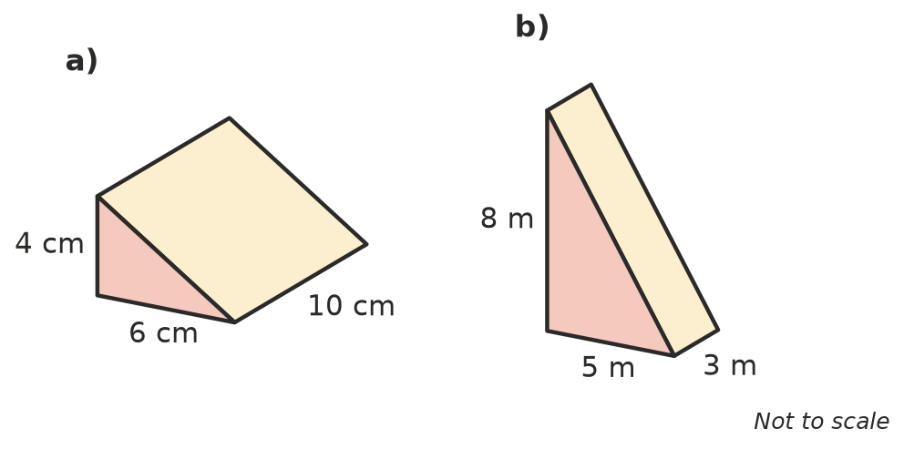
  - area of triangle = ______________ volume =
  - area of triangle = ______________ volume =
- A cube has edges 5 cm long. What is its volume?

 Reasoning
- Explain why multiplying the area of the cross-section by the length gives the volume of a prism. Tip: think about layers.
- A triangular prism has a triangle with base 10 cm and height 6 cm, and it is 5 cm long. Jai says the volume is 10 × 6 × 5 = 300 cm³. Explain his mistake and find the correct volume.

 Problem solving
- A sandpit is 3 m long and 2 m wide. It is filled with sand to a depth of 0.5 m. What volume of sand is in the sandpit?
- A cereal box is 30 cm tall, 20 cm wide and 8 cm deep. What is its volume?
- A rectangular prism has a volume of 60 cm³. It is 5 cm long and 3 cm wide. How high is it?

