13.04 Units of volume
Year 7 Maths · A5 question sheet · Level 2 · Core
This worksheet practises converting between units of volume (mm³, cm³, m³) and units of capacity (mL, L, kL, ML), and using the link between them. Tip: 1 cm³ = 1 mL, 1000 cm³ = 1 L and 1 m³ = 1000 L = 1 kL. To go to a smaller unit, multiply; to go to a bigger unit, divide.

 Understanding
- Use the chart to complete each sentence.
- 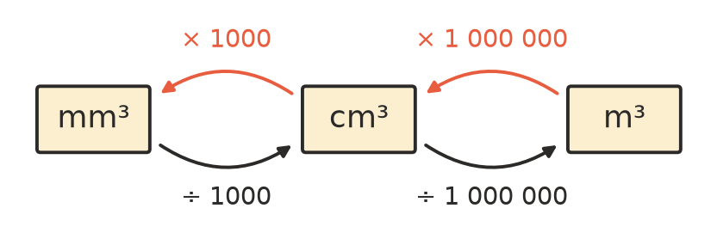
  - To change cm³ to mm³, ______________ by 1000.
  - To change cm³ to m³, ______________ by 1 000 000.
  - Explain why the number for cm³ and m³ is 1 000 000 and not 100.
- Copy and complete the table of capacity units.
Unit | Equal to
1 L | ______________ mL
1 kL | ______________ L
1 ML (megalitre) | ______________ L
1 m³ | ______________ L

- Choose the most sensible unit for each: mm³, cm³, m³, mL, L, kL or ML.
  - the amount of water in Sydney Harbour
  - the volume of a brick
  - the capacity of a car’s fuel tank
  - the volume of soil a truck carries

 Fluency
- Convert each volume.
  - 7.5 cm³ = ______________ mm³
  - 850 mm³ = ______________ cm³
  - 0.3 m³ = ______________ cm³
  - 2 500 000 cm³ = ______________ m³
- Convert each capacity.
  - 4.2 L = ______________ mL
  - 650 mL = ______________ L
  - 4500 L = ______________ kL
  - 2.8 ML = ______________ kL
- Convert each volume to a capacity.
  - 600 cm³ = ______________ mL
  - 3500 cm³ = ______________ L
  - 1.5 m³ = ______________ L
  - 12 m³ = ______________ kL

 Reasoning
- Which is bigger, and by how much: 1.2 L or 1250 cm³?
- Rebecca says the volume of a matchbox is about 30 m³. Explain why this can’t be right, and suggest a more sensible volume.

 Problem solving
- A carton of juice is 6 cm long, 4 cm wide and 10 cm high. How many millilitres of juice does it hold? Is that more or less than 250 mL?
- A swimming pool is 25 m long, 10 m wide and 2 m deep.
  - What is its volume in m³?
  - How many kilolitres of water does it hold?
  - How many litres is that?
- A water tank holds 2000 L. A family uses 160 L of water a day from the tank. How many full days will a full tank last? Show your working.
- When 1 mm of rain falls on a flat shed roof with an area of 100 m², the water collected is a layer 100 m² in area and 1 mm (0.001 m) deep.
  - What volume of water is that, in m³?
  - How many litres is that?

