13.04 Units of volume
Year 7 Maths · A5 question sheet · Level 1 · Warm-up
Volume is measured in cubic units: cubic millimetres (mm³), cubic centimetres (cm³) and cubic metres (m³). The amount a container holds is called its capacity, measured in millilitres (mL), litres (L) and kilolitres (kL). This worksheet practises choosing units and converting between them. Tip: 1 cm³ holds exactly 1 mL, and 1000 cm³ holds 1 L.

 Understanding
- Look at the two cubes.
- 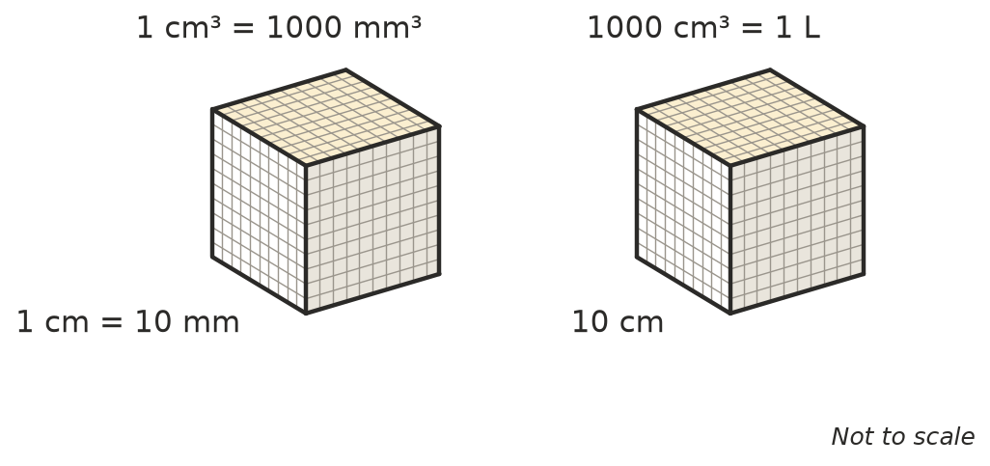
  - A 1 cm cube is 10 mm long, 10 mm wide and 10 mm high. How many 1 mm³ cubes fit inside it?
  - A 10 cm cube holds 1 L. How many 1 cm³ cubes fit inside it?
  - So 1 cm³ holds how many millilitres?
- Which unit would you use to measure the volume of each object: mm³, cm³ or m³?
  - a grain of rice
  - a dice
  - a shipping container
  - a lunchbox
- Which unit would you use to measure the capacity of each container: mL, L or kL?
  - a teaspoon
  - a bucket
  - a backyard swimming pool
  - a can of drink

 Fluency
- Convert between cm³ and mm³. Remember: 1 cm³ = 1000 mm³.
  - 3 cm³ = ______________ mm³
  - 12 cm³ = ______________ mm³
  - 5000 mm³ = ______________ cm³
  - 45 000 mm³ = ______________ cm³
- Convert between m³ and cm³. Remember: 1 m³ = 1 000 000 cm³.
  - 2 m³ = ______________ cm³
  - 4 000 000 cm³ = ______________ m³
- Convert each volume to a capacity.
  - 250 cm³ = ______________ mL
  - 2000 cm³ = ______________ L
  - 3 m³ = ______________ L
  - 1500 mL = ______________ L
- A box is 10 cm long, 5 cm wide and 4 cm high.
  - What is its volume in cm³?
  - How many millilitres of water would fill it?

 Reasoning
- Sam says, “1 m = 100 cm, so 1 m³ = 100 cm³.” Explain why Sam is wrong.
- Write these amounts in order from smallest to largest: 3000 mL, 2 L, 2500 cm³

 Problem solving
- A fish tank is 50 cm long, 30 cm wide and 20 cm high. How many litres of water does it hold when full? Show your working.
- A farm water tank holds 5 m³ of water.
  - How many litres is this?
  - How many 10 L buckets would it take to fill the tank?

