13.03 Volume using unit cubes
Year 7 Maths · Worksheet · Level 3 · Challenge
Name: ____________________ Date: ______________
This worksheet practises finding volume by counting unit cubes, including hidden cubes, hollow solids and cubes that are not 1 cm across. Tip: for a rectangular prism, volume = length × width × height. For other stacks, split them into rectangular blocks or count column by column.

 Understanding
- Each cube is 1 cm³. Find the volume of each stack. Some cubes are hidden behind or under others.
- 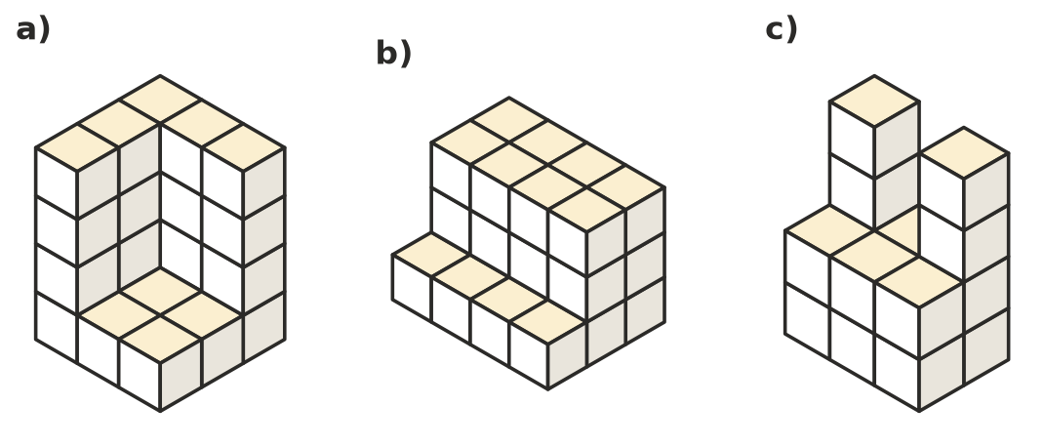
  - ______________
  - ______________
  - ______________
- This rectangular prism is built from cubes with edges 2 cm long.
- 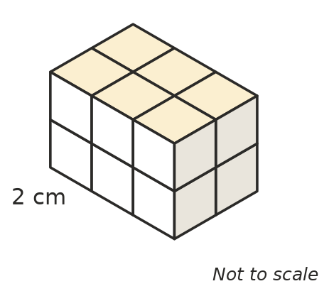
  - How many cubes are used? ______________
  - What is the volume of one cube? ______________
  - What is the volume of the prism? ______________
  - Find the length, width and height of the prism in cm, and use them to check your answer to c). ______________

 Fluency
- Find the missing measurement of each rectangular prism.
Length | Width | Height | Volume
8 cm | 5 cm |  | 120 cm³
 | 4 cm | 4 cm | 112 cm³
9 cm |  | 2 cm | 54 cm³
12 cm | 10 cm |  | 600 cm³

- A box is 20 cm long, 15 cm wide and 12 cm high inside. It is packed with cubes that have edges 5 cm long.
  - How many cubes fit in the box? ______________
  - How much space in the box is left empty? ______________
- How many different rectangular prisms can be made with exactly 36 cubes? (Count 2 × 3 × 6 and 6 × 3 × 2 as the same prism.) List them.

 Reasoning
- A picture of a 3 × 3 × 3 cube shows 19 cubes, and 8 are hidden. A picture of a 4 × 4 × 4 cube shows 37 cubes, and 27 are hidden.
  - How many cubes are hidden in a picture of a 5 × 5 × 5 cube? ______________
  - How many cubes can you see? ______________
  - Describe the pattern in the number of hidden cubes. ______________
- A hollow cube is 5 cubes long, 5 wide and 5 high. Every face is a solid wall one cube thick, with nothing inside. How many cubes are used? ______________
- A 4 × 4 × 4 cube has a square tunnel, 2 cubes by 2 cubes, cut straight through the middle from the front to the back.
- 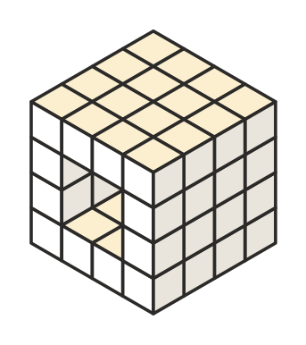
  - How many cubes are left? ______________
  - A second tunnel of the same size is cut through the middle from the left side to the right side. How many cubes are left now? Explain.

 Problem solving
- A staircase is built from cubes. It has 10 steps: the first step is 1 cube high, the second is 2 cubes high, and so on up to 10 cubes high. The staircase is 2 cubes wide. How many cubes are used? Show your working.

- A rectangular prism is made of 24 cubes. Its top face shows 8 cubes, its front face shows 6 cubes and its side face shows 12 cubes. Find its length, width and height. ______________

- A cube 1 m long, 1 m wide and 1 m high is filled with 1 cm³ cubes.
  - How many small cubes are needed? ______________
  - If all the small cubes were stacked in one tower, how tall would it be in kilometres? ______________

