13.03 Volume using unit cubes
Year 7 Maths · Worksheet · Level 2 · Core
Name: ____________________ Date: ______________
Volume is the amount of space a solid takes up, measured by counting unit cubes. This worksheet practises counting cubes in layers and finding the rule for the volume of a rectangular prism. Tip: volume = cubes in one layer × number of layers, which is the same as length × width × height.

 Understanding
- Each cube is 1 cm³. Find the volume of each rectangular prism.
- 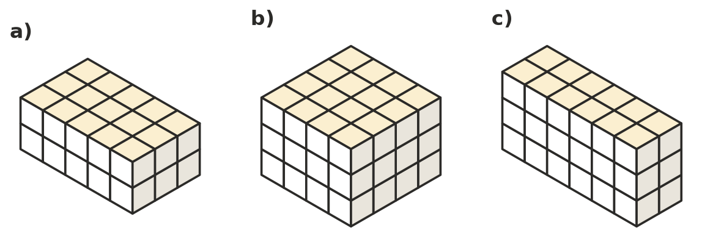
  - ______________
  - ______________
  - ______________
- Complete the table for rectangular prisms made of 1 cm³ cubes.
Length | Width | Height | Cubes in one layer | Volume
7 cm | 3 cm | 2 cm
5 cm | 5 cm | 4 cm
12 cm | 2 cm | 3 cm
8 cm | 1 cm | 6 cm

 Fluency
- Each cube is 1 cm³. Find the volume of each stack. Some cubes are hidden underneath others.
- 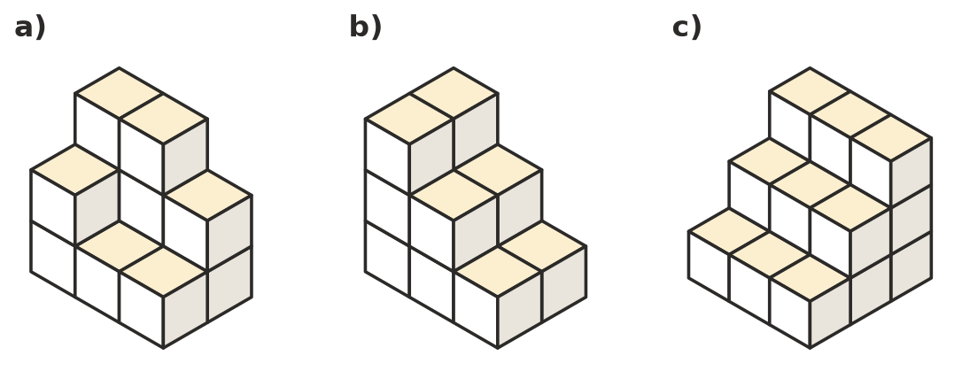
  - ______________
  - ______________
  - ______________
- Each rectangular prism is made of 1 cm³ cubes. Find the missing measurement.
  - volume 40 cm³, length 5 cm, width 4 cm, height = ______________
  - volume 72 cm³, length 6 cm, height 3 cm, width = ______________
  - volume 90 cm³, width 3 cm, height 5 cm, length = ______________
  - a cube with a volume of 64 cm³, edge length = ______________
- A box is 10 cm long, 6 cm wide and 4 cm high inside. It is packed with wooden cubes that have edges 2 cm long.
  - How many cubes fit along the length, the width and the height? ______________
  - How many cubes fit in the box? ______________
  - What is the volume of one wooden cube? ______________
  - Show that the cubes fill the whole volume of the box. ______________

 Reasoning
- List all the different rectangular prisms that can be made with exactly 24 cubes. (Count 2 × 3 × 4 and 4 × 3 × 2 as the same prism.)

- Ari counts the cubes he can see in a picture of a 4 × 4 × 4 cube. He sees 37 cubes.
  - How many cubes are hidden? ______________
  - What is the volume of the cube in cubes? ______________
- A cube is 2 cubes long, 2 wide and 2 high. Mel doubles every edge to make a cube 4 long, 4 wide and 4 high. She thinks the new cube uses twice as many small cubes. Is she right? Explain.

 Problem solving
- Nina wants to finish this stack as a solid block 4 cubes long, 3 cubes deep and 3 cubes high. How many more cubes does she need? Show your working.
- 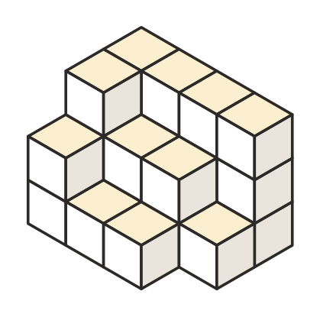

- A tunnel is cut straight through the middle of this 3 × 3 × 3 cube, from the front to the back. What is the volume of what is left, in cubes?
- 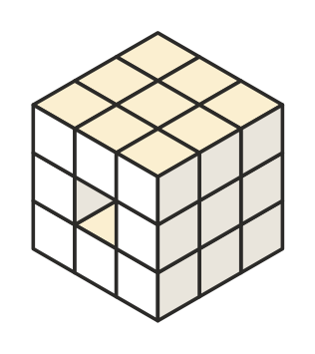
- Answer: ______________
- A hollow cube is built from 1 cm³ cubes. It is 4 cubes long, 4 wide and 4 high, and every face is a solid wall one cube thick, with nothing inside. How many cubes are used? Show your working.

