13.03 Volume using unit cubes
Year 7 Maths · A5 question sheet · Level 1 · Warm-up
Volume is the amount of space a solid takes up. One way to measure it is to count how many unit cubes fit inside. A cube with edges 1 cm long has a volume of 1 cubic centimetre, written 1 cm³. Tip: count the cubes in one layer, then multiply by the number of layers.

 Understanding
- Each cube is 1 cm³. Find the volume of each solid.
- 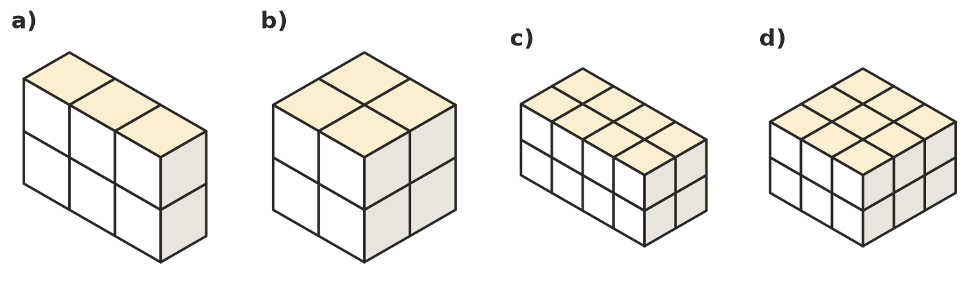
  - ______________ cm³
  - ______________ cm³
  - ______________ cm³
  - ______________ cm³
- This box is made of 1 cm³ cubes. The top layer is shaded.
- 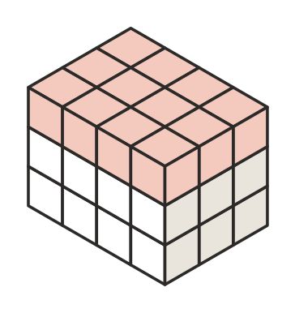
  - How many cubes are in the top layer?
  - How many layers are there?
  - What is the volume of the box?
- Complete each sentence.
  - Volume is the amount of ______________ a solid takes up.
  - A cube with edges 1 cm long has a volume of

 Fluency
- Each cube is 1 cm³. Find the volume of each stack. Some cubes are hidden underneath others.
  - 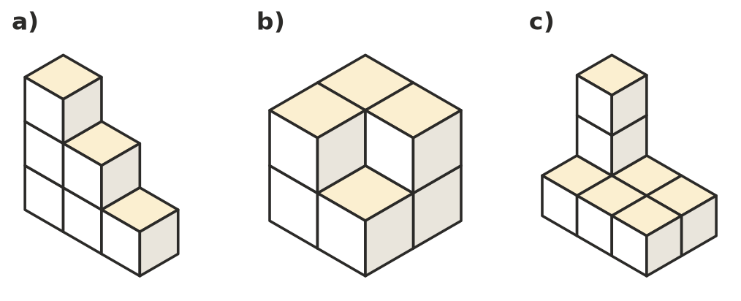

- Copy and complete the table for these boxes made of 1 cm³ cubes.
Length (cubes) | Width (cubes) | Height (layers) | Cubes in one layer
5 | 2 | 3
4 | 4 | 2
6 | 3 | 2
10 | 2 | 5

- Box A is 4 cubes long, 2 cubes wide and 2 cubes high. Box B is 3 cubes long, 3 cubes wide and 2 cubes high. Which box has the bigger volume, and by how much?

 Reasoning
- Jo counts the cubes she can see in this 3 × 3 × 3 cube. She counts 19, so she says the volume is 19 cm³.
- 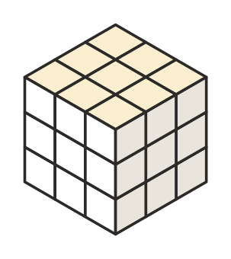
  - What is the real volume?
  - Explain Jo’s mistake.
- Find three different rectangular prisms that can each be made with exactly 12 cubes. Write the length, width and height of each.

 Problem solving
- Theo is building a solid block that will be 3 cubes long, 3 cubes deep and 2 cubes high. This is what he has built so far.
- 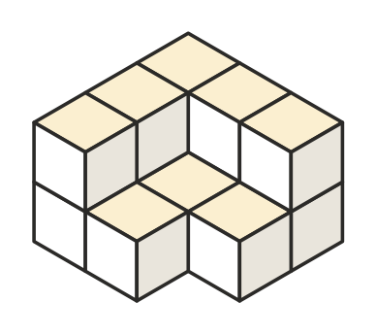
  - How many cubes has he used so far?
  - How many more cubes does he need?
- A box is 5 cm long, 4 cm wide and 3 cm high inside. How many 1 cm³ cubes will fit in it?
- Marcus has 30 cubes. He builds a rectangular prism 5 cubes long and 3 cubes wide, using all of them. How many layers high is it?

