13.02 Visualise solids
Year 7 Maths · Worksheet · Level 1 · Warm-up
Name: ____________________ Date: ______________
A solid can be shown on flat paper in different ways: a 3D drawing, a plan with numbers, or views from the top, the front and the side. This worksheet practises reading and drawing these. Tip: in every stack of cubes on this sheet, each cube sits on the table or on another cube, and there are no gaps.

 Understanding
- Here is a stack of cubes and three of its views.
- 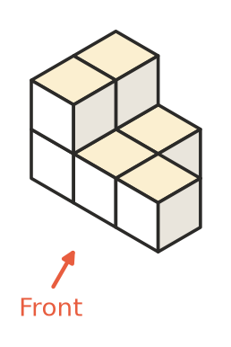
- 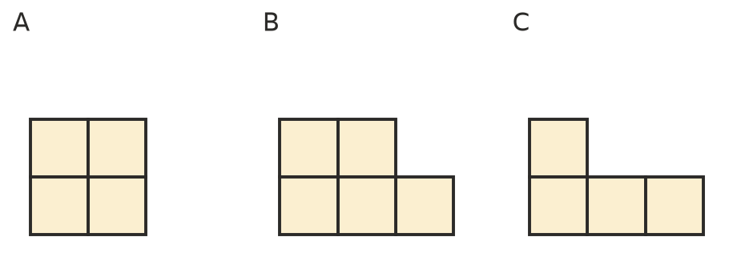
  - Which view is the top view? ______________
  - Which view is the front view? ______________
  - Which view is the right view? ______________
- How many cubes are in each stack? None of the cubes are hidden except those holding up other cubes.
- 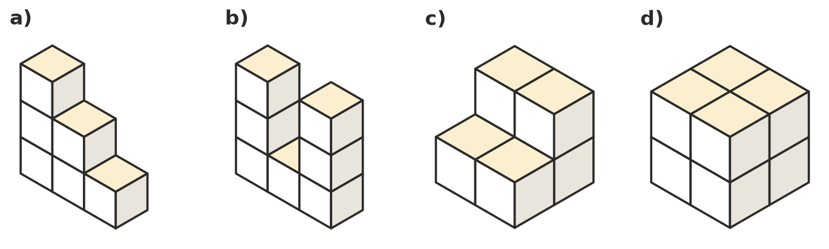
  - ______________
  - ______________
  - ______________
  - ______________
- A plan with numbers is a top view that shows how many cubes are stacked on each square. How many cubes are in each stack?
- 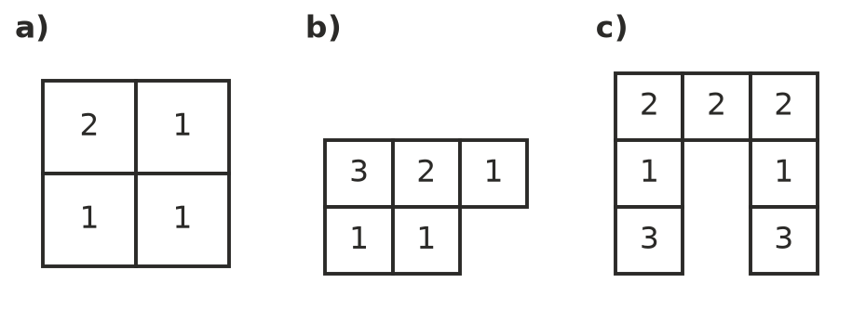
  - ______________
  - ______________
  - ______________

 Fluency
- Draw the top view, front view and right view of this stack on the grids.
- 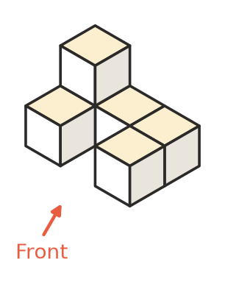
- 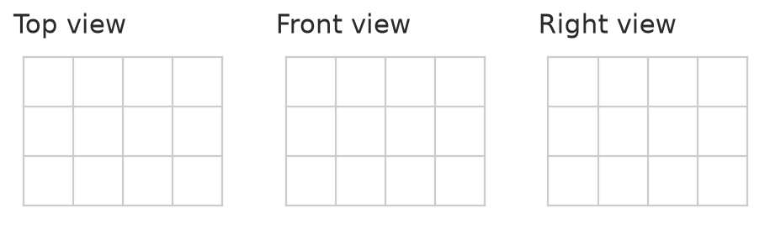
- A solid is sliced straight across. The flat face you make is called a cross-section. Name the shape of each cross-section.
  - A cube is sliced parallel to one of its faces. ______________
  - A cylinder is sliced parallel to its base. ______________
  - A triangular prism is sliced parallel to its triangle ends. ______________
  - A square pyramid is sliced parallel to its base. ______________
- Name a solid that has these views.
  - Top view: circle. Front view: rectangle. ______________
  - Top view: circle. Front view: triangle. ______________
  - Top view: square. Front view: triangle. ______________
  - Top view: square. Front view: square. Right view: square. ______________

 Reasoning
- Stack A and stack B have the same front view.
- 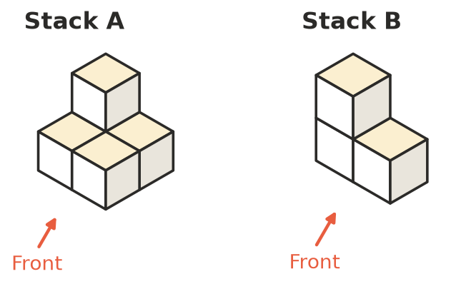
  - How many cubes are in each stack? ______________
  - Explain why the front view alone does not tell you how many cubes are in a stack.

- Give one thing a 3D drawing of a stack shows that a top view does not show.

 Problem solving
- Copy this drawing onto the isometric dot paper. Then add one more cube on top of the shortest part of the stack.
- 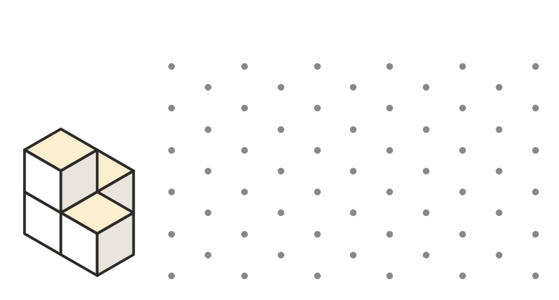
- Ella built this stack.
- 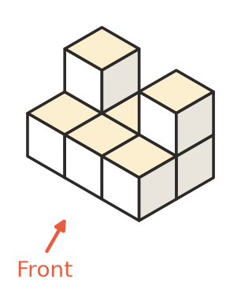
  - How many cubes did she use? ______________
  - How many more cubes does she need to turn it into a solid block 3 cubes long, 2 cubes deep and 2 cubes high? ______________

