13.02 Visualise solids
Year 7 Maths · A5 question sheet · Level 3 · Challenge
This worksheet practises reasoning between 3D drawings, plans with numbers and the three views of a solid, and thinking about cross-sections and hidden cubes. Tip: in every stack of cubes on this sheet, each cube sits on the table or on another cube, and there are no gaps unless you can see them.

 Understanding
- Draw the top view, front view and right view of this stack on the grids.
- 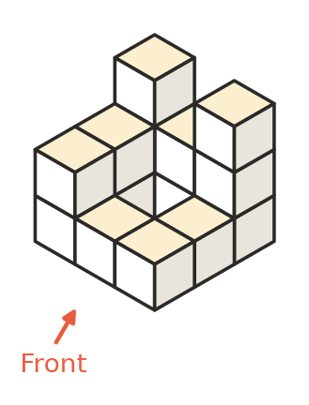
- 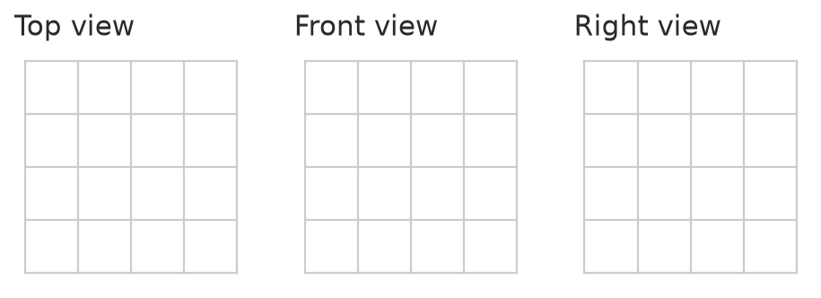
- Use the plan with numbers to make an isometric drawing of the stack on the dot paper. The front is at the bottom of the plan.
- 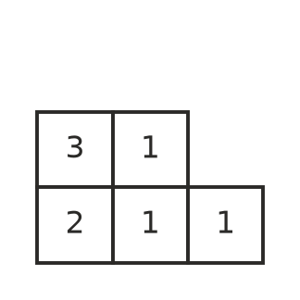
- 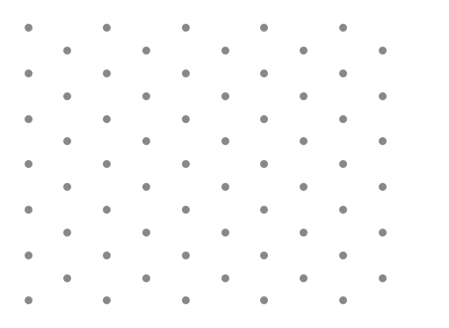

 Fluency
- How many cubes are in each stack?
  - 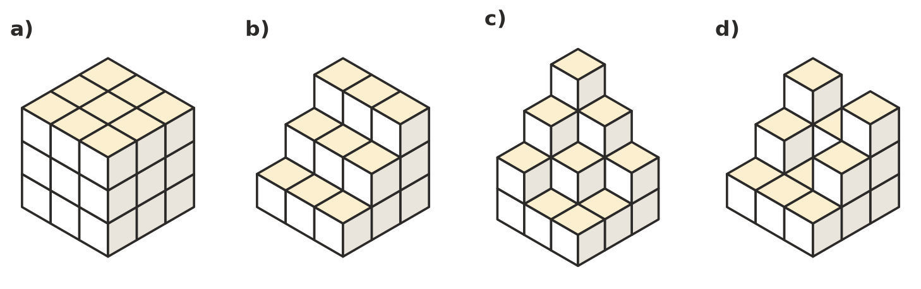

- A cube is cut by one straight slice. Can the cross-section be each of these shapes? Write Yes or No.
  - a square
  - a rectangle that is not a square
  - a triangle
  - a hexagon
  - a circle
  - Explain why the cross-section of a cube can never have 7 sides.
- Name the solid that has these views.
  - Top view: a square with lines from each corner to the centre. Front view: a triangle.
  - Top view: a circle with a dot in the centre. Front view: a triangle.
  - Top view: a hexagon. Front view: a rectangle.
  - Top view: a rectangle. Front view: a rectangle. Right view: a triangle.

 Reasoning
- A stack has these three views.
- 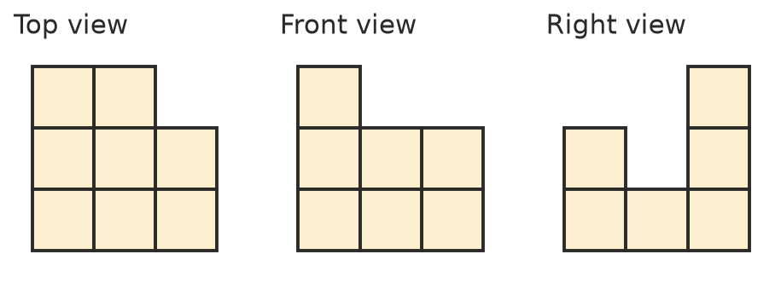
  - What is the greatest number of cubes the stack could have?
  - What is the least number of cubes the stack could have? Draw a plan with numbers to show it.
- The outside of this 3 × 3 × 3 cube is painted red. Then it is taken apart into its 27 small cubes.
- 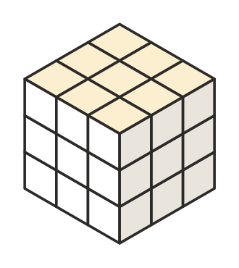
- How many small cubes have paint on:
  - 3 faces?
  - 2 faces?
  - 1 face?
  - no faces?
- A builder, a furniture shop and a warehouse worker each need to show a solid on paper. For each one, choose the best way: an isometric drawing, a plan with numbers, or top, front and side views. Give a reason.
  - A builder needs exact measurements of a shed from every side.
  - A shop wants customers to see what a bookcase looks like.
  - A warehouse worker needs to record how many boxes are in each pile.

 Problem solving
- Repeat Question 7 for a 4 × 4 × 4 cube that is painted on the outside and taken apart into 64 small cubes.
  - 3 faces
  - 2 faces
  - 1 face
  - no faces
  - Check that your four answers add to 64.
- Look at stack c) in Question 3. How many more cubes are needed to fill it out into a solid rectangular block 3 cubes long, 3 cubes deep and 4 cubes high?
- A cylinder is sliced at a slant, not parallel to its base and not through both circles. What shape is the cross-section?

