13.02 Visualise solids
Year 7 Maths · A5 question sheet · Level 2 · Core
This worksheet practises moving between different ways of showing a solid on paper: isometric drawings, plans with numbers, and top, front and right views. It also looks at cross-sections, the flat faces you get when you slice a solid. Tip: in every stack of cubes on this sheet, each cube sits on the table or on another cube, and there are no gaps. Some cubes are hidden because they hold up the cubes you can see.

 Understanding
- Draw the top view, front view and right view of this stack on the grids.
- 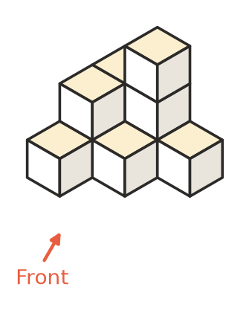
- 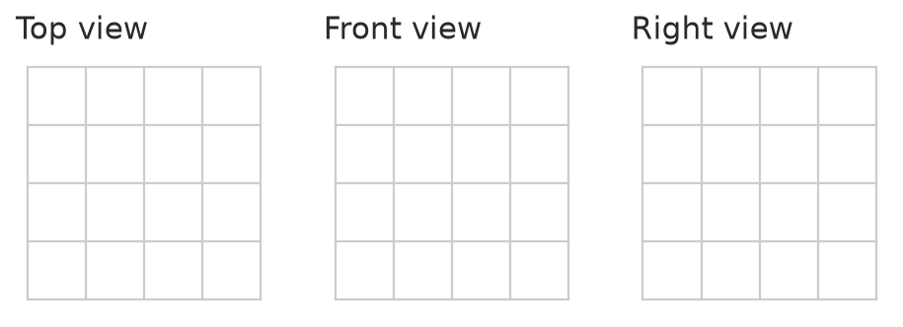
- Here is a plan with numbers for a stack. The front of the stack is at the bottom of the plan.
- 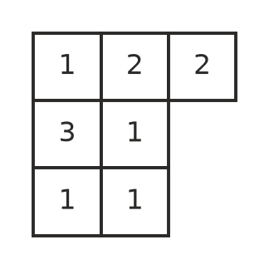
  - How many cubes are in the stack?
  - Draw the front view and the right view on the grids.
- 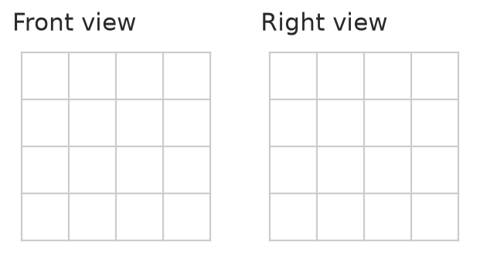

 Fluency
- How many cubes are in each stack?
  - 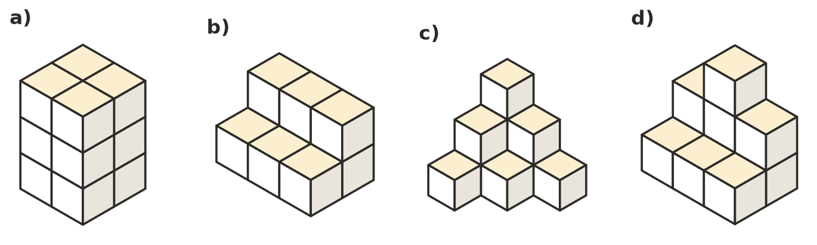

- Use the plan with numbers to make an isometric drawing of the stack on the dot paper. The front is at the bottom of the plan.
- 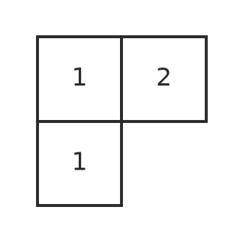
- 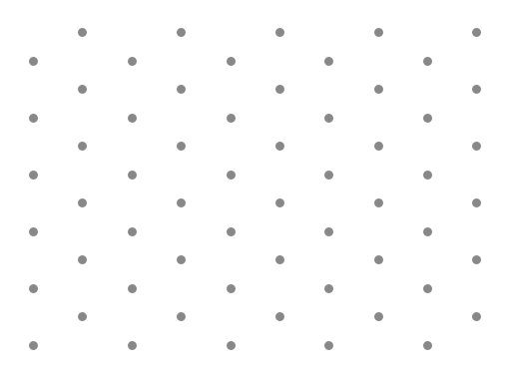
- Name the shape of each cross-section.
  - A hexagonal prism is sliced parallel to its ends.
  - A cylinder is sliced straight down through the centre of its circle ends.
  - A cone is sliced parallel to its base.
  - A square pyramid is sliced straight down through its top point, parallel to one edge of the base.
  - A rectangular prism is sliced parallel to one of its faces.
- Here are the top, front and right views of a stack. Which stack, A, B, C or D, has these views?
- 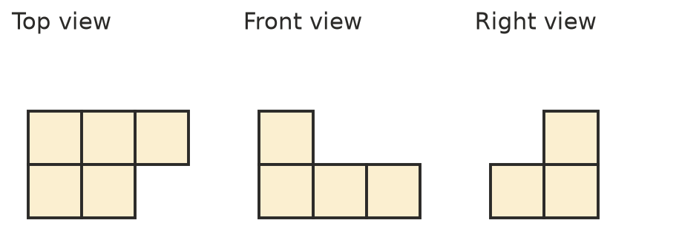
- 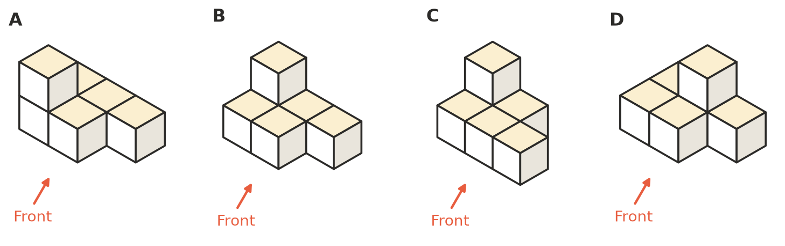

 Reasoning
- A stack has this top view and this front view. The right view is not given.
- 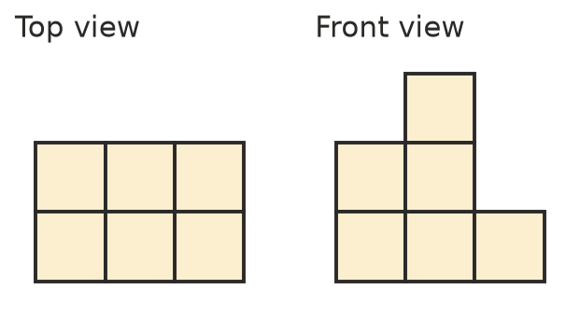
  - What is the greatest number of cubes the stack could have?
  - What is the least number of cubes the stack could have?
- Give one advantage and one disadvantage of using a plan with numbers instead of an isometric drawing.
  - Advantage:
  - Disadvantage:
- A 3 × 3 × 3 block of cubes has the cube at each of its 8 corners removed.
- 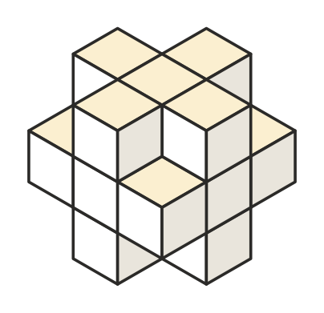
  - How many cubes are left?
  - Lily says the front view is a 3 by 3 square with a square missing at each corner. Is she right? Explain.

 Problem solving
- A stack has a top view that is a 2 by 2 square. Its front view and right view are also 2 by 2 squares.
  - What is the greatest number of cubes in the stack?
  - What is the least number of cubes in the stack? Draw a plan with numbers to show how.

