13.01 Nets of solids
Year 7 Maths · A5 question sheet · Level 3 · Challenge
This worksheet practises finding patterns in the faces, edges and vertices of prisms and pyramids, using Euler’s rule, and reasoning about nets, including nets of cylinders and cones. Euler’s rule says that for any solid with flat faces, F + V − E = 2. Tip: to picture a net folding, choose one face as the base and fold the faces next to it up first.

 Understanding
- The end of a prism is a polygon with n sides. Copy and complete the table, then write a rule for each column.
Prism | Sides on each end | Faces | Vertices
Triangular prism | 3
Pentagonal prism | 5
Hexagonal prism | 6
Octagonal prism | 8
Any prism | n

- The base of a pyramid is a polygon with n sides. Copy and complete the table, then write a rule for each column.
Pyramid | Sides on the base | Faces | Vertices
Square pyramid | 4
Pentagonal pyramid | 5
Hexagonal pyramid | 6
Decagonal pyramid | 10
Any pyramid | n

 Fluency
- Name the solid that each net folds up to make.
  - 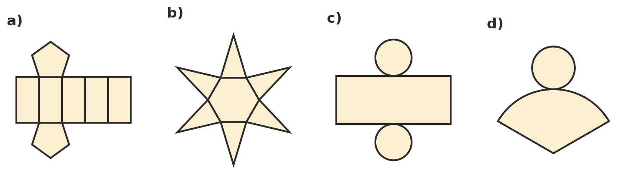

- Which of these nets fold up to make a cube? Write Yes or No for each one.
- 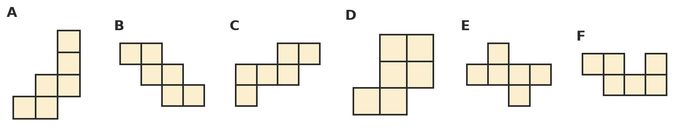
Net | A | B | C | D | E | F
Yes or No

- This net folds up to make a cube.
- 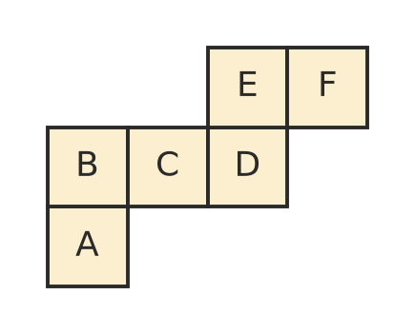
  - Which face is opposite face A?
  - Which face is opposite face D?
  - Which four faces share an edge with face C on the cube?
- Use Euler’s rule, F + V − E = 2.
  - A solid has 8 faces and 12 vertices. How many edges does it have?
  - A solid has 6 vertices and 12 edges. How many faces does it have?
  - A solid has 12 faces and 30 edges. How many vertices does it have?
  - Could a solid with flat faces have 5 faces, 5 vertices and 9 edges? Explain.

 Reasoning
- These five squares are part of the net of a cube. The dashed squares 1 to 7 show places where a sixth square could go. Which positions would finish a net of a cube?
- 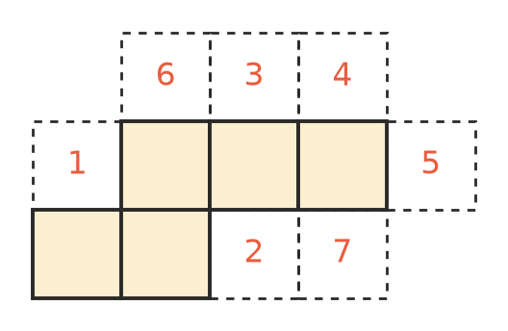
- On a normal dice, the numbers on opposite faces add to 7. Without folding, explain how you can tell that this net is not the net of a normal dice.
- 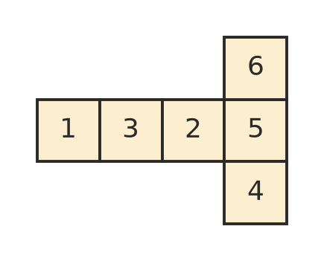
- A prism has 30 edges.
  - What shape are its ends?
  - How many faces and vertices does it have?
  - Can a prism have 25 edges? Explain.
  - Can a pyramid have 30 edges? Explain.

 Problem solving
- An open box (no lid) is made from a sheet of card 30 cm by 20 cm. A 5 cm square is cut from each corner, then the sides are folded up along the dashed lines.
- 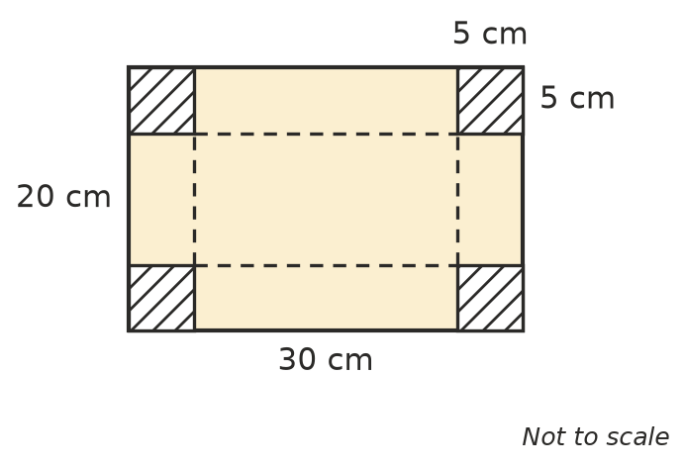
  - What are the length, width and height of the box?
  - What area of card is used in your book?
  - How many faces does the box have?
- Here is the net of a square pyramid. The base is a square with sides of 10 cm. Each triangle has a perpendicular height of 12 cm. How much card is in the net? Show your working.
- 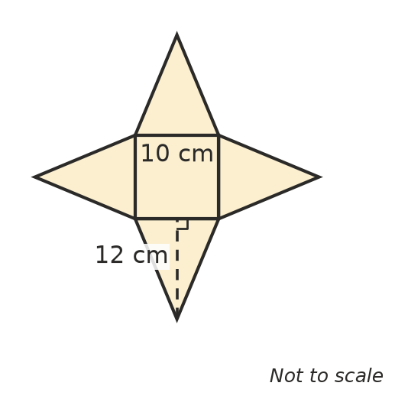
- A can is a cylinder with a radius of 4 cm and a height of 10 cm. The label wraps exactly once around the side of the can. Calculator allowed.
- 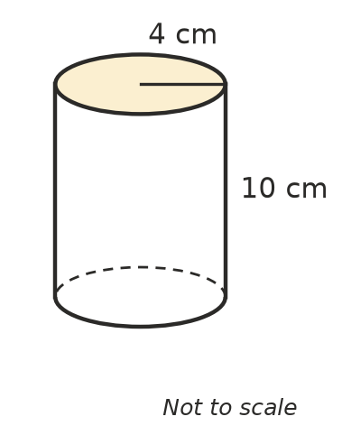
  - The label is a rectangle in the net of the can. How long is the rectangle? Give your answer to 1 decimal place.
  - What is the area of the label, to 1 decimal place?
  - What other shapes are in the net of the can?

