13.01 Nets of solids
Year 7 Maths · A5 question sheet · Level 2 · Core
This worksheet practises naming prisms and pyramids, counting faces, edges and vertices, and working with nets. A prism has two identical ends joined by rectangles, and is named after the shape of its ends. A pyramid has one base and triangles that meet at a point, and is named after its base. Tip: when you look at a net, find the ends or the base first.

 Understanding
- Name each solid.
  - 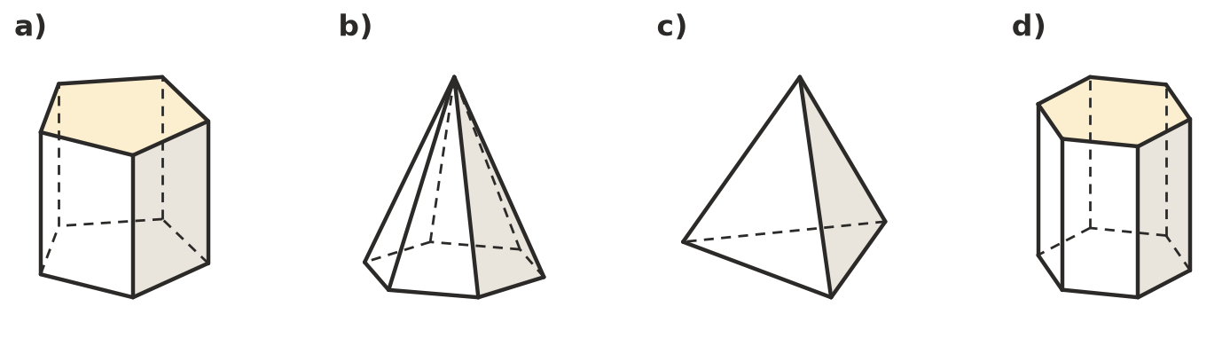

- Each row describes all the faces of a solid. Write prism or pyramid, then name the solid.
Faces | Prism or pyramid?
2 hexagons and 6 rectangles
1 square and 4 triangles
2 triangles and 3 rectangles
1 pentagon and 5 triangles
4 triangles

 Fluency
- Name the solid that each net folds up to make.
  - 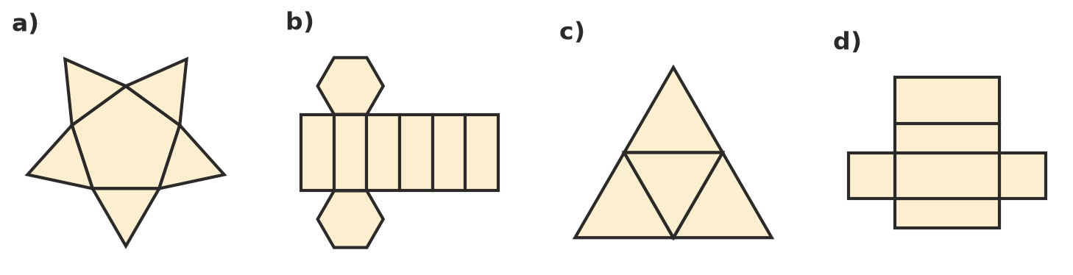

- Which of these nets fold up to make a cube? Write Yes or No for each one.
- 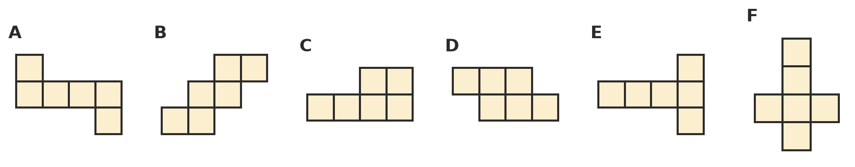
Net | A | B | C | D | E | F
Yes or No

- This net folds up to make a cube.
- 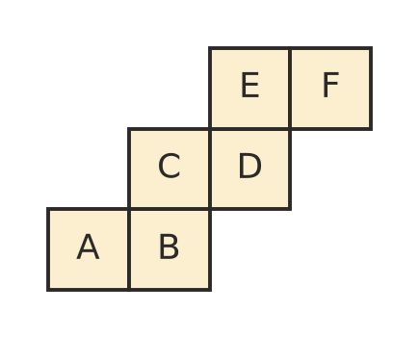
  - Which face is opposite face A?
  - Which face is opposite face B?
  - Which face is opposite face C?
- Copy and complete the table. In the last column, work out faces + vertices − edges.
Solid | Faces (F) | Vertices (V) | Edges (E) | F + V − E
Triangular prism
Square pyramid
Pentagonal prism
Hexagonal pyramid

What do you notice about the last column?

 Reasoning
- These five squares are part of the net of a cube. The dashed squares 1 to 6 show places where a sixth square could go. Which positions would finish a net of a cube? There may be more than one.
- 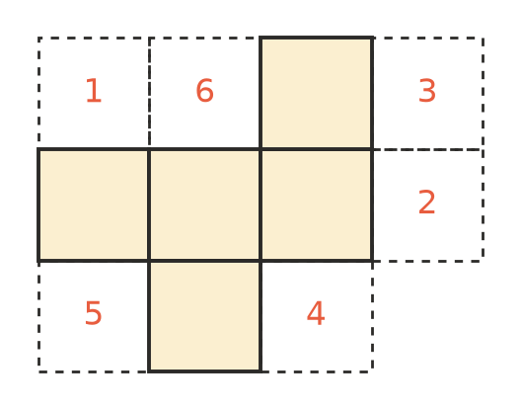
- Lucy drew this net for a triangular prism. Explain what is wrong with it, and how she could fix it.
- 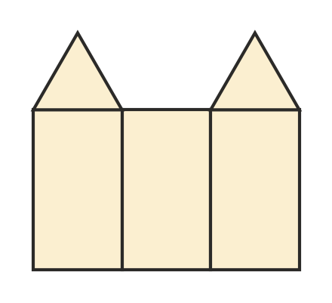
- Jake wants to show a cereal box to his class. He could show a 3D drawing of the box or a net of the box. Give one advantage of each.
  - 3D drawing:
  - Net:

 Problem solving
- A box is a rectangular prism 20 cm long, 15 cm wide and 8 cm high. It is made from a net cut out of card.
- 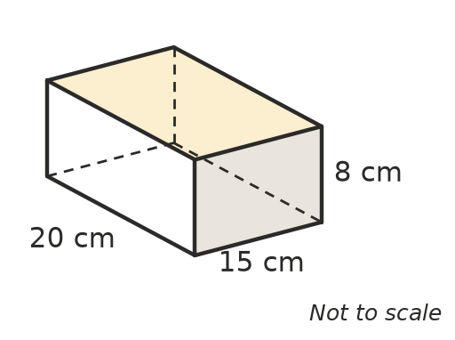
- How much card is in the net? Show your working.
- On a normal dice, the numbers on opposite faces add to 7. Copy and fill in the missing numbers on this dice net.
- 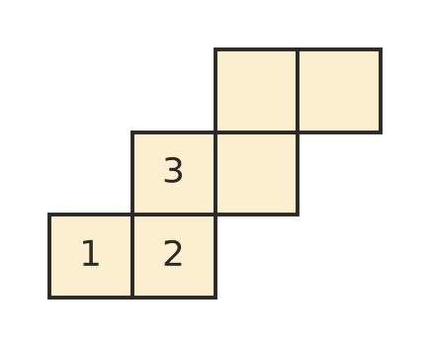
- A prism has 12 vertices.
  - What shape are its two ends?
  - How many faces does it have?
  - How many edges does it have?

