13.01 Nets of solids
Year 7 Maths · A5 question sheet · Level 1 · Warm-up
A solid is a 3D shape, like a box or a tent. A net is a flat pattern that folds up to make a solid. This worksheet practises naming solids, counting their faces, edges and vertices, and matching solids to their nets. Tip: the number of shapes in a net is the same as the number of faces on the solid.

 Understanding
- Name each solid. Choose from: cube, rectangular prism, triangular prism, square pyramid.
  - 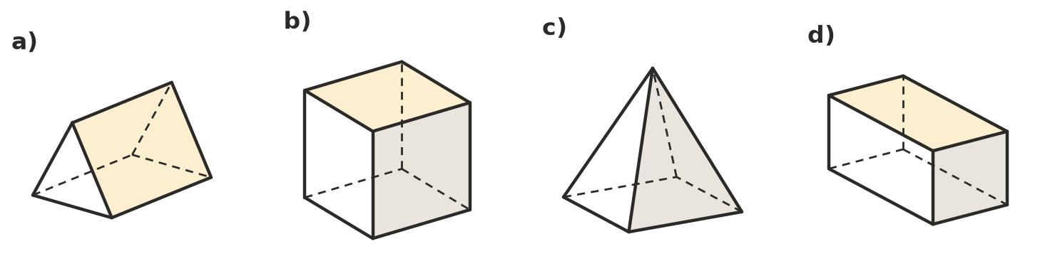

- Copy and complete the table. Use the pictures in Question 1 to help. The dashed lines show edges you can’t see from the front.
Solid | Faces | Edges
Cube
Rectangular prism
Triangular prism
Square pyramid

- Complete each sentence with one of these words: face, edge, vertex, net.
  - A flat surface of a solid is called a
  - The line where two faces meet is called an
  - A corner point where edges meet is called a
  - A flat pattern that folds up to make a solid is called a

 Fluency
- Name the solid that each net folds up to make.
  - 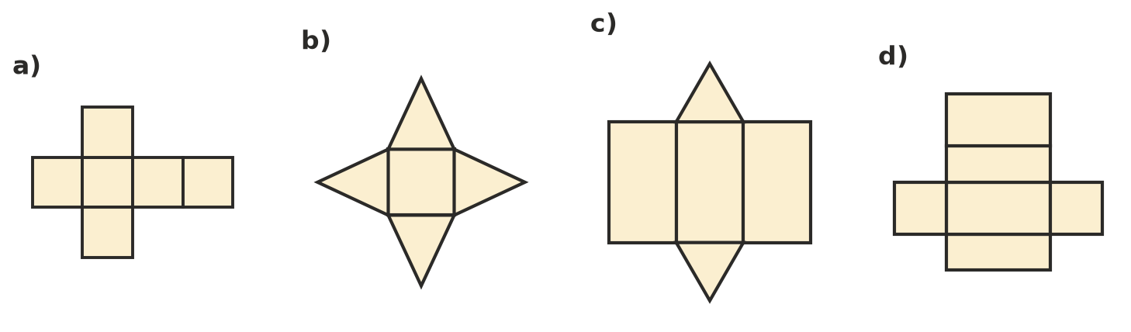

- Which of these nets fold up to make a cube? Write Yes or No for each one. Tip: picture one square as the bottom and fold the others up around it.
- 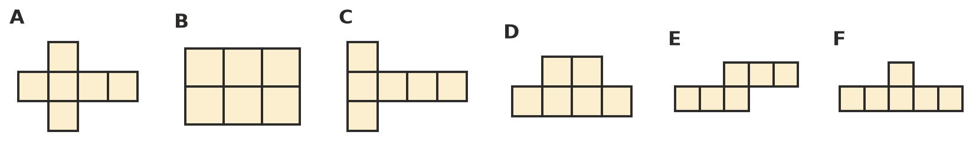
Net | A | B | C | D | E | F
Yes or No

- This net folds up to make a cube.
- 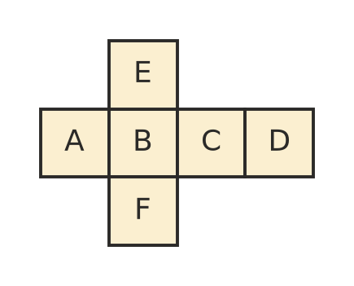
  - Which face is opposite face A?
  - Which face is opposite face B?
  - Which face is opposite face E?
- Look at net c) in Question 4.
  - How many triangles are in the net?
  - How many rectangles are in the net?
  - How many faces does the solid have?

 Reasoning
- Ben says this net folds up to make a cube. Explain why Ben is wrong.
- 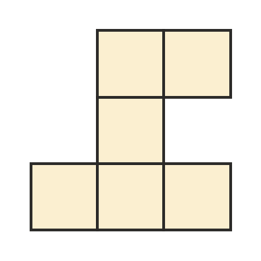
- Is each statement true or false? Write True or False in your book.
Statement
A cube has 6 faces.
A square pyramid has 2 square faces.
A triangular prism has 2 triangle faces.
The net of a cube is made of 6 squares.
A square pyramid has the same number of faces as a triangular prism.

 Problem solving
- A gift box is a cube with edges 10 cm long. Kim makes it from a net cut out of card.
  - How many squares are in the net?
  - What is the area of one square?
  - What is the total area of card in the net?
- Sam makes the frame of a solid from straws. He uses one straw for each edge and a ball of clay at each vertex.
  - How many straws and balls of clay does he need for a square pyramid?
  - How many straws and balls of clay does he need for a cube?

