Ratios and rates: Practice test 2
Year 7 Maths · Test · Test 2
Name: ____________________ Date: ______________
Time: 45 minutes
Total: 40 marks
Show your working in the boxes. Then write each final answer on the answer sheet on the last page. Write ratios like this: 3 : 5. Give every ratio in simplest form unless the question says otherwise.

 Section A: No calculator
- Look at this group of shapes.
- 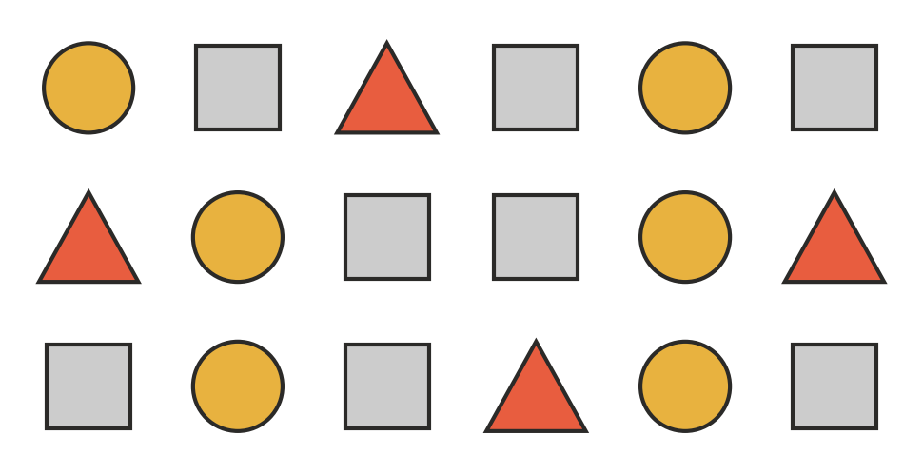
  - Write the ratio of triangles to circles in simplest form. (1 mark)

  - Write the ratio of squares to the total number of shapes in simplest form. (1 mark)

  - What fraction of the shapes are circles? (1 mark)

- In a footy match, a team kicked 12 goals and 9 behinds. Write the ratio of goals to behinds in simplest form. (1 mark)

- Simplify each ratio.
  - 56 : 21 (1 mark)

  - 18 : 42 : 30 (1 mark)

  - 0.6 : 1.5 (1 mark)

  - $\frac{2}{3}$ : $\frac{5}{6}$ (2 marks)

- Write each ratio in simplest form. Change to the same units first.
  - 750 g : 2 kg (1 mark)

  - 36 cents : $1.20 (1 mark)

- Find the missing number in each pair of equivalent ratios.
  - 4 : 9 = □ : 54 (1 mark)

  - 15 : □ = 3 : 8 (1 mark)

- Tom says that the ratios 2 : 5 and 5 : 2 are the same, because they use the same numbers. Is Tom right? Explain, using an example. (2 marks)

- Share $84 between Ella and Josh in the ratio 3 : 4. How much does each person get? (2 marks)

- A fruit punch is made from orange juice and lemonade in the ratio 3 : 2.
  - How much lemonade should be mixed with 600 mL of orange juice? (1 mark)

  - How much orange juice is needed to make 2.5 L of punch altogether? (2 marks)

- On a school camp, the ratio of teachers to students is 2 : 15. There are 90 students.
  - How many teachers are on the camp? (1 mark)

  - How many people are on the camp altogether? (1 mark)

- In a car park, the ratio of red cars to all cars is 2 : 9.
  - Write the ratio of red cars to cars that are not red. (1 mark)

  - There are 63 cars that are not red. How many red cars are there? (1 mark)

- Ben and Grace pick apples in the ratio 4 : 7. Grace picks 15 more apples than Ben. How many apples does Ben pick? (2 marks)

- A bag of trail mix contains nuts, raisins and chocolate in the ratio 6 : 3 : 1 by mass. The bag holds 800 g of trail mix.
  - What mass of chocolate is in the bag? (1 mark)

  - How many more grams of nuts than raisins are in the bag? (1 mark)

 Section B: Calculator allowed
- A model of a ute is built to a scale of 1 : 18. The model is 26 cm long. How long is the real ute, in metres? (2 marks)

- A 500 g bag of coffee beans costs $13.75 and a 750 g bag costs $19.50. Work out the cost per 100 g of each bag, and say which bag is better value. (2 marks)

- Three friends run a stall at the school fete and share the profit of $7200 in the ratio 4 : 5 : 6.
  - How much is the smallest share? (1 mark)

  - How much is the largest share? (1 mark)

- A gardener makes potting mix from compost and soil in the ratio 3 : 8. She has 4.8 kg of compost.
  - How much soil does she need? (1 mark)

  - What is the total mass of potting mix she can make? (1 mark)

- A bag holds red and blue marbles in the ratio 5 : 3. Twelve red marbles are taken out, and now there are the same number of red and blue marbles. How many marbles were in the bag at the start? Show your reasoning. (3 marks)

- A tap fills a trough with 45 L of water in 6 minutes. At this rate, how many minutes will it take to fill a 300 L tank? (1 mark)

 Answer sheet
Name: ____________________
Write your final answer for each question in the table.
Question | Answer | Marks | Question | Answer | Marks
1a |  | /1 | 9a |  | /1
1b |  | /1 | 9b |  | /1
1c |  | /1 | 10a |  | /1
2 |  | /1 | 10b |  | /1
3a |  | /1 | 11 |  | /2
3b |  | /1 | 12a |  | /1
3c |  | /1 | 12b |  | /1
3d |  | /2 | 13 |  | /2
4a |  | /1 | 14 |  | /2
4b |  | /1 | 15a |  | /1
5a |  | /1 | 15b |  | /1
5b |  | /1 | 16a |  | /1
6 |  | /2 | 16b |  | /1
7 |  | /2 | 17 |  | /3
8a |  | /1 | 18 |  | /1
8b |  | /2
 |  |  |  | Total | /40

