7.03 Find part or whole measures
Year 7 Maths · A5 question sheet · Level 3 · Challenge
This worksheet stretches your skills with three-part ratios, ratios that change, and problems where you know a difference or one part instead of the total. Tip: label a bar model with what you know, then find the value of one part.

 Understanding
- Ari and Bea share some money in the ratio 7 : 2. Ari gets $35 more than Bea.
- 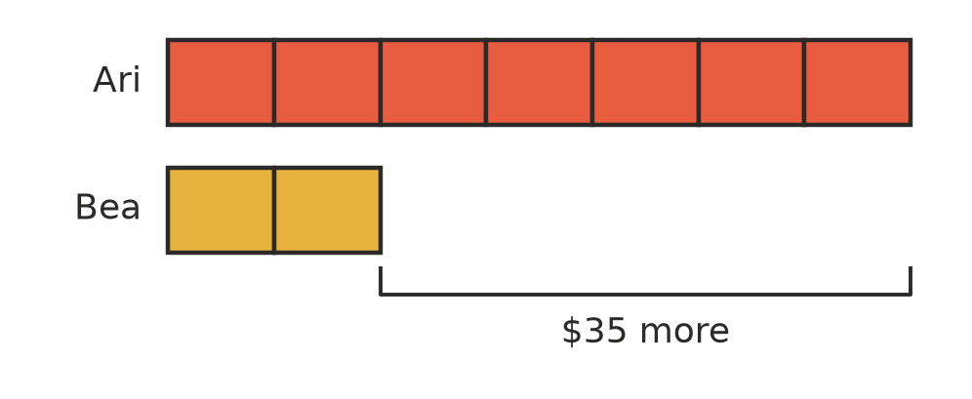
  - How many parts is the difference between their shares?
  - How much is one part worth?
  - How much does each person get?
- The ratio of girls to boys at a camp is 4 : 5. Which of these could be the number of campers? Write all the correct letters.
  - 36
  - 40
  - 54
  - 60
  - 81

 Fluency
- Share each amount in the given ratio.
  - 1.6 kg in the ratio 3 : 5 (give your answers in grams)
  - $1350 in the ratio 4 : 5 : 6
  - 3 hours in the ratio 2 : 3 : 7 (give your answers in minutes)
  - 275 in the ratio 2 : 9 : 14
- Answer each question.
  - The ratio of a to b is 7 : 11 and b = 99. Find a.
  - Two numbers are in the ratio 4 : 9. The larger number is 35 more than the smaller number. Find both numbers.
  - An amount is shared in the ratio 2 : 5 : 6. The largest share is 48. Find the other two shares and the whole amount.

 Reasoning
- Paula shares $96 among three people in the ratio 1 : 2 : 3. She gets $16, $32 and $48. Show two different ways to check her answer.
- Right now, the ratio of Ana’s age to her dad’s age is 1 : 4. Ana is 11. Will the ratio of their ages still be 1 : 4 in 11 years’ time? Explain.
- Explain why 100 cannot be shared in the ratio 3 : 4 : 5 using whole numbers. What is the smallest number bigger than 100 that can be?

 Problem solving
- A youth group has 42 members, and the ratio of boys to girls is 3 : 4. Then 6 more boys join. Write the new ratio of boys to girls in simplest form.
- A metal for making medals is made of copper, zinc and nickel in the ratio 13 : 5 : 2. A medal has a mass of 60 g. Find the mass of each metal in the medal.
- Three friends start a lawn-mowing business. They put in money in the ratio 2 : 3 : 5, and they share the profit of $1800 in the same ratio.
  - How much does each friend get?
  - The friend with the largest share then gives $100 to each of the other two. Write the new ratio of their money in simplest form.
- Jo and Kim’s ages add to 40, and the ratio of Jo’s age to Kim’s age is 3 : 5. In how many years will the ratio of their ages be 2 : 3?
- A 2 L jug of punch is made of juice and soda water in the ratio 3 : 5. Jen then adds 250 mL more juice. Write the new ratio of juice to soda water in simplest form.
- In AFL, a goal is worth 6 points and a behind is worth 1 point. A team kicked goals and behinds in the ratio 5 : 3, and scored 99 points. How many goals and how many behinds did the team kick?
- The ratio of a rectangle’s length to its width is 5 : 3. Its perimeter is 64 cm. Find the area of the rectangle.

