7.03 Find part or whole measures
Year 7 Maths · A5 question sheet · Level 1 · Warm-up
This worksheet practises sharing an amount in a given ratio, and working out an amount when you know one part. Tip: add the numbers in the ratio to find how many equal parts there are, then work out what one part is worth.

 Understanding
- Sam and Ella share $40 in the ratio 3 : 2. The bar model shows this.
- 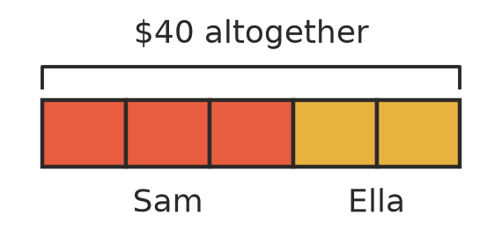
  - How many equal parts are there altogether?
  - How much is one part worth?
  - How much does Sam get?
  - How much does Ella get?
- Follow the steps to share 30 lollies in the ratio 1 : 2.
  - How many parts are there altogether?
  - How many lollies are in one part?
  - How many lollies does each person get? ______________ and

 Fluency
- Share each amount in the given ratio.
  - 20 in the ratio 1 : 3
  - 36 in the ratio 2 : 1
  - $50 in the ratio 3 : 2
  - 42 in the ratio 4 : 3
  - 64 kg in the ratio 5 : 3
  - 90 in the ratio 2 : 7
- Find the missing part.
  - The ratio is 2 : 3 and the first part is 10. The second part is
  - The ratio is 1 : 4 and the first part is 6. The second part is
  - The ratio is 3 : 5 and the second part is 20. The first part is
  - The ratio is 5 : 2 and the second part is 8. The first part is
- The ratio of boys to girls in a group is 2 : 3. There are 8 boys.
  - How many girls are there?
  - How many people are in the group altogether?

 Reasoning
- Tia shares $30 between herself and her brother in the ratio 2 : 1. She says she gets $20 and her brother gets $15. Explain what is wrong and give the correct shares.
- Max shares 35 marbles in the ratio 3 : 4. He gets 15 and 20. Show two ways to check that his answer is correct.

 Problem solving
- A school fundraiser raised $120. The money is shared between the school library and a charity in the ratio 1 : 3. How much does each get?
  - Library:
  - Charity:
- A cordial drink is made with syrup and water in the ratio 1 : 4. How much of each do you need to make 1000 mL of drink?
  - Syrup:
  - Water:
- A footy team’s wins and losses are in the ratio 3 : 1. There were no draws. The team won 15 games.
  - How many games did the team lose?
  - How many games did the team play altogether?
- Grandma gives $60 to Ava and Leo. She shares it in the ratio of their ages, 7 : 5. How much does each child get?

