7.01 Identify ratios
Year 7 Maths · A5 question sheet · Level 2 · Core
This worksheet practises writing ratios from pictures, tables and words, including part-to-whole ratios and ratios of measurements. Tip: before you write a ratio of two measurements, change them to the same unit.

 Understanding
- The grid has shaded, striped and white tiles.
- 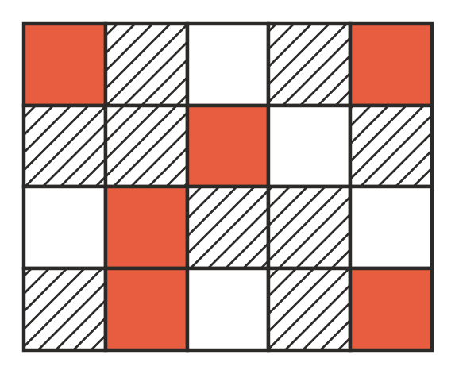
  - Write the ratio of shaded tiles to white tiles.
  - Write the ratio of white tiles to striped tiles.
  - Write the ratio of shaded to striped to white tiles.
  - Write the ratio of striped tiles to all the tiles.
  - What fraction of the tiles are striped?
- A ratio compares amounts of the same kind. A rate compares amounts of different kinds. Write ratio or rate for each one.
  - 3 parts cordial to 10 parts water
  - 110 kilometres per hour
  - $2.10 per litre
  - 12 wins to 5 losses
- In a class, the ratio of students who catch the bus to students who do not catch the bus is 3 : 5.
  - For every 3 students who catch the bus, how many do not?
  - Write the ratio of students who catch the bus to the whole class.
  - What fraction of the class catches the bus?

 Fluency
- The table shows what the school canteen sold on Monday.
Item | Number sold
Sausage rolls | 23
Wraps | 14
Sushi | 9
Pies | 17

- Write the ratio of:
  - wraps to pies
  - pies to sushi
  - sushi to sausage rolls to wraps
  - sausage rolls to all the items sold
- Write each ratio with both amounts in the smaller unit. Do not simplify.
  - 45 minutes to 2 hours
  - 3 m to 85 cm
  - 750 g to 2 kg
  - $3 to 40 cents
  - 2 days to 7 hours
- Answer each question.
  - The ratio of cats to dogs at a vet clinic is 4 : 7. What fraction of these animals are cats?
  - The ratio of red apples to green apples in a box is 5 : 3. What fraction of the apples are green?
  - $\frac{2}{9}$ of the lollies in a bag are red and the rest are yellow. Write the ratio of red lollies to yellow lollies.
  - $\frac{5}{12}$ of the players in a soccer club kick with their left foot and the rest kick with their right foot. Write the ratio of left-footed to right-footed players.

 Reasoning
- A group has 4 boys and 6 girls. Mel says the ratio of boys to girls is 4 : 10. Explain her mistake and write the correct ratio.
- Is the ratio 1 m : 50 cm the same as the ratio 1 : 50? Explain.
- The ratio of adults to children on a bus is 2 : 5. Jordan says $\frac{2}{5}$ of the people on the bus are adults. Explain his mistake.

 Problem solving
- A footy team played 22 games. They won 13, drew 2 and lost the rest.
  - How many games did they lose?
  - Write the ratio of wins to losses to draws.
  - Write the ratio of losses to games played.
- Mr Scott mixes concrete using 1 bucket of cement, 2 buckets of sand and 3 buckets of gravel.
  - Write the ratio of cement to sand to gravel.
  - What fraction of the mix is gravel?
  - For a bigger job he uses 4 buckets of cement and keeps the same mix. How many buckets of gravel does he need?
- On a road trip, a family drove for 3 hours and 20 minutes, then stopped for lunch for 40 minutes. Write the ratio of driving time to lunch time, in minutes.
- Draw a group of circles and triangles where the ratio of circles to triangles is 3 : 2 and there are 15 shapes altogether.

