Probability: Practice test 3
Year 7 Maths · Test · Test 3
Name: ____________________ Date: ______________
Time: 45 minutes
Total: 40 marks
Show your working in the boxes. Then write each final answer on the answer sheet on the last page.

 Section A: No calculator
- Describe the chance of each event using one of these words: impossible, unlikely, even chance, likely, certain.
  - The day after a Tuesday is a Wednesday. (1 mark)

  - You take a red counter at random from a bag with 1 red counter and 9 blue counters. (1 mark)

  - A spinner has 3 equal sections, all labelled 4. It lands on a number other than 4. (1 mark)

- A fair six-sided die is rolled once. Write the letters of these events in order from least likely to most likely. (2 marks)
- A: rolling an even number
- B: rolling a 1
- C: rolling a number less than 6
- D: rolling a 7

- Each spinner below is divided into equal sections. Some sections are shaded.
- 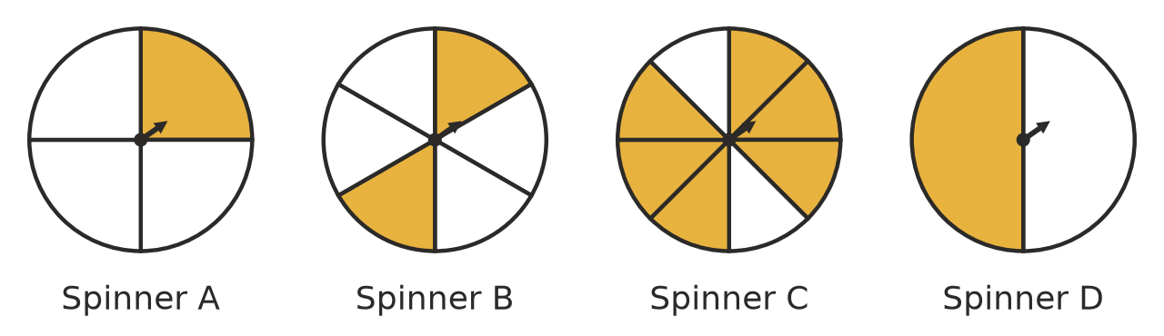
  - Which spinner has a probability of $\frac{1}{3}$ of landing on a shaded section? (1 mark)

  - Which spinner is most likely to land on a shaded section? (1 mark)

  - Write the probability that spinner C lands on a shaded section as a decimal. (1 mark)

- Probabilities can be written as fractions, decimals or percentages.
  - Write 0.85 as a fraction in simplest form. (1 mark)

  - Write $\frac{7}{25}$ as a decimal. (1 mark)

  - Write these probabilities in order from least likely to most likely: 0.7, $\frac{3}{4}$, 72%, $\frac{2}{3}$ (1 mark)

- A month of the year is chosen at random.
  - How many outcomes are in the sample space? (1 mark)

  - List the outcomes that start with the letter J. (1 mark)

  - What is the probability that the month starts with the letter J? Write your answer as a fraction in simplest form. (1 mark)

- A box holds 24 muesli bars: 10 apricot, 8 choc chip and 6 apple. One bar is taken out at random. Write each answer as a fraction in simplest form. Find the probability that the bar is:
  - apple (1 mark)

  - not choc chip (1 mark)

  - banana. (1 mark)

- The numbers 1 to 30 are written on 30 cards. One card is chosen at random. Write each answer as a fraction in simplest form. Find the probability that the number on the card:
  - is a multiple of 3 (1 mark)

  - has the digit 2 in it (1 mark)

  - is a factor of 30. (1 mark)

- The probability that the morning ferry leaves on time is 0.92. What is the probability that it does not leave on time? (1 mark)

- A packet of bean seeds says that 90% of the seeds will sprout. Mia plants one seed from the packet and it does not sprout. She says, “The packet was wrong.” Explain why Mia is not right. (2 marks)

- A jar holds only red, green and yellow jelly beans. There are twice as many green jelly beans as red ones, and three times as many yellow jelly beans as red ones. One jelly bean is taken out at random. What is the probability that it is yellow? Show your working. (2 marks)

- A factory tests 400 light globes and finds that 6 of them are faulty.
  - What is the experimental probability that a globe is faulty? Write your answer as a fraction in simplest form. (1 mark)

  - The factory makes 10 000 globes. Predict how many of them will be faulty. Show your working. (2 marks)

 Section B: Calculator allowed
- A café recorded the hot drinks it sold one morning.
Drink | Flat white | Latte | Cappuccino | Tea | Hot chocolate
Number sold | 56 | 40 | 24 | 28 | 12

  - What is the relative frequency of a latte? Write your answer as a decimal. (1 mark)

  - What is the relative frequency of a flat white? Write your answer as a percentage. (1 mark)

  - Predict how many hot chocolates the café will sell in its next 1000 hot drinks. Show your working. (2 marks)

- Isla uses a spreadsheet to simulate spinning this spinner, which has 5 equal sections. She counts how many times it lands on a shaded section.
- 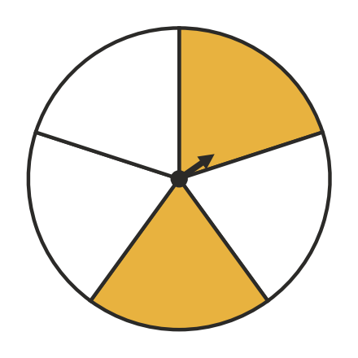
Number of spins | 50 | 5000
Number of shaded | 26 | 2014

  - What is the theoretical probability of landing on a shaded section? Write your answer as a decimal. (1 mark)

  - How many shaded results would you expect in 5000 spins? (1 mark)

  - Find the relative frequency of a shaded result for 50 spins and for 5000 spins. Write each as a decimal rounded to 2 decimal places. (1 mark)

  - Explain why the 5000-spin result is closer to the theoretical probability than the 50-spin result. (1 mark)

- This spinner is spun once. The angle of each section is shown.
- 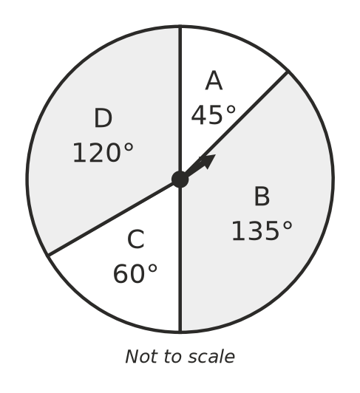
  - Find the probability of landing on B. Write your answer as a fraction in simplest form. (1 mark)

  - Find the probability of not landing on D. Write your answer as a fraction in simplest form. (1 mark)

- A bag holds 20 counters. Each counter is red or white. Zoe takes out a counter, records its colour and puts it back. She does this 200 times and gets red 148 times. About how many red counters are in the bag? Show your working. (2 marks)

 Answer sheet
Name: ____________________
Write your final answer for each question in the table.
Question | Answer | Marks | Question | Answer | Marks
1a |  | /1 | 7b |  | /1
1b |  | /1 | 7c |  | /1
1c |  | /1 | 8 |  | /1
2 |  | /2 | 9 |  | /2
3a |  | /1 | 10 |  | /2
3b |  | /1 | 11a |  | /1
3c |  | /1 | 11b |  | /2
4a |  | /1 | 12a |  | /1
4b |  | /1 | 12b |  | /1
4c |  | /1 | 12c |  | /2
5a |  | /1 | 13a |  | /1
5b |  | /1 | 13b |  | /1
5c |  | /1 | 13c |  | /1
6a |  | /1 | 13d |  | /1
6b |  | /1 | 14a |  | /1
6c |  | /1 | 14b |  | /1
7a |  | /1 | 15 |  | /2
 |  |  |  | Total | /40

