Probability: Practice test 2
Year 7 Maths · Test · Test 2
Name: ____________________ Date: ______________
Time: 45 minutes
Total: 40 marks
Show your working in the boxes. Then write each final answer on the answer sheet on the last page.

 Section A: No calculator
- Describe the chance of each event using one of these words: impossible, unlikely, even chance, likely, certain.
  - You roll a fair six-sided die and get a number greater than 6. (1 mark)

  - A spinner has 10 equal sections and 9 of them are blue. It lands on blue. (1 mark)

  - A card is chosen at random from eight cards numbered 1 to 8. It shows an even number. (1 mark)

- Look at the arrows A, B and C on this probability scale.
- 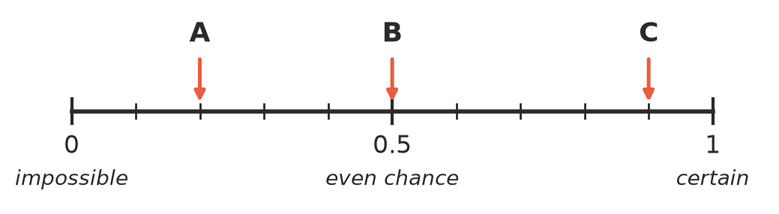
  - Write the probability shown by arrow A as a decimal. (1 mark)

  - Write the probability shown by arrow B as a fraction. (1 mark)

  - Which word best describes the chance shown by arrow C? (1 mark)

- This spinner has 5 equal sections. It is spun once.
- 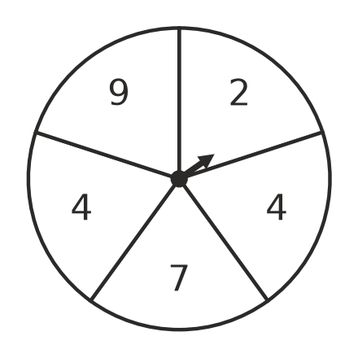
  - List the sample space. (1 mark)

  - Are all the outcomes in the sample space equally likely? Explain. (1 mark)

  - What is the probability of landing on 4? (1 mark)

  - What is the probability of landing on a number less than 5? (1 mark)

- The probability that the school bus is late on any day is $\frac{3}{20}$.
  - What is the probability that the bus is not late? Write your answer as a fraction. (1 mark)

  - Write your answer to part a) as a percentage. (1 mark)

- Write these probabilities in order from least likely to most likely: $\frac{3}{10}$, 0.25, 28%, $\frac{1}{5}$ (1 mark)

- Each letter of the word TASMANIA is written on its own card. One card is chosen at random. Write each answer as a fraction in simplest form. Find the probability that the letter is:
  - A (1 mark)

  - a vowel (1 mark)

  - one of the letters in the word MAST. (1 mark)

- A fair 12-sided die has the numbers 1 to 12 on its faces. It is rolled once. Write each answer as a fraction in simplest form. Find the probability of rolling:
  - a factor of 12 (1 mark)

  - a multiple of 5 (1 mark)

  - a number greater than 8. (1 mark)

- Liam rolls a fair six-sided die three times and gets a 6 every time. He says, “I won’t get a 6 on my next roll. Four 6s in a row is too unlikely.” Explain why Liam is wrong. (2 marks)

- A bag holds 20 marbles. Each marble is red, blue or white. The probability of choosing a red marble at random is $\frac{1}{4}$ and the probability of choosing a blue marble is $\frac{2}{5}$. How many white marbles are in the bag? Show your working. (2 marks)

- A spinner has 4 equal sections labelled A, B, C and C. Jo spins it 40 times and records the results.
Letter | A | B | C
Number of spins | 12 | 9 | 19

  - What is the experimental probability of landing on C? (1 mark)

  - What is the experimental probability of not landing on A? Write your answer as a fraction in simplest form. (1 mark)

  - What is the theoretical probability of landing on C? (1 mark)

- At basketball training, Kira scores with 4 out of every 5 free throws. Predict how many baskets she will score from 45 free throws. Show your working. (2 marks)

 Section B: Calculator allowed
- A school asked 250 students how they travel to school.
Transport | Car | Bus | Walk | Bike | Train
Number of students | 95 | 70 | 45 | 30 | 10

  - What is the relative frequency of students who travel by bus? Write your answer as a percentage. (1 mark)

  - A student from the survey is chosen at random. What is the probability that the student walks or rides a bike? Write your answer as a fraction in simplest form. (1 mark)

  - The whole school has 1400 students. Predict how many of them travel by car. Show your working. (2 marks)

- Tom uses a digital tool to simulate tossing a fair coin. He records the number of heads.
Number of tosses | 10 | 100 | 1000 | 10 000
Number of heads | 7 | 46 | 512 | 4987

  - Find the relative frequency of heads for 100 tosses and for 10 000 tosses. Write each as a decimal. (2 marks)

  - What happens to the relative frequency of heads as the number of tosses gets larger? Explain why this happens. (2 marks)

- This spinner is spun once. The angle of each section is shown.
- 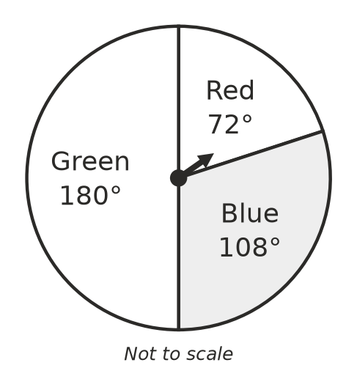
  - Find the probability of landing on blue. Write your answer as a fraction in simplest form. (1 mark)

  - The spinner is spun 250 times. Predict how many times it will land on red. (1 mark)

- Kai rolls a fair six-sided die 600 times. His results are shown below.
Number | 1 | 2 | 3 | 4 | 5 | 6
Frequency | 96 | 104 | 98 | 101 | 92 | 109

- Kai says, “The die is unfair, because none of the numbers came up exactly 100 times.” Do you agree? Explain. (2 marks)

 Answer sheet
Name: ____________________
Write your final answer for each question in the table.
Question | Answer | Marks | Question | Answer | Marks
1a |  | /1 | 7b |  | /1
1b |  | /1 | 7c |  | /1
1c |  | /1 | 8 |  | /2
2a |  | /1 | 9 |  | /2
2b |  | /1 | 10a |  | /1
2c |  | /1 | 10b |  | /1
3a |  | /1 | 10c |  | /1
3b |  | /1 | 11 |  | /2
3c |  | /1 | 12a |  | /1
3d |  | /1 | 12b |  | /1
4a |  | /1 | 12c |  | /2
4b |  | /1 | 13a |  | /2
5 |  | /1 | 13b |  | /2
6a |  | /1 | 14a |  | /1
6b |  | /1 | 14b |  | /1
6c |  | /1 | 15 |  | /2
7a |  | /1
 |  |  |  | Total | /40

