Probability: Practice test 1
Year 7 Maths · Test · Test 1
Name: ____________________ Date: ______________
Time: 45 minutes
Total: 40 marks
Show your working in the boxes. Then write each final answer on the answer sheet on the last page.

 Section A: No calculator
- Describe the chance of each event using one of these words: impossible, unlikely, even chance, likely, certain.
  - A month chosen at random has at least 28 days. (1 mark)

  - You roll a fair six-sided die and get a number less than 6. (1 mark)

  - You take a green counter from a bag that holds only red and blue counters. (1 mark)

- Each letter of the word CANBERRA is written on its own tile. The tiles are put in a bag and one tile is taken out at random.
  - List the sample space. (1 mark)

  - Which two letters are the most likely to be taken out? (1 mark)

  - What is the probability of taking out an R? Write your answer as a fraction in simplest form. (1 mark)

- The arrows on this probability scale are labelled P, Q, R, S and T.
- 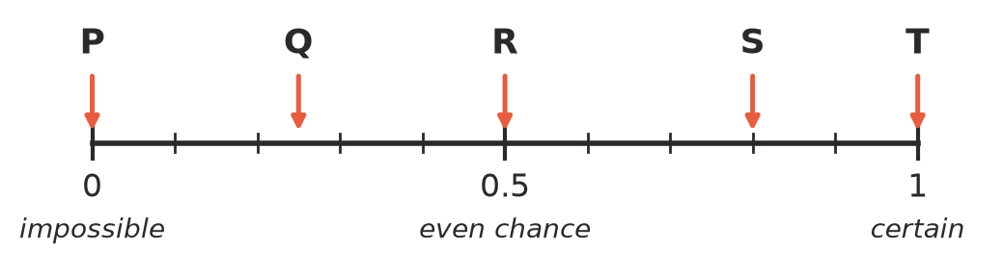
- Which arrow shows the probability of each event?
  - A spinner has 4 equal sections and 1 of them is shaded. It lands on the shaded section. (1 mark)

  - A card is taken at random from four cards numbered 1, 3, 5 and 7. It shows an odd number. (1 mark)

  - A fair coin is tossed and lands on tails. (1 mark)

- Probabilities can be written as fractions, decimals or percentages.
  - Write 0.35 as a fraction in simplest form. (1 mark)

  - Write $\frac{3}{5}$ as a percentage. (1 mark)

  - Write these probabilities in order from least likely to most likely: 0.6, $\frac{1}{2}$, 45%, $\frac{2}{3}$ (1 mark)

- The weather forecast gives a 30% chance of rain tomorrow. What is the probability that it will not rain tomorrow? Write your answer as a decimal. (1 mark)

- This spinner has 8 equal sections. It is spun once.
- 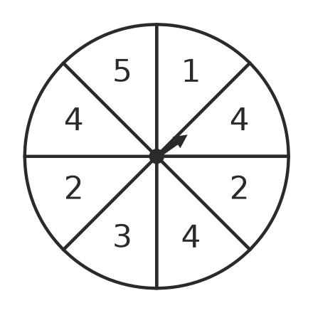
- Find the probability of each outcome. Write each answer as a fraction in simplest form.
  - It lands on 4. (1 mark)

  - It lands on an even number. (1 mark)

  - It does not land on 2. (1 mark)

  - It lands on a number greater than 5. (1 mark)

- The numbers 1 to 20 are written on 20 cards. One card is chosen at random. Find the probability that the number on the card is:
  - a multiple of 4 (1 mark)

  - a prime number. (1 mark)

- Sam looks at this spinner and says, “There are three colours, so the probability of landing on red is $\frac{1}{3}$.”
- 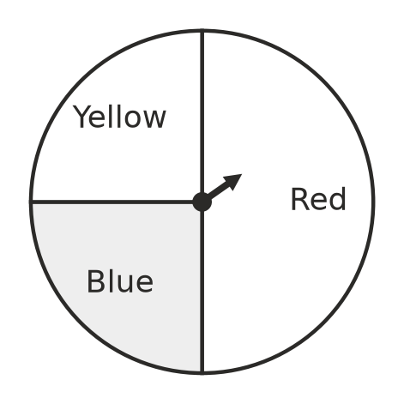
- Explain why Sam is wrong, and give the correct probability of landing on red. (2 marks)

- A bag holds only red and blue counters. The probability of taking a red counter at random is $\frac{3}{8}$. There are 15 blue counters in the bag. How many red counters are in the bag? Show your working. (2 marks)

- Lena tosses a fair coin 50 times. It lands on heads 28 times.
  - What is the experimental probability of heads? Write your answer as a fraction in simplest form. (1 mark)

  - How many heads would you expect in 50 tosses of a fair coin? (1 mark)

  - Lena says the coin must be unfair because she did not get your answer to part b). Do you agree? Explain. (1 mark)

- A fair six-sided die is rolled 120 times. Predict how many times it will show a number greater than 4. Show your working. (2 marks)

 Section B: Calculator allowed
- Students counted the colours of 200 cars that drove past the school gate.
Colour | White | Black | Silver | Red | Blue
Number of cars | 74 | 46 | 38 | 22 | 20

  - What is the relative frequency of silver cars? Write your answer as a decimal. (1 mark)

  - Use the results to find the experimental probability that the next car is not white. Write your answer as a fraction in simplest form. (1 mark)

  - Predict how many of the next 1500 cars will be red. Show your working. (2 marks)

- Ella uses a digital tool to simulate rolling a fair six-sided die. She counts how many times a 6 comes up.
Number of rolls | 60 | 6000
Number of 6s | 14 | 1012

  - How many 6s would you expect in 6000 rolls? (1 mark)

  - Find the relative frequency of a 6 for 60 rolls and for 6000 rolls. Write each as a decimal rounded to 2 decimal places. (2 marks)

  - Which set of rolls gives a relative frequency closer to the theoretical probability? Explain why. (1 mark)

- This spinner is spun once. The angle of each section is shown.
- 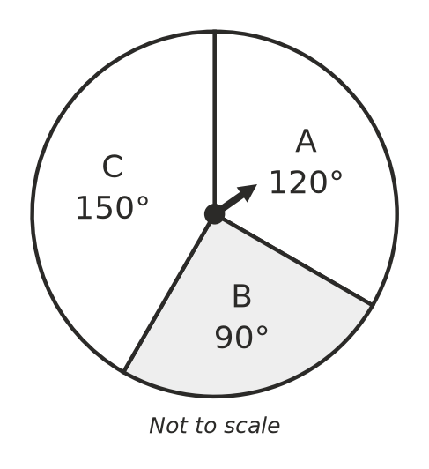
  - Find the probability of landing on C. Write your answer as a fraction in simplest form. (1 mark)

  - The spinner is spun 600 times. Predict how many times it will land on B. (1 mark)

- Ari rolls a six-sided die 300 times. The die lands on 1 a total of 82 times. Do you think the die is fair? Use the number of 1s you would expect to explain your answer. (2 marks)

 Answer sheet
Name: ____________________
Write your final answer for each question in the table.
Question | Answer | Marks | Question | Answer | Marks
1a |  | /1 | 7a |  | /1
1b |  | /1 | 7b |  | /1
1c |  | /1 | 8 |  | /2
2a |  | /1 | 9 |  | /2
2b |  | /1 | 10a |  | /1
2c |  | /1 | 10b |  | /1
3a |  | /1 | 10c |  | /1
3b |  | /1 | 11 |  | /2
3c |  | /1 | 12a |  | /1
4a |  | /1 | 12b |  | /1
4b |  | /1 | 12c |  | /2
4c |  | /1 | 13a |  | /1
5 |  | /1 | 13b |  | /2
6a |  | /1 | 13c |  | /1
6b |  | /1 | 14a |  | /1
6c |  | /1 | 14b |  | /1
6d |  | /1 | 15 |  | /2
 |  |  |  | Total | /40

