15.04 Experimental probability
Year 7 Maths · A5 question sheet · Level 2 · Core
This worksheet practises relative frequency (experimental probability), comparing it with theoretical probability, and making predictions. Tip: expected number = probability × number of trials. Results from a small number of trials can be a long way from what you expect.

 Understanding
- Explain the difference between experimental probability and theoretical probability. Give an example of a situation where you can only find the experimental probability.
- A coin was tossed 50 times and landed heads 28 times.
  - Find the experimental probability of heads, as a fraction in simplest form and as a decimal.
  - Find the experimental probability of tails, as a decimal.
  - What do your answers to a) and b) add up to?

 Fluency
- This spinner was spun 100 times. Copy and complete the table.
- 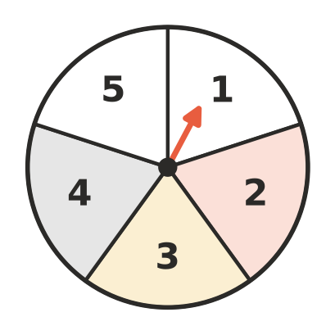
Number | Frequency | Relative frequency (decimal)
1 | 18
2 | 24
3 | 17
4 | 22
5 | 19
Total | 100

  - Which number’s relative frequency is furthest from its theoretical probability?
  - Predict how many times the spinner would land on 4 or 5 in 500 spins.
- Predict how many times each event will happen.
  - A die is rolled 120 times. How many 6s?
  - A die is rolled 120 times. How many even numbers?
  - A card is chosen from a standard deck and put back, 200 times. How many hearts?
  - A card is chosen from a standard deck and put back, 260 times. How many picture cards (jacks, queens and kings)?
- Forty Year 7 students were asked how they travel to school.
Transport | car | bus | walk | bike
Number of students | 14 | 12 | 8 | 6

  - Find the experimental probability that a Year 7 student catches the bus, in simplest form.
  - Find the experimental probability that a student walks or rides a bike, in simplest form.
  - The school has 600 students. Predict how many catch the bus.

 Reasoning
- A water bottle was flipped 60 times. It landed standing upright 9 times.
  - Find the experimental probability that it lands upright, as a fraction and a decimal.
  - Can you find the theoretical probability of the bottle landing upright? Explain.
  - Predict how many times it would land upright in 200 flips.
- A coin was tossed many times. The total number of heads was recorded at different stages.
Number of tosses | 10 | 50 | 100 | 500 | 1000
Number of heads | 7 | 29 | 54 | 246 | 507
Relative frequency of heads

  - Copy and complete the last row as decimals.
  - What happens to the relative frequency as the number of tosses grows?
- Liam rolled a die 12 times and did not get a single 6. He says, “The die must be broken, or a 6 is due on the next roll.” Explain why both of Liam’s ideas are not good reasoning.

 Problem solving
- A bag holds 20 counters coloured red, blue and white. Priya took out a counter, recorded its colour and put it back, 50 times. She got red 22 times, blue 18 times and white 10 times. Estimate how many counters of each colour are in the bag. Show your working.
- A footy player kicked 34 goals from 50 shots at goal this season.
  - Find the experimental probability that the player kicks a goal, as a percentage.
  - In the next game the player has 15 shots at goal. About how many goals would you expect?
- One of these spinners was spun 200 times. It landed on A 52 times, on B 98 times and on C 50 times.
- 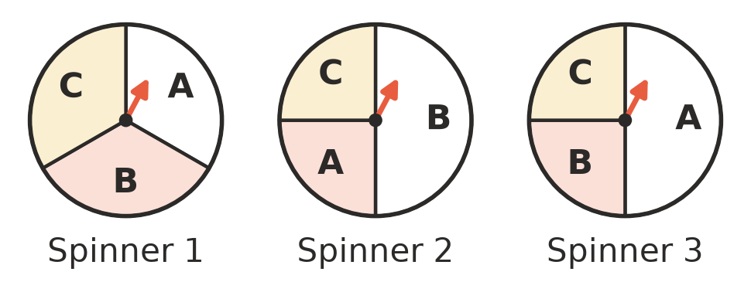
- Which spinner do you think was used? Explain.
- Ruby rolled a die 90 times and got a 1 or a 2 on 27 of the rolls.
  - How many times would you expect to get a 1 or a 2 in 90 rolls?
  - Should Ruby be surprised by her result? Explain.

