15.04 Experimental probability
Year 7 Maths · A5 question sheet · Level 1 · Warm-up
This worksheet practises finding probabilities from experiments and results, and predicting how often something will happen. Tip: experimental probability = number of times the event happened ÷ total number of trials.

 Understanding
- Grace tossed a coin 20 times and got 12 heads.
  - How many trials did Grace do?
  - How many times did heads happen?
  - What is the experimental probability of heads, in simplest form?
  - What is the theoretical probability of heads?
  - Are the two probabilities the same?
- Write experimental or theoretical in each gap.
  - The ______________ probability is found by counting the equally likely outcomes.
  - The ______________ probability is found from the results of trials.

 Fluency
- A die was rolled 30 times. The results are in the table.
Number | 1 | 2 | 3 | 4 | 5 | 6
Frequency | 4 | 6 | 5 | 3 | 7 | 5

  - Which number came up most often?
  - Find the experimental probability of rolling a 5.
  - Find the experimental probability of rolling a 4, in simplest form.
  - Find the experimental probability of rolling an even number, in simplest form.
  - What is the theoretical probability of rolling a 5?
- This spinner was spun 40 times. It landed on A 12 times, B 9 times, C 8 times and D 11 times.
- 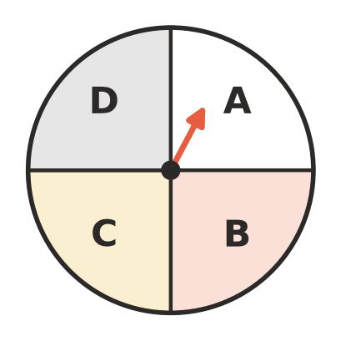
  - Find the experimental probability of A, in simplest form.
  - Write your answer to a) as a percentage.
  - Find the experimental probability of C, in simplest form.
  - What is the theoretical probability of each letter?
- Predict how many times each event will happen.
  - A coin is tossed 100 times. About how many heads?
  - A die is rolled 60 times. About how many 3s?
  - The spinner in question 4 is spun 200 times. About how many times will it land on A?

 Reasoning
- Zoe tossed a coin 10 times and got 7 heads. She says, “This coin must be unfair.” Do you agree? Explain, and say what Zoe could do to find out more.
- Ben tossed a coin 20 times and got 13 heads. Kira tossed a coin 200 times and got 104 heads.
  - Find each person’s experimental probability of heads as a decimal.
  - Whose result is closer to the theoretical probability? Why would you expect this?

 Problem solving
- At netball training, Mia scored 18 goals from 25 shots.
  - Find the experimental probability that Mia scores with a shot, as a decimal and a percentage.
  - Predict how many goals Mia will score from 50 shots.
- Students counted the colours of 50 cars that drove past the school.
Colour | white | black | silver | red | blue
Number of cars | 18 | 9 | 12 | 5 | 6

  - Find the experimental probability that a car is white, in simplest form.
  - Find the experimental probability that a car is red, in simplest form.
  - Predict how many of the next 200 cars will be white.
- A bag holds 10 marbles. Lachlan took out a marble, wrote down its colour and put it back. He did this 30 times and got a red marble 21 times. About how many red marbles do you think are in the bag? Explain.
- Last June, 18 of the 30 days in a town were sunny.
  - Find the experimental probability that a June day is sunny, in simplest form.
  - Predict how many of the first 10 days of next June will be sunny.

