15.03 Theoretical probability
Year 7 Maths · Worksheet · Level 3 · Challenge
Name: ____________________ Date: ______________
This worksheet stretches your probability skills with unequal spinners, events joined by “or” and “and”, and working backwards from a probability. Tip: for an “or” event, list every favourable outcome once only, so you don’t count any outcome twice.

 Understanding
- The sizes of the angles in this spinner are shown.
- 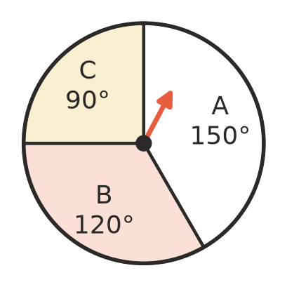
  - Explain why P(A) is not $\frac{1}{3}$.

  - Find P(A), P(B) and P(C) as fractions in simplest form. ______________
- The numbers 1 to 12 are written on cards and one card is chosen at random.
  - List the outcomes that are even and a multiple of 3. Find the probability. ______________
  - List the outcomes that are even or a multiple of 3 (or both). Find the probability. ______________

 Fluency
- One card is chosen at random from a standard deck of 52 playing cards. The picture cards are the jacks, queens and kings. Find each probability in simplest form.
  - P(red picture card) ______________
  - P(ace or king) ______________
  - P(heart or king) ______________
  - P(neither a picture card nor an ace) ______________
  - P(a black card with a number from 2 to 10) ______________
- A bag holds 24 marbles. P(red) = $\frac{1}{3}$, P(blue) = $\frac{1}{4}$ and the rest are green.
  - How many marbles of each colour are there? ______________
  - Find P(green). ______________
- The letters of the word MATHEMATICS are written on 11 cards. One card is chosen at random. (The vowels are A, E, I, O and U.)
  - P(M) ______________
  - P(a vowel) ______________
  - P(a letter that is in the word TEAM) ______________
  - P(a letter that appears only once in MATHEMATICS) ______________
- The numbers 1 to 50 are written on cards and one card is chosen at random. Write each probability as a fraction in simplest form, a decimal and a percentage.
  - P(a multiple of 7) ______________
  - P(a number containing the digit 3) ______________
  - P(a prime number) ______________

 Reasoning
- Noah says, “If I pick a day of the week at random, the chance of a weekday is $\frac{1}{2}$, because it is either a weekday or the weekend.” Explain Noah’s mistake and give the correct probability.

- Bag A holds 2 red counters out of 5. Bag B holds 15 counters. How many red counters must Bag B hold so that both bags give the same chance of red? ______________
- True or false? “If you double the number of marbles of every colour in a bag, every probability stays the same.” Explain.

 Problem solving
- A bag holds red and blue marbles, and P(red) = $\frac{3}{8}$. When 4 more red marbles are added, P(red) becomes $\frac{1}{2}$. How many red and blue marbles were in the bag at the start? Show your working.

- A spinner has three sectors. P(A) = $\frac{1}{3}$ and P(B) = $\frac{1}{4}$.
  - Find P(C). ______________
  - Find the angle of each sector. (A full turn is 360°.) ______________
- Write a number in each part of this blank spinner, using only 1, 2, 3 and 4, so that P(1) = $\frac{1}{4}$, P(4) = $\frac{1}{6}$ and P(even number) = $\frac{1}{2}$.
- 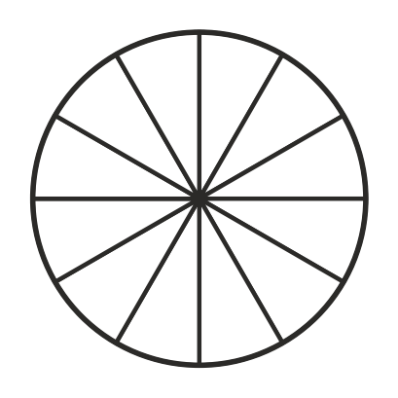
  - How many parts did you give each number? ______________
  - What is P(3)? ______________
- All 13 hearts are taken out of a standard deck of 52 cards. One card is then chosen at random from the cards that are left. Find:
  - P(red card) ______________
  - P(king) ______________
  - P(picture card) ______________

