15.03 Theoretical probability
Year 7 Maths · Worksheet · Level 2 · Core
Name: ____________________ Date: ______________
This worksheet practises finding probabilities with dice, spinners, playing cards, marbles and letters. Tip: P(event) = number of favourable outcomes ÷ total number of outcomes, but only when every outcome is equally likely. A standard deck has 52 cards: 4 suits of 13, and the picture cards are the jacks, queens and kings.

 Understanding
- This spinner has 6 equal parts.
- 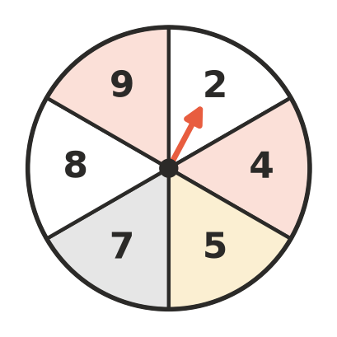
  - Write the sample space. ______________
  - List the favourable outcomes for the event “an odd number”. ______________
  - Find P(odd number) in simplest form. ______________
- Sam says that P(A) on this spinner is $\frac{1}{3}$ because there are three letters.
- 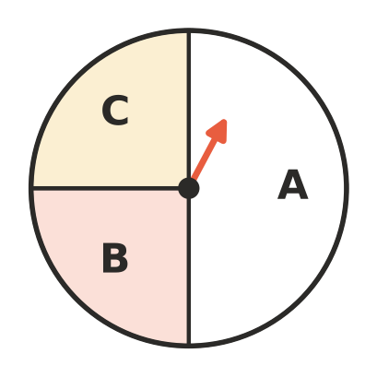
  - Explain why Sam is wrong.

  - What is the correct value of P(A)? ______________

 Fluency
- One card is chosen at random from a standard deck of 52 playing cards. Find each probability in simplest form.
  - P(red card) ______________
  - P(heart) ______________
  - P(king) ______________
  - P(queen of spades) ______________
  - P(picture card) ______________
  - P(not a club) ______________
  - P(red ace) ______________
- A normal six-sided die is rolled. Find each probability in simplest form.
  - P(a factor of 6) ______________
  - P(a prime number) ______________
  - P(a square number) ______________
  - P(a multiple of 3) ______________
- A bag holds 6 red, 9 blue and 5 green marbles. One marble is taken out without looking. Complete the table.
Event | Fraction (simplest form) | Decimal | Percentage
red
blue
green
not red

- On this spinner, A is half of the circle, B is a quarter, and C and D are an eighth each.
- 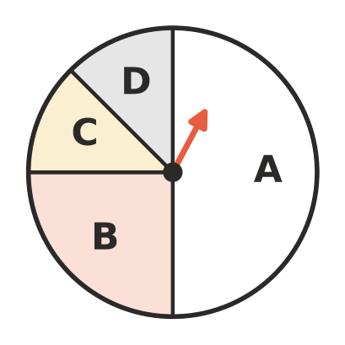
  - P(A) ______________
  - P(C) ______________
  - P(not B) ______________
  - P(C or D) ______________
- The letters of the word PROBABILITY are written on 11 cards, one letter on each card. One card is chosen at random. (The vowels are A, E, I, O and U.)
  - P(B) ______________
  - P(a vowel) ______________
  - P(a letter that is in the word BAIT) ______________
  - P(not I) ______________

 Reasoning
- A bag holds 3 red and 5 blue counters. Ava writes P(red) = $\frac{3}{5}$. Explain Ava’s mistake and give the correct probability.

- Bag A holds 3 red marbles out of 8. Bag B holds 4 red marbles out of 12. You want a red marble. Which bag should you choose from? Show your working.

 Problem solving
- The numbers 1 to 20 are written on cards and one card is chosen at random. Find each probability in simplest form.
  - P(a multiple of 4) ______________
  - P(a prime number) ______________
  - P(a two-digit number) ______________
  - P(a number whose digits add up to 5) ______________
- A bag holds 12 marbles, which are red or blue. P(red) = $\frac{1}{3}$.
  - How many blue marbles are in the bag? ______________
  - Three blue marbles are taken out. Find the new P(red). ______________
- Design a bag of 10 counters coloured red, blue and white so that P(red) = $\frac{1}{2}$ and P(blue) = $\frac{2}{5}$. How many of each colour are there, and what is P(white)?

- Write a number in each part of this blank spinner, using only 1, 2 and 3, so that P(1) = $\frac{1}{2}$ and P(3) = $\frac{1}{8}$.
- 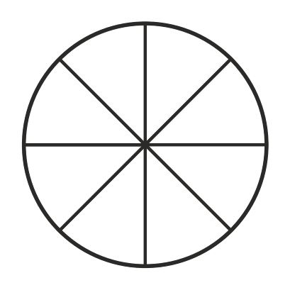
- What is P(2)? ______________

