15.03 Theoretical probability
Year 7 Maths · A5 question sheet · Level 1 · Warm-up
This worksheet practises working out probabilities by counting outcomes. Tip: when all the outcomes are equally likely, P(event) = number of favourable outcomes ÷ total number of outcomes. Always simplify the fraction.

 Understanding
- A normal six-sided die is rolled.
  - How many possible outcomes are there?
  - Which outcomes are even numbers? How many are there?
  - Write P(even number) as a fraction in simplest form.
- A coin is tossed.
  - What is P(heads)?
  - What is P(tails)?
  - What is P(heads or tails)?

 Fluency
- A normal six-sided die is rolled. Find each probability as a fraction in simplest form.
  - P(5)
  - P(a number less than 3)
  - P(an odd number)
  - P(7)
  - P(a number greater than 4)
  - P(a number from 1 to 6)
- This spinner has 5 equal parts.
- 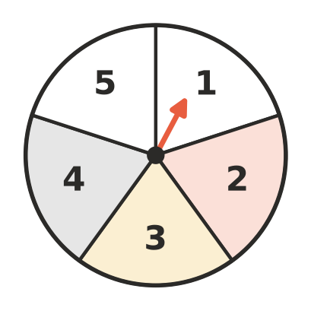
  - P(3)
  - P(an even number)
  - P(a number less than 4)
  - P(not 5)
- A bag holds 3 red, 5 blue and 2 green marbles. One marble is taken out without looking. Find each probability in simplest form.
  - P(red)
  - P(blue)
  - P(green)
  - P(not blue)
  - P(yellow)
- This spinner has 8 equal parts.
- 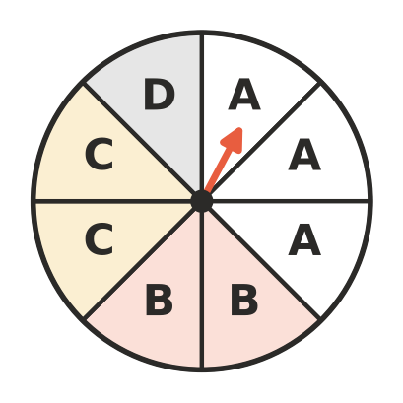
  - P(A)
  - P(B)
  - P(D)
  - P(not A)

 Reasoning
- The letters of the word AUSTRALIA are written on 9 cards, one letter on each card. One card is chosen at random.
  - P(A)
  - P(a vowel). The vowels are A, E, I, O and U.
  - P(L)
- Liam says, “The probability of rolling a 6 on a die is $\frac{1}{2}$, because you either get a 6 or you don’t.” Explain Liam’s mistake and give the correct probability.

 Problem solving
- The numbers 1 to 10 are written on cards and one card is chosen at random. Find each probability in simplest form.
  - P(an even number)
  - P(a multiple of 3)
  - P(a number greater than 7)
  - P(10)
- A bag holds 4 red and 6 yellow counters.
  - Find P(red).
  - Two more red counters are put in the bag. Find the new P(red).
- A bag holds 20 marbles and 5 of them are blue. Write P(blue) as a fraction, a decimal and a percentage.

