15.02 Probability as a number
Year 7 Maths · Worksheet · Level 1 · Warm-up
Name: ____________________ Date: ______________
This worksheet practises writing chance as a number from 0 to 1, using fractions, decimals and percentages. Tip: 0 means impossible, 1 means certain, and $\frac{1}{2}$ = 0.5 = 50% means an even chance.

 Understanding
- Complete each sentence with a number.
  - An impossible event has a probability of ______________ .
  - A certain event has a probability of ______________ .
  - An even chance is a probability of $\frac{1}{2}$, which is ______________ as a decimal and ______________ as a percentage.
- Each arrow points to a probability on this probability scale.
- 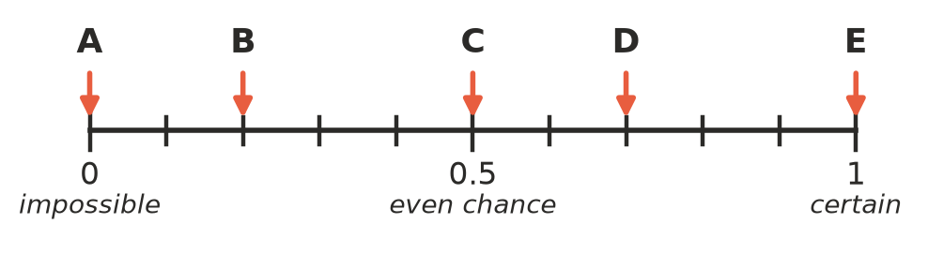
Arrow | Probability as a decimal | Chance word
A
B
C
D
E

 Fluency
- Complete the table. Write fractions in simplest form.
Fraction | Decimal | Percentage
$\frac{1}{2}$
 | 0.25
 |  | 75%
$\frac{1}{10}$
 | 0.2

- Describe each probability with a chance word: impossible, unlikely, even chance, likely or certain.
  - 0.9 ______________
  - $\frac{1}{2}$ ______________
  - 0 ______________
  - 15% ______________
  - 1 ______________
  - $\frac{3}{5}$ ______________
- Write these probabilities in order from least likely to most likely.
- 0.6 $\frac{1}{4}$ 90% 0 $\frac{1}{2}$
- Order: ______________
- Circle the numbers that cannot be probabilities.
- 0.4 1.2 −0.3 $\frac{3}{2}$ 100% $\frac{7}{8}$
- Draw an arrow on this scale to show each probability. Label the arrows a, b and c.
- 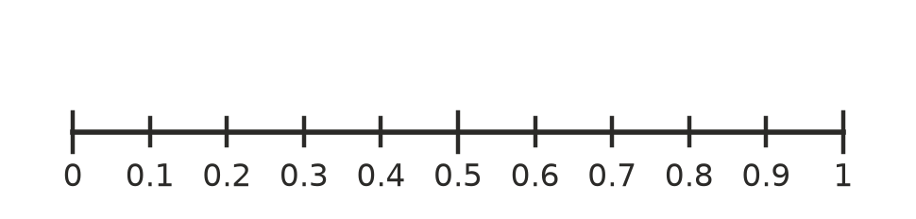
  - 0.3 b) $\frac{1}{2}$ c) 90%

 Reasoning
- An event either happens or it doesn’t. The two probabilities always add up to 1.
  - The probability that it rains tomorrow is 0.3. What is the probability that it does not rain? ______________
  - The probability that a bus is late is 10%. What is the probability that it is not late? ______________
  - The probability of taking out a red marble is $\frac{2}{5}$. What is the probability of not taking out a red marble? ______________
- This spinner has 4 equal parts.
- 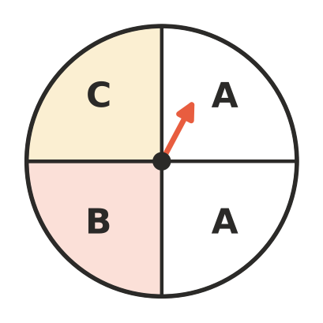
  - What fraction of the spinner is A? So what is the probability of landing on A? ______________
  - Write the probability of landing on B and of landing on C. ______________
  - Add the three probabilities. What do you notice? ______________

 Problem solving
- Ella’s weather app says there is a 20% chance of rain. Sam’s app says the probability of rain is 0.2. Are the apps giving the same chance? Explain.

- This spinner has 10 equal parts.
- 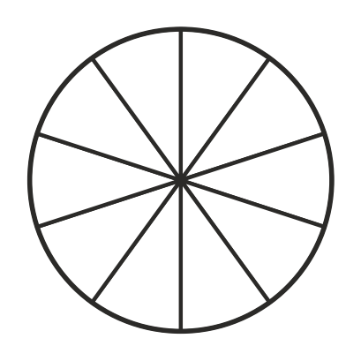
  - Shade parts of the spinner so that the probability of landing on a shaded part is 0.3.
  - What is the probability of landing on a part that is not shaded? Write it as a decimal and as a percentage. ______________

