15.02 Probability as a number
Year 7 Maths · A5 question sheet · Level 3 · Challenge
This worksheet stretches your skills with probabilities written in different forms, missing probabilities and events that overlap. Tip: change every probability to a decimal when you need to compare them.

 Understanding
- Each arrow points to a probability on this scale. The small marks are every 0.05.
- 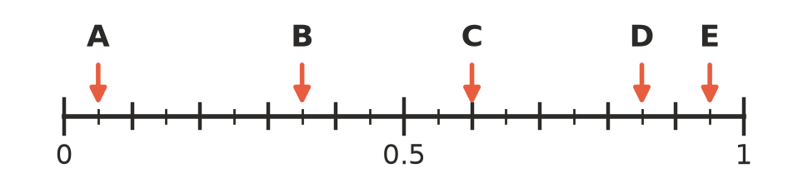
Arrow | Decimal | Fraction (simplest form)
A
B
C
D
E

- Explain why P(A) + P(not A) is always equal to 1.

 Fluency
- Write these probabilities in order from least likely to most likely.
- $\frac{1}{3}$ 0.3 33% 0.303 $\frac{7}{20}$ 0.34
- Find P(not A) in the form asked for.
  - P(A) = 0.125. Write P(not A) as a fraction.
  - P(A) = 37.5%. Write P(not A) as a fraction.
  - P(A) = $\frac{2}{3}$. Write P(not A) as a percentage, rounded to 1 decimal place.
  - P(A) = 0.04. Write P(not A) as a fraction.
- A spinner can only land on A, B or C. P(A) = 0.4 and P(B) = $\frac{1}{4}$. Find P(C) as a fraction and as a percentage.
- A spinner can only land on A, B, C or D.
  - P(A) = P(B), P(C) = 0.3 and P(D) = 0.1. Find P(A).
  - On a different spinner, P(A) is twice P(B), P(C) = 0.4 and P(D) = 0. Find P(A) and P(B).

 Reasoning
- The weather forecast says “70% chance of rain”. Maya says, “That means it will rain for 70% of the day.” Explain what the forecast really means.
- A spinner has 10 equal parts numbered 1 to 10. Jacob says event A has probability 0.6 and event B has probability 0.5.
  - Jacob’s friend says this is impossible because 0.6 + 0.5 is more than 1. Explain why the friend is wrong, and give an example of events A and B that work.
  - Could events A and B have no outcomes in common? Explain.
- Is each statement possible? Write yes or no and give a reason.
  - An event has a probability of 1.05.
  - P(A) = 0.3 and P(not A) = 0.6.

 Problem solving
- A bag holds 40 counters that are red, blue, green or yellow. P(red) = 0.25, P(blue) = 30% and P(green) = $\frac{3}{8}$.
  - Find P(yellow) as a fraction.
  - How many counters of each colour are in the bag?
  - Some red counters are taken out of the bag. Now P(red) = $\frac{1}{6}$. How many red counters were taken out? Show your working.
- Write a letter in each part of this blank spinner so that P(A) = 0.25, P(B) = $\frac{1}{3}$ and P(C) = $\frac{5}{12}$.
  - How many parts did you give each letter?
  - Find P(not B).
- Answer each question.
  - The probability that an event does not happen is 4 times the probability that it does happen. Find the probability that it happens.
  - P(A) is 0.36 more than P(not A). Find P(A).
- Draw an arrow on this scale for each probability. Label the arrows a, b, c and d.
- 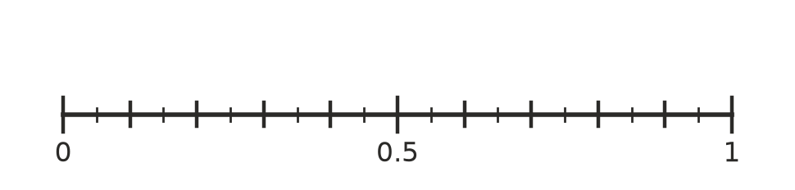
  - $\frac{1}{3}$ b) $\frac{1}{8}$ c) 0.875 d) $\frac{2}{3}$
  - Which two pairs of these probabilities belong to an event and its complement (the event not happening)?

