15.02 Probability as a number
Year 7 Maths · A5 question sheet · Level 2 · Core
This worksheet practises probabilities as fractions, decimals and percentages, placing them on a scale from 0 to 1, and finding the probability that an event does not happen. Tip: the probabilities of all the outcomes add up to 1, so P(not A) = 1 − P(A).

 Understanding
- Each arrow points to a probability on this scale.
- 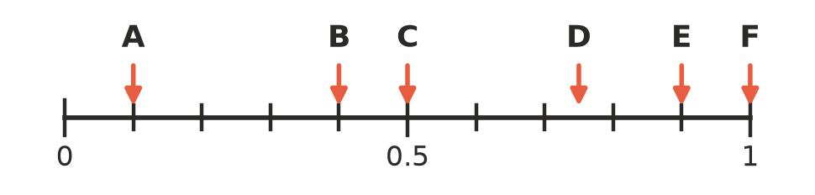
Arrow | Decimal | Fraction (simplest form) | Percentage
A
B
C
D
E
F

- Explain why a probability can never be greater than 1 or less than 0.

 Fluency
- Copy and complete the table. Write fractions in simplest form.
Fraction | Decimal | Percentage
$\frac{3}{5}$
 | 0.35
 |  | 12%
$\frac{1}{8}$
 | 0.08
 |  | 95%

- Write these probabilities in order from least likely to most likely.
- 0.45 $\frac{2}{5}$ 48% $\frac{3}{8}$ 0.5 $\frac{11}{25}$
- P(A) means “the probability of event A”. Find the probability that each event does not happen. Give your answer in the same form as the question.
  - P(A) = 0.35
  - P(A) = $\frac{3}{8}$
  - P(A) = 62%
  - P(A) = 0.07
  - P(A) = $\frac{11}{20}$
- Each spinner can only land on A, B or C. Find the missing probability.
  - P(A) = 0.5, P(B) = 0.3, P(C) =
  - P(A) = $\frac{1}{4}$, P(B) = $\frac{1}{3}$, P(C) =
  - P(A) = 45%, P(B) = 45%, P(C) =

 Reasoning
- A bag holds only red and blue counters. Tom says the probability of taking out a red counter is 0.4 and the probability of taking out a blue counter is 0.7. Explain why Tom must have made a mistake.
- Event X has a probability of $\frac{5}{8}$. Event Y has a probability of 0.6. Which event is more likely? Show your working.
- A normal six-sided die is rolled. Match each event to its probability from the list: 0, $\frac{1}{6}$, $\frac{1}{2}$, $\frac{5}{6}$, 1.
  - Rolling a 3.
  - Rolling a number that is not 3.
  - Rolling an even number.
  - Rolling a 7.
  - Rolling a number from 1 to 6.

 Problem solving
- The chance of rain on four days is: Monday 30%, Tuesday 0.25, Wednesday $\frac{1}{5}$, Thursday $\frac{7}{20}$.
  - List the days from most likely to least likely to have rain.
  - What is the probability that Wednesday stays dry? Write it as a decimal.
- A bag holds only red, blue and yellow counters. P(red) = 0.45 and P(blue) = 0.35.
  - Find P(yellow).
  - Find P(not blue).
  - There are 20 counters in the bag. How many are yellow?
- Draw an arrow on this scale for each probability. Label the arrows a, b, c and d.
- 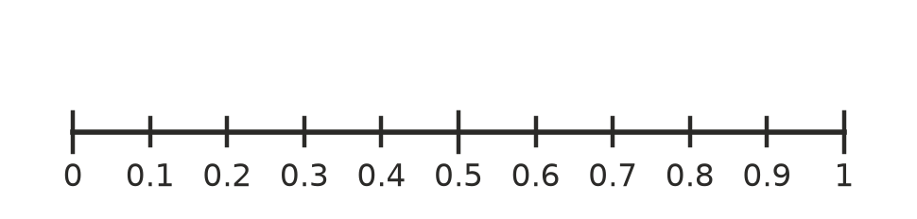
  - The probability of a tossed coin landing tails: $\frac{1}{2}$
  - The probability of rolling a number less than 3 on a die: $\frac{1}{3}$
  - 85%
  - The probability that a card chosen from a standard deck is not a heart: $\frac{3}{4}$
- This spinner has 12 equal parts.
  - Shade the spinner so that P(shaded) = 0.25.
  - Write P(not shaded) as a fraction and as a percentage.

