15.01 Language of probability
Year 7 Maths · Worksheet · Level 2 · Core
Name: ____________________ Date: ______________
This worksheet practises the language of chance: trials, outcomes, sample spaces, events and the words from impossible to certain. Tip: before you choose a chance word, count how many outcomes are in the event and compare it with the total.

 Understanding
- A spinner numbered 1 to 5 is spun once. Fill each gap with one of these words: trial, outcome, sample space, event.
  - Spinning the spinner once is called a ______________ .
  - Landing on 3 is one possible ______________ .
  - The list {1, 2, 3, 4, 5} is the ______________ .
  - “Landing on an even number” is an ______________ .
- Describe each event with one of these words: impossible, unlikely, even chance, likely, certain.
  - Choosing a red card from a standard deck of 52 playing cards. ______________
  - Rolling a number less than 3 on a normal six-sided die. ______________
  - The day after Sunday is a Monday. ______________
  - Choosing a vowel from the letters of the word BANANA. ______________
  - Choosing a consonant from the letters of the word STRING. ______________

 Fluency
- Write the sample space for each of these.
  - Spinning this spinner.
- 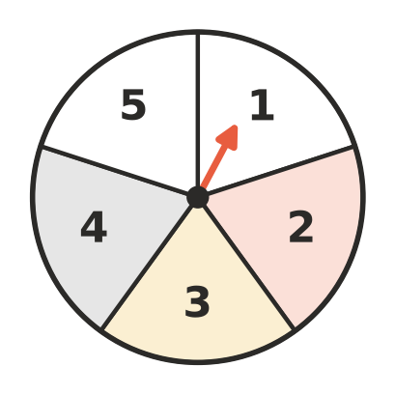
- Sample space: ______________
  - Choosing a letter from the word MATHS. ______________
  - The suit of a card chosen from a standard deck. ______________
  - Choosing a letter from the word PROBABILITY. (Write each letter only once.) ______________
- This spinner has 10 equal parts.
- 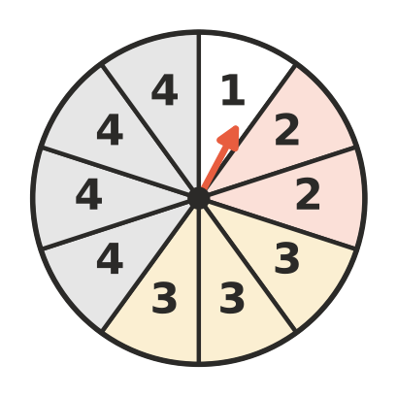
  - Which number is most likely? ______________
  - Which number is least likely? ______________
  - Describe the chance of landing on a number less than 5. ______________
  - Describe the chance of landing on 3 or 4. ______________
  - Describe the chance of landing on 1. ______________
  - Describe the chance of landing on 5. ______________
- One card is chosen from a standard deck of 52 playing cards. Describe the chance of choosing:
  - an ace. ______________
  - a card that is not a heart. ______________
  - a heart, diamond, club or spade. ______________
  - a green card. ______________
- A bag holds 7 blue, 2 white and 11 red counters. One counter is taken out without looking.
  - List the colours in order from least likely to most likely. ______________
  - Is taking out a red counter likely, unlikely or an even chance? Explain.

 Reasoning
- Are the outcomes equally likely? Write yes or no and give a reason.
  - Landing on A, B or C on this spinner.
- 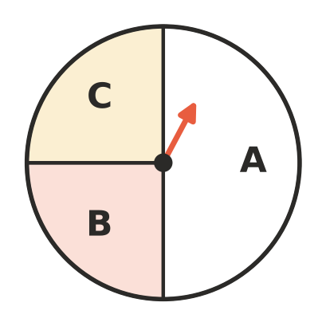

  - A footy team’s next game: win, lose or draw.

  - Choosing a red card or a black card from a standard deck.

- Josh says, “When I roll a die, a 6 is harder to get than a 1, because 6 is the biggest number.” Is Josh right? Explain.

- A normal six-sided die is rolled. List the outcomes in each event.
  - An even number. ______________
  - A number greater than 4. ______________
  - A factor of 6. ______________
  - A prime number. ______________

 Problem solving
- A bag holds 4 red, 4 blue and 2 green marbles. What is the smallest number of red marbles you must add to make taking out a red marble likely (more likely than not)? Show your working.

- Write a letter in each part of this blank spinner, using only the letters A, B and C, so that landing on A is likely, landing on B and landing on C are equally likely, and landing on C is unlikely. There is only one way to do it (in any order).
- 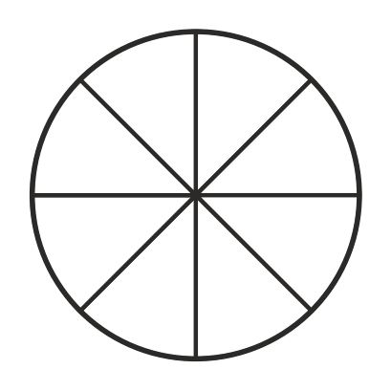
- How many parts did you give each letter? A: ______________ B: ______________ C: ______________
- The numbers 1 to 20 are written on cards and one card is chosen at random. Describe the chance of each event and give a reason.
  - A number less than 21. ______________
  - A multiple of 5. ______________
  - An even number. ______________
  - A two-digit number. ______________
- A normal six-sided die is rolled. Write your own event that is:
  - impossible ______________
  - certain ______________
  - an even chance ______________
  - unlikely ______________

