15.01 Language of probability
Year 7 Maths · A5 question sheet · Level 3 · Challenge
This worksheet stretches your chance language with unequal spinners, playing cards, letters and harder sample spaces. Tip: an event can contain many outcomes, so count them all before you decide how likely it is.

 Understanding
- A normal six-sided die is rolled once.
  - What is the sample space?
  - Explain the difference between an outcome and an event, using this die as an example.
- Write the sample space for each of these. Write each outcome only once.
  - Choosing a letter from the word MISSISSIPPI.
  - The number of heads when you toss one coin.
  - The remainder when a whole number chosen at random is divided by 3.
  - The last digit of a whole number chosen at random.

 Fluency
- On this spinner, A is half of the circle, B is a quarter, C is $\frac{1}{6}$ and D is $\frac{1}{12}$.
- 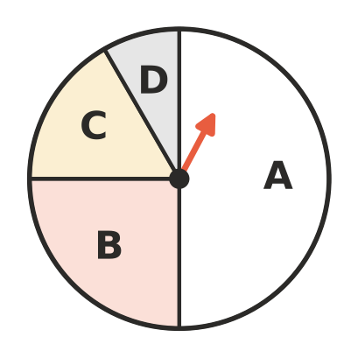
  - List the letters in order from least likely to most likely.
  - Which single letter has an even chance?
  - Name an event using two letters that is likely.
  - Describe the chance of landing on B, C or D.
- One card is chosen from a standard deck of 52 playing cards. Describe the chance of each event and give the number of cards in the event.
  - A red king.
  - A card that is not a picture card (jack, queen or king).
  - A black card or a heart.
  - A red card or a black card.
- A letter is chosen at random from a word. The vowels are A, E, I, O and U. Write a word of your own for which choosing a vowel is:
  - an even chance
  - impossible
  - likely
- A normal six-sided die is rolled. Put these events in order from least likely to most likely.
- A: rolling a factor of 12 B: rolling a prime number C: rolling a square number
- D: rolling a multiple of 7 E: rolling a number whose square is less than 40
- Order:

 Reasoning
- Kai says, “In the swimming race I will either win or not win. That’s two outcomes, so I have an even chance of winning.” Explain what is wrong with Kai’s thinking.
- A bag holds 5 red marbles and some blue marbles. One marble is taken out without looking.
  - How many blue marbles would make red and blue an even chance?
  - For which numbers of blue marbles is taking out a red marble likely?
  - For which numbers of blue marbles is taking out a blue marble likely?
- True or false? Give a reason for each.
  - If an event is unlikely, it will never happen.
  - Rolling an even number on a die is just as likely as rolling an odd number.
  - If the outcomes in a sample space are not equally likely, the sample space must be wrong.

 Problem solving
- Write a number in each part of this blank spinner, using only 1, 2 and 3, so that landing on 3 is an even chance and landing on 1 is twice as likely as landing on 2.
- How many parts did you give each number? 1: ______________ 2: ______________ 3:
- A bag holds 3 red, 5 blue and 7 green counters.
  - What is the smallest number of red counters you must add so that red becomes the most likely colour?
  - After adding them, is taking out a red counter likely? Explain.
- The numbers 1 to 30 are written on cards and one card is chosen at random. Describe the chance of each event and say how many cards are in it.
  - A multiple of 3.
  - A number that is not a multiple of 10.
  - A number whose digits add up to 3.
  - An odd number.
- This spinner has 8 equal parts.
- 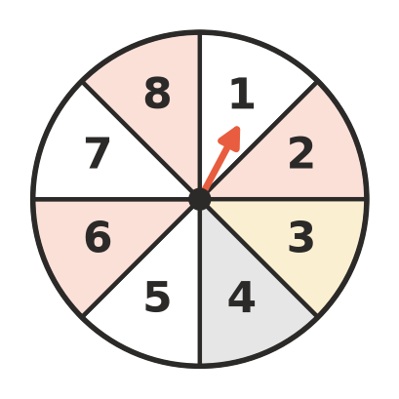
  - Write two events that each have an even chance and have no outcomes in common.
  - Write two events that each have an even chance and have exactly two outcomes in common.

