15.01 Language of probability
Year 7 Maths · A5 question sheet · Level 1 · Warm-up
This worksheet practises the words we use to describe chance and how to list every possible outcome. Tip: the five chance words, from least likely to most likely, are impossible, unlikely, even chance, likely and certain.

 Understanding
- Choose the best word from the list for each event: impossible, unlikely, even chance, likely, certain.
  - The sun will rise tomorrow morning.
  - You roll a normal six-sided die and get a 7.
  - You toss a coin and it lands heads up.
  - You roll a normal six-sided die and get a 6.
  - You roll a normal six-sided die and get a number bigger than 1.
- Write the five chance words in order, from least likely to most likely.
- The list of all the possible outcomes is called the sample space. Write the sample space for each of these.
  - Tossing a coin.
  - Rolling a normal six-sided die.
  - Spinning this spinner.
- 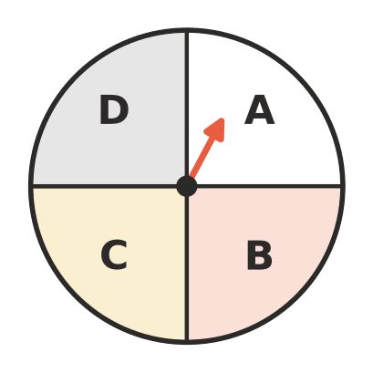
- Sample space:
  - Choosing a day of the week at random.

 Fluency
- A normal six-sided die is rolled. Describe each event with one of the five chance words.
  - Rolling a number less than 7.
  - Rolling a 0.
  - Rolling an even number.
  - Rolling a 4.
  - Rolling a number bigger than 2.
- This spinner has 8 equal parts.
- 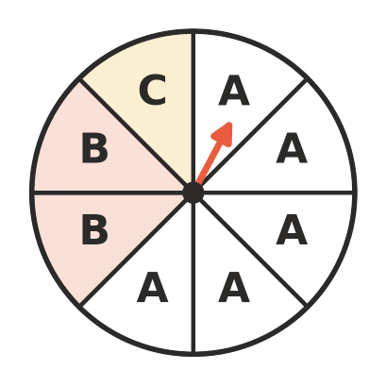
  - Which letter is the spinner most likely to land on?
  - Which letter is it least likely to land on?
  - Is landing on A likely or unlikely?
  - Describe the chance of landing on D.
  - Describe the chance of landing on A, B or C.
- A bag holds 6 red marbles, 3 blue marbles and 1 green marble. One marble is taken out without looking.
  - Write the sample space (the possible colours).
  - Which colour is most likely?
  - Which colour is least likely?
  - Describe the chance of taking out a yellow marble.

 Reasoning
- Outcomes are equally likely when each one has the same chance of happening. Write yes or no for each.
  - Heads and tails when you toss a coin.
  - The numbers 1 to 6 when you roll a normal die.
  - Red, blue and green for the bag of marbles in question 6.
- Mia looks at this spinner and says, “There are three letters, so A, B and C are all equally likely.”
- 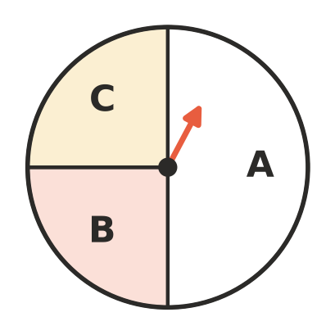
- Explain why Mia is wrong.

 Problem solving
- A normal six-sided die is rolled. Put these events in order from least likely to most likely.
- A: rolling a 5 B: rolling an even number C: rolling a number less than 5 D: rolling a 9
- Order:
- There are 12 girls and 14 boys in a class. The teacher pulls one name out of a hat.
  - Is it more likely to be a girl’s name or a boy’s name?
  - Is the chance of choosing a boy exactly an even chance? Explain.
- A box holds 10 counters. Each counter is red, blue or yellow. Say how many of each colour could be in your book so that:
  - taking out a red counter is certain.
  - taking out a red counter is impossible.
  - red and blue have an even chance each.
  - red is likely, but not certain.

