Powers, factors and multiples: Practice test 3
Year 7 Maths · Test · Test 3
Name: ____________________ Date: ______________
Time: 45 minutes
Total: 40 marks
Show your working in the boxes. Then write each final answer on the answer sheet on the last page.

 Section A: No calculator
- Number properties.
  - Use the commutative and associative laws to calculate 2 × 46 × 50. Show your steps. (1 mark)

  - Use the distributive law to calculate 6 × 47. Show your steps. (1 mark)

  - Which law is shown by (14 + 9) + 1 = 14 + (9 + 1)? (1 mark)

- Square numbers.
  - Evaluate ${20}^{2}$. (1 mark)

  - List all the square numbers between 30 and 90. (1 mark)

- Square roots.
  - Evaluate $\sqrt{225}$. (1 mark)

  - Evaluate $\sqrt{144}$ ÷ $\sqrt{16}$. (1 mark)

- A square courtyard is paved with 196 square pavers, each 1 m long and 1 m wide.
  - How many pavers are along each side of the courtyard? (1 mark)

  - The courtyard is made bigger by adding one more row and one more column of pavers, so it is still a square. How many extra pavers are needed? (1 mark)

- Powers.
  - Write 5 × 5 × 5 × 9 × 9 in index form. (1 mark)

  - Evaluate $2^{3}$ × $5^{2}$. (1 mark)

  - Evaluate $1^{7}$ + $3^{3}$. (1 mark)

- Powers of ten.
  - Write 405 060 in expanded notation using powers of ten. (2 marks)

  - Write this as a basic numeral: 8 × ${10}^{3}$ + 2 × ${10}^{1}$ + 4 × 1 (1 mark)

- Factors, multiples and primes.
  - List all the factors of 64. (1 mark)

  - Find the largest multiple of 12 that is less than 200. (1 mark)

  - Write down two prime numbers between 70 and 80. (1 mark)

- Complete the factor tree for 600. Then write 600 as a product of prime factors in index form. (2 marks)
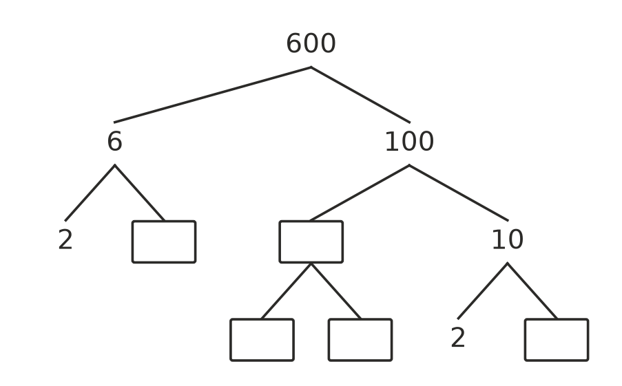

- HCF and LCM.
  - Find the HCF of 48 and 80. (1 mark)

  - Find the LCM of 12 and 18. (1 mark)

  - 90 = 2 × $3^{2}$ × 5 and 150 = 2 × 3 × $5^{2}$. Use these to find the HCF of 90 and 150. (1 mark)

  - Use them to find the LCM of 90 and 150. (1 mark)

- Noah says that $\sqrt{100}$ + $\sqrt{36}$ is the same as $\sqrt{136}$, because 100 + 36 = 136. Is Noah right? Explain your answer. (2 marks)

- Number puzzle. Two numbers are both between 10 and 40. Their HCF is 6 and their LCM is 72. Find the two numbers. Show how you found them. (2 marks)

 Section B: Calculator allowed
- Use a calculator to evaluate each of these.
  - $9^{5}$ (1 mark)

  - $\sqrt{9604}$ (1 mark)

- Write 5880 as a product of prime factors in index form. Show your working. (2 marks)

- Is 437 a prime number? Use your calculator to test it, and explain your answer. (2 marks)

- Two lighthouses on the coast both flash at exactly 9:00 pm. After that, one flashes every 45 seconds and the other flashes every 60 seconds.
  - At what time will they next flash together? (2 marks)

  - How many times will they flash together after 9:00 pm, up to and including 10:00 pm? (1 mark)

- A rectangular hall floor is 1080 cm long and 840 cm wide. It is covered with identical square tiles, with no gaps and no cut tiles.
  - What is the side length of the largest square tile that can be used? (2 marks)

  - How many of these tiles are needed? (1 mark)

 Answer sheet
Name: ____________________
Write your final answer for each question in the table.
Question | Answer | Marks | Question | Answer | Marks
1a |  | /1 | 7c |  | /1
1b |  | /1 | 8 |  | /2
1c |  | /1 | 9a |  | /1
2a |  | /1 | 9b |  | /1
2b |  | /1 | 9c |  | /1
3a |  | /1 | 9d |  | /1
3b |  | /1 | 10 |  | /2
4a |  | /1 | 11 |  | /2
4b |  | /1 | 12a |  | /1
5a |  | /1 | 12b |  | /1
5b |  | /1 | 13 |  | /2
5c |  | /1 | 14 |  | /2
6a |  | /2 | 15a |  | /2
6b |  | /1 | 15b |  | /1
7a |  | /1 | 16a |  | /2
7b |  | /1 | 16b |  | /1
 |  |  |  | Total | /40

