Powers, factors and multiples: Practice test 2
Year 7 Maths · Test · Test 2
Name: ____________________ Date: ______________
Time: 45 minutes
Total: 40 marks
Show your working in the boxes. Then write each final answer on the answer sheet on the last page.

 Section A: No calculator
- Number properties.
  - Use the commutative and associative laws to calculate 25 × 13 × 4. Show your steps. (1 mark)

  - Use the distributive law to calculate 7 × 98. Hint: 98 = 100 − 2. (1 mark)

  - Work out (48 ÷ 4) ÷ 2 and 48 ÷ (4 ÷ 2). Does it matter where the brackets go when you divide? (1 mark)

- Evaluate ${15}^{2}$. (1 mark)

- Square roots.
  - Evaluate $\sqrt{169}$ − $\sqrt{49}$. (1 mark)

  - Evaluate $\sqrt{144}$ ÷ $\sqrt{9}$. (1 mark)

  - Between which two consecutive whole numbers does $\sqrt{55}$ lie? (1 mark)

- A square photo frame has a perimeter of 44 cm. What is the area of the frame? Show your working. (2 marks)

- Powers.
  - Write $6^{4}$ in expanded form. (1 mark)

  - Evaluate ${10}^{2}$ − $3^{4}$. (1 mark)

  - Which is larger, $2^{6}$ or $6^{2}$? Show how you know. (1 mark)

- Powers of ten.
  - Write 7 050 309 in expanded notation using powers of ten. (2 marks)

  - Write this as a basic numeral: 4 × ${10}^{4}$ + 9 × ${10}^{2}$ + 6 × ${10}^{1}$ (1 mark)

- Factors, multiples and primes.
  - List all the factors of 90. (1 mark)

  - List the multiples of 6 that are between 40 and 70. (1 mark)

  - Is 91 a prime number? Show how you know. (1 mark)

- Complete the factor tree for 252. Then write 252 as a product of prime factors in index form. (2 marks)
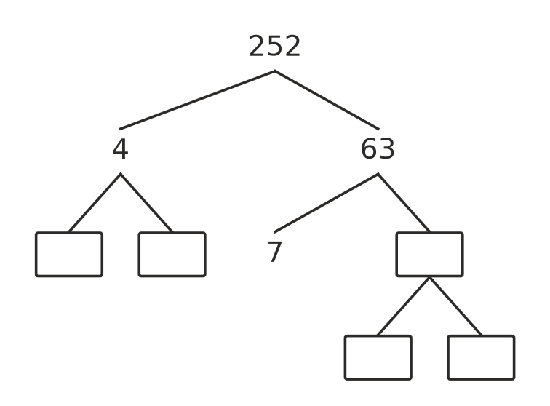

- HCF and LCM.
  - Find the HCF of 42 and 70. (1 mark)

  - Find the LCM of 9 and 12. (1 mark)

  - Two numbers are written as products of primes: A = $2^{2}$ × $3^{3}$ × 5 and B = $2^{3}$ × 3 × 7. Write the HCF of A and B in index form. (1 mark)

  - Write the LCM of A and B in index form. (1 mark)

- Liam says that $3^{4}$ = 12, because 3 × 4 = 12. Explain the mistake Liam made, then find the correct value of $3^{4}$. (2 marks)

- Number puzzle. I am a whole number between 50 and 100. When you divide me by 2, 3, 4 or 5, the remainder is always 1. What number am I? Show how you found it. (2 marks)

 Section B: Calculator allowed
- Use a calculator to evaluate each of these.
  - ${28}^{3}$ (1 mark)

  - $\sqrt{8649}$ (1 mark)

- Write 3150 as a product of prime factors in index form. Show your working. (2 marks)

- 1296 = $2^{4}$ × $3^{4}$. Use this prime factorisation to find $\sqrt{1296}$. Show your working. (2 marks)

- Two players run laps of a footy oval. They start together from the goalposts. Jai takes 75 seconds to run one lap and Ollie takes 90 seconds. They both keep running at the same pace.
  - After how many seconds will they first be back at the goalposts together? (2 marks)

  - How many laps will Jai have run by then? (1 mark)

- A Landcare group has 180 gum tree seedlings and 252 wattle seedlings. They plant them in identical rows, with the same number of gums and the same number of wattles in each row, and none left over.
  - What is the greatest number of rows they can plant? (2 marks)

  - How many gums and how many wattles are in each row? (1 mark)

 Answer sheet
Name: ____________________
Write your final answer for each question in the table.
Question | Answer | Marks | Question | Answer | Marks
1a |  | /1 | 8 |  | /2
1b |  | /1 | 9a |  | /1
1c |  | /1 | 9b |  | /1
2 |  | /1 | 9c |  | /1
3a |  | /1 | 9d |  | /1
3b |  | /1 | 10 |  | /2
3c |  | /1 | 11 |  | /2
4 |  | /2 | 12a |  | /1
5a |  | /1 | 12b |  | /1
5b |  | /1 | 13 |  | /2
5c |  | /1 | 14 |  | /2
6a |  | /2 | 15a |  | /2
6b |  | /1 | 15b |  | /1
7a |  | /1 | 16a |  | /2
7b |  | /1 | 16b |  | /1
7c |  | /1
 |  |  |  | Total | /40

