Powers, factors and multiples: Practice test 1
Year 7 Maths · Test · Test 1
Name: ____________________ Date: ______________
Time: 45 minutes
Total: 40 marks
Show your working in the boxes. Then write each final answer on the answer sheet on the last page.

 Section A: No calculator
- Number properties.
  - Use the commutative and associative laws to calculate 4 × 37 × 25. Show your steps. (1 mark)

  - Use the distributive law to calculate 8 × 53. Show your steps. (1 mark)

  - Which law is shown by 19 + 46 + 81 = 19 + 81 + 46? (1 mark)

- Square numbers.
  - Evaluate ${13}^{2}$. (1 mark)

  - List all the square numbers between 130 and 230. (1 mark)

- Square roots.
  - Evaluate $\sqrt{121}$. (1 mark)

  - Between which two consecutive whole numbers does $\sqrt{90}$ lie? (1 mark)

- A square vegetable patch at the school farm has an area of 81 m².
  - How long is each side of the patch? (1 mark)

  - The patch needs a fence all the way around it. How many metres of fencing are needed? (1 mark)

- Powers.
  - Write 7 × 7 × 7 × 7 × 7 in index form. (1 mark)

  - Write 3 × 3 × 2 × 3 × 2 in index form. (1 mark)

  - Evaluate $2^{5}$. (1 mark)

- Powers of ten.
  - Write 60 408 in expanded notation using powers of ten. (2 marks)

  - Write this as a basic numeral: 3 × ${10}^{5}$ + 2 × ${10}^{3}$ + 7 × ${10}^{1}$ + 5 × 1 (1 mark)

- Factors, multiples and primes.
  - List all the factors of 54. (1 mark)

  - Find the smallest multiple of 17 that is greater than 300. (1 mark)

  - Which of these numbers are prime: 51, 53, 57, 59? (1 mark)

- Complete the factor tree for 360. Then write 360 as a product of prime factors in index form. (2 marks)
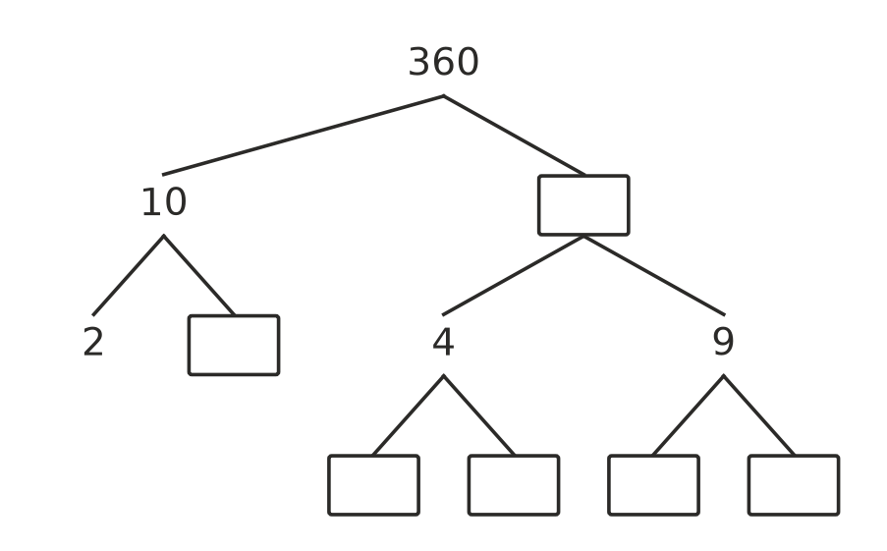

- HCF and LCM.
  - Find the highest common factor (HCF) of 36 and 60. (1 mark)

  - Find the lowest common multiple (LCM) of 8 and 14. (1 mark)

  - Two numbers are written as products of primes: P = $2^{3}$ × 3 × 5 and Q = 2 × $3^{2}$ × 5. Find the HCF of P and Q. (1 mark)

  - Find the LCM of P and Q. (1 mark)

- Mia says, “Every odd number is a prime number.” Is Mia right? Explain your answer and give an example. (2 marks)

- Number puzzle. I am a two-digit square number. The sum of my digits is 10. What number am I? Show how you found it. (2 marks)

 Section B: Calculator allowed
- Use a calculator to evaluate each of these.
  - ${17}^{3}$ (1 mark)

  - $\sqrt{5329}$ (1 mark)

  - $2^{10}$ − ${10}^{3}$ (1 mark)

- Write 2772 as a product of prime factors in index form. Show your working. (2 marks)

- Two sprinklers on a farm turn on at 6:00 am. After that, sprinkler A turns on every 18 minutes and sprinkler B turns on every 30 minutes. At what time will they next turn on together? Show your working. (2 marks)

- For a church camp, the leaders have 84 muesli bars and 126 apples. They want to pack them into identical snack bags, with nothing left over.
  - What is the greatest number of snack bags they can make? (2 marks)

  - How many muesli bars and how many apples go in each bag? (1 mark)

- A square paddock has an area of 5776 m². Fencing costs $14.50 per metre. How much will it cost to fence all the way around the paddock? Show your working. (2 marks)

 Answer sheet
Name: ____________________
Write your final answer for each question in the table.
Question | Answer | Marks | Question | Answer | Marks
1a |  | /1 | 7c |  | /1
1b |  | /1 | 8 |  | /2
1c |  | /1 | 9a |  | /1
2a |  | /1 | 9b |  | /1
2b |  | /1 | 9c |  | /1
3a |  | /1 | 9d |  | /1
3b |  | /1 | 10 |  | /2
4a |  | /1 | 11 |  | /2
4b |  | /1 | 12a |  | /1
5a |  | /1 | 12b |  | /1
5b |  | /1 | 12c |  | /1
5c |  | /1 | 13 |  | /2
6a |  | /2 | 14 |  | /2
6b |  | /1 | 15a |  | /2
7a |  | /1 | 15b |  | /1
7b |  | /1 | 16 |  | /2
 |  |  |  | Total | /40

