Investigation: The sieve of Eratosthenes
Year 7 Maths · Worksheet
Name: ____________________ Date: ______________
Eratosthenes was a Greek mathematician who lived over 2000 years ago and ran the great library in Alexandria, Egypt. He is famous for working out the size of the Earth, and for a clever way of finding prime numbers. His method works like a sieve: you shake out all the composite numbers, and only the primes are left behind. You will need a pencil and two coloured pencils.

Part A: Sieve the numbers from 1 to 100
- Follow these steps on the grid below.
- Cross out 1. It is not prime.
- Circle 2. Then cross out every other multiple of 2 (4, 6, 8, …).
- Circle 3. Then cross out every other multiple of 3 that is not already crossed out.
- Circle 5 and cross out its other multiples. Then do the same for 7.
- Circle every number that is left. These are the prime numbers.
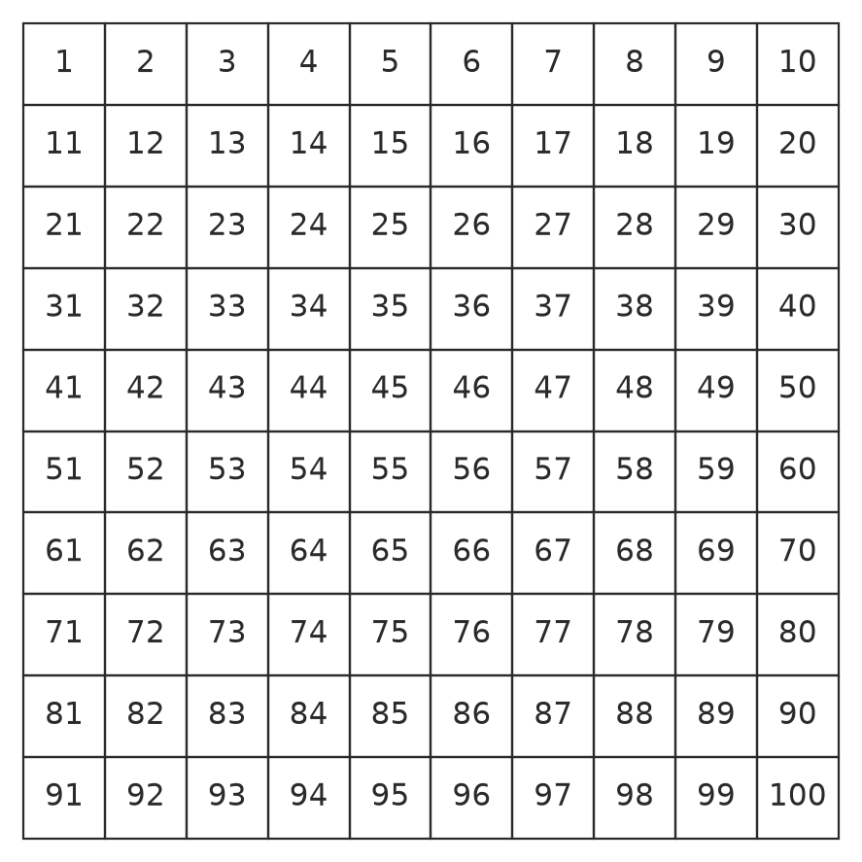
- How many prime numbers are there less than 100? ______________
- When you got to 7, some multiples of 7 had not been crossed out yet. Which ones were they? ______________
- After 7, the next prime is 11. Explain why you did not need to cross out any multiples of 11. (Hint: think about 11 × 2, 11 × 3, and so on, and about 11 × 11.)

- Twin primes are two primes that are 2 apart, such as 11 and 13. List all the pairs of twin primes less than 100.

Part B: Primes in six columns
- This grid shows the numbers 1 to 60 in six columns. Circle the prime numbers. (Use your answers from Part A.)
- 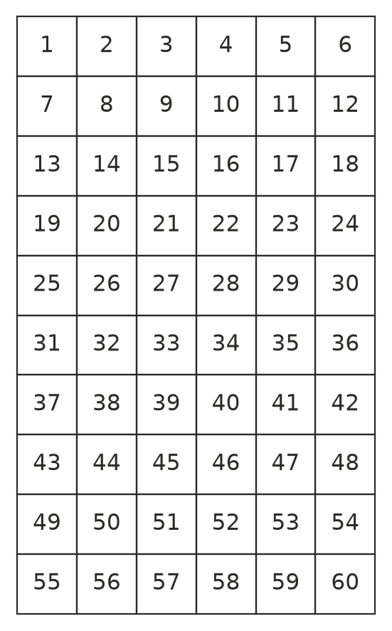
  - In which columns are all the primes that are bigger than 3? ______________
  - Explain why the 2nd, 4th and 6th columns can never contain a prime number bigger than 3.

  - Explain why the 3rd column can never contain a prime number bigger than 3.

  - Is every number in the 1st and 5th columns prime? Give examples. ______________

Part C: A famous puzzle
In 1742 the mathematician Christian Goldbach guessed that every even number bigger than 2 can be written as the sum of two prime numbers. For example, 10 = 3 + 7. Nobody has ever found an even number where it fails, but nobody has been able to prove it is always true, either.
- Write each even number as the sum of two primes. Where you can, find more than one way.
Even number | Sum of two primes
4
6
8
10 | 3 + 7 and 5 + 5
12
14
16
18
20
22
24
26
28
30

- Which even numbers in your table can be written as the sum of two primes in three different ways? (5 + 7 and 7 + 5 count as the same way.) ______________

 Part D: Reflect
- Suppose you used the sieve to find all the primes up to 200. Which primes would you need to cross out the multiples of? Explain how you know when to stop.

- Why do you think this method is called a sieve? Is it a quicker way to find primes than testing every number one at a time? Explain.

