2.08 HCF and LCM
Year 7 Maths · Worksheet · Level 3 · Challenge
Name: ____________________ Date: ______________
This worksheet stretches your skills with the HCF and LCM: larger numbers, three numbers at once, and harder problems. Tip: with prime factorisations, the HCF uses the lowest power of each shared prime, and the LCM uses the highest power of every prime that appears.

 Understanding
- What is the LCM of $2^{3}$ × 3 and 2 × $3^{2}$ × 5? Answer: ______________
  - 6
  - 360
  - 1080
  - 120
- 180 = $2^{2}$ × $3^{2}$ × 5 and 252 = $2^{2}$ × $3^{2}$ × 7.
- 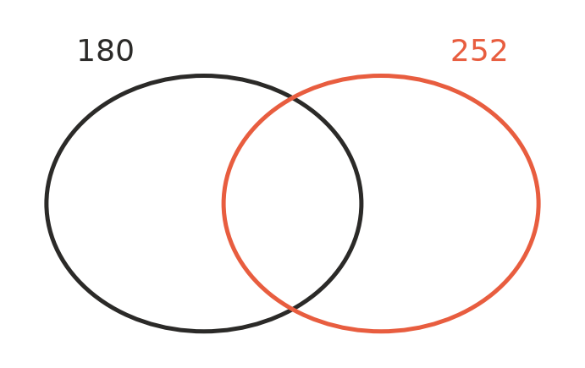
  - Write the prime factors of 180 and 252 in the Venn diagram.
  - Use the diagram to find the HCF of 180 and 252. ______________
  - Use the diagram to find the LCM of 180 and 252. ______________

 Fluency
- Find the HCF and the LCM of each pair.
  - 84 and 126 ______________

  - 90 and 150 ______________

  - 56 and 98 ______________

  - 108 and 144 ______________

- Calculate.
  - the HCF of 48, 72 and 120 ______________
  - the LCM of 6, 8 and 15 ______________
  - the LCM of all the whole numbers from 1 to 10 ______________
- Find the HCF and the LCM of $2^{3}$ × $3^{2}$ × 7 and $2^{2}$ × $3^{4}$ × 5. Give each answer in index form and as an ordinary number.

 Reasoning
- Is each statement always, sometimes or never true for two different whole numbers? Write Always, Sometimes or Never in each empty box.
Statement | Always, sometimes or never
The HCF is smaller than both numbers.
The LCM is at least as big as the larger number.
HCF × LCM equals the two numbers multiplied together.
The LCM is the two numbers multiplied together.
The HCF of two even numbers is at least 2.

- Explain why multiplying the primes in the middle of a Venn diagram gives the HCF, and multiplying all the primes in the diagram gives the LCM.

- Dividing the top and bottom of a fraction by their HCF simplifies it in one step. Use the HCF of 84 and 126 to simplify $\frac{84}{126}$. ______________

 Problem solving
- Two gears are touching. Gear A has 24 teeth and gear B has 36 teeth. A mark is painted where they touch. How many full turns must each gear make before the two marks touch again? Explain.

- Three lighthouses flash every 12 seconds, 18 seconds and 30 seconds. They all flash together at exactly 9:00 pm.
  - When will they next all flash together? ______________
  - How many more times will they all flash together before 10:00 pm? ______________
- A rectangular paddock is 84 m by 132 m. Fence posts are placed around the edge with equal gaps between them, a post in every corner, and each gap a whole number of metres. The gaps must be as long as possible.
  - How long is each gap? ______________
  - How many posts are needed? ______________
- Two numbers have an HCF of 12 and an LCM of 360. Neither number is 12 or 360. Find all the possible pairs. ______________

- Find the smallest whole number bigger than 1 that leaves a remainder of 1 when it is divided by 2, 3, 4, 5 or 6. ______________

