2.08 HCF and LCM
Year 7 Maths · A5 question sheet · Level 3 · Challenge
This worksheet stretches your skills with the HCF and LCM: larger numbers, three numbers at once, and harder problems. Tip: with prime factorisations, the HCF uses the lowest power of each shared prime, and the LCM uses the highest power of every prime that appears.

 Understanding
- What is the LCM of $2^{3}$ × 3 and 2 × $3^{2}$ × 5?
  - 6
  - 360
  - 1080
  - 120
- 180 = $2^{2}$ × $3^{2}$ × 5 and 252 = $2^{2}$ × $3^{2}$ × 7.
- 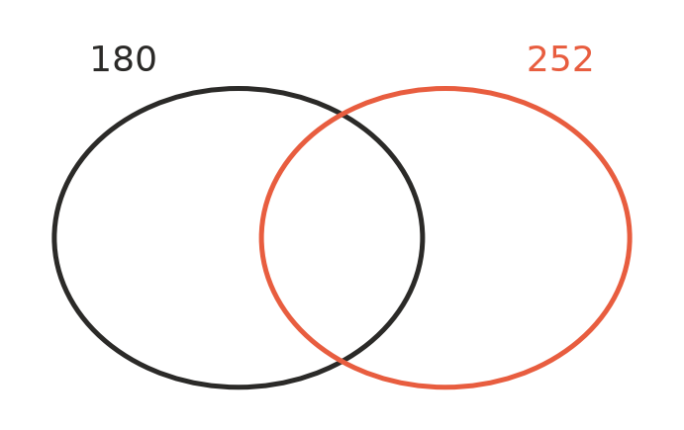
  - Write the prime factors of 180 and 252 in the Venn diagram.
  - Use the diagram to find the HCF of 180 and 252.
  - Use the diagram to find the LCM of 180 and 252.

 Fluency
- Find the HCF and the LCM of each pair.
  - 84 and 126
  - 90 and 150
  - 56 and 98
  - 108 and 144
- Calculate.
  - the HCF of 48, 72 and 120
  - the LCM of 6, 8 and 15
  - the LCM of all the whole numbers from 1 to 10
- Find the HCF and the LCM of $2^{3}$ × $3^{2}$ × 7 and $2^{2}$ × $3^{4}$ × 5. Give each answer in index form and as an ordinary number.

 Reasoning
- Is each statement always, sometimes or never true for two different whole numbers? Write Always, Sometimes or Never in your book.
Statement
The HCF is smaller than both numbers.
The LCM is at least as big as the larger number.
HCF × LCM equals the two numbers multiplied together.
The LCM is the two numbers multiplied together.
The HCF of two even numbers is at least 2.

- Explain why multiplying the primes in the middle of a Venn diagram gives the HCF, and multiplying all the primes in the diagram gives the LCM.
- Dividing the top and bottom of a fraction by their HCF simplifies it in one step. Use the HCF of 84 and 126 to simplify $\frac{84}{126}$.

 Problem solving
- Two gears are touching. Gear A has 24 teeth and gear B has 36 teeth. A mark is painted where they touch. How many full turns must each gear make before the two marks touch again? Explain.
- Three lighthouses flash every 12 seconds, 18 seconds and 30 seconds. They all flash together at exactly 9:00 pm.
  - When will they next all flash together?
  - How many more times will they all flash together before 10:00 pm?
- A rectangular paddock is 84 m by 132 m. Fence posts are placed around the edge with equal gaps between them, a post in every corner, and each gap a whole number of metres. The gaps must be as long as possible.
  - How long is each gap?
  - How many posts are needed?
- Two numbers have an HCF of 12 and an LCM of 360. Neither number is 12 or 360. Find all the possible pairs.
- Find the smallest whole number bigger than 1 that leaves a remainder of 1 when it is divided by 2, 3, 4, 5 or 6.

