2.08 HCF and LCM
Year 7 Maths · A5 question sheet · Level 2 · Core
This worksheet practises finding the highest common factor (HCF) and lowest common multiple (LCM), by listing and by using prime factorisations, and using them to solve problems. Tip: problems about splitting things into equal groups usually need the HCF. Problems about things happening together again usually need the LCM.

 Understanding
- What is the HCF of 24 and 36?
  - 6
  - 12
  - 72
  - 4
- 60 = 2 × 2 × 3 × 5 and 84 = 2 × 2 × 3 × 7.
- 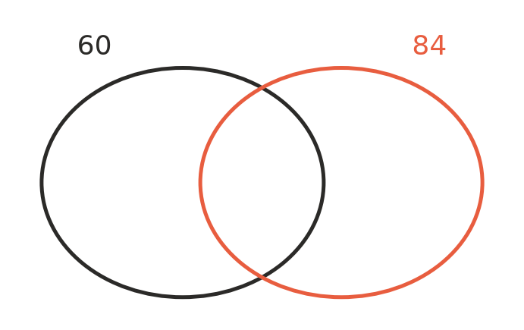
  - Write the prime factors in the Venn diagram. Put the primes that both numbers share in the middle (write each shared prime only once). Put the other primes on the correct side.
  - Multiply the primes in the middle to find the HCF of 60 and 84.
  - Multiply all the primes in the diagram to find the LCM of 60 and 84.
- Write the first eight multiples of 9 and of 12. Use them to find the LCM of 9 and 12.
LCM:

 Fluency
- Find the HCF.
  - 18 and 27
  - 28 and 42
  - 45 and 75
  - 36 and 48
  - 24, 36 and 60
- Find the LCM.
  - 6 and 9
  - 8 and 12
  - 10 and 15
  - 12 and 18
  - 4, 6 and 10
- Use prime factorisations to find the HCF and LCM of each pair.
  - 60 and 18
  - 72 and 120

 Reasoning
- Explain why the HCF of two different prime numbers is always 1, and why their LCM is always the two primes multiplied together.
- The HCF of 12 and 18 is 6, and the LCM is 36. Notice that 6 × 36 = 216 and 12 × 18 = 216.
  - Find the HCF and LCM of 8 and 20. Is their product equal to 8 × 20?
  - What do you notice?
- Ollie says the LCM of 6 and 8 is 48, because 6 × 8 = 48. Explain why he is wrong and give the correct LCM.

 Problem solving
- A youth group has 36 Year 7 students and 48 Year 8 students. The leaders want to make equal groups, each with the same number of Year 7s and the same number of Year 8s, with nobody left out.
  - What is the greatest number of groups they can make?
  - How many Year 7s and Year 8s are in each group?
- One bus leaves the station every 15 minutes, and another leaves every 20 minutes. Both leave at 7:00 am. When will they next leave at the same time?
- Rectangular tiles are 6 cm wide and 10 cm long. They are placed side by side, all facing the same way, to make a square.
  - What is the side length of the smallest square they can make?
  - How many tiles are needed?
- Two numbers, both bigger than 6, have an HCF of 6 and an LCM of 72. What are the two numbers?

