2.07 Prime factorisations
Year 7 Maths · Worksheet · Level 3 · Challenge
Name: ____________________ Date: ______________
This worksheet stretches your skills with prime factorisations: larger numbers, square and cube numbers, and using primes to reason about factors. Tip: a prime factorisation is like a number’s DNA. Once you have it, you can tell what its factors are, and whether it is a square or a cube.

 Understanding
- What is the value of 2 × $3^{2}$ × $5^{3}$? Answer: ______________
  - 2250
  - 1125
  - 450
  - 750
- Some numbers are missing from this factor tree. Fill them in, then write the number at the top as a product of primes in index form.
- 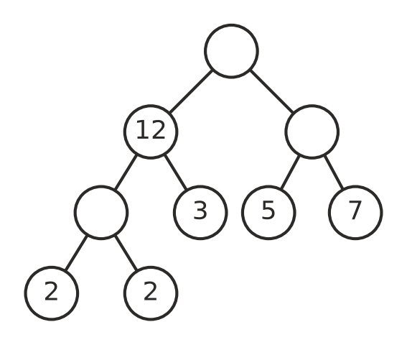
Product of primes: ______________

 Fluency
- Write each number as a product of primes in index form.
  - 360 = ______________

  - 1001 = ______________

  - 792 = ______________

  - 1575 = ______________

  - 2048 = ______________

  - 980 = ______________

- When every index in a prime factorisation is even, the number is a square number. You can find its square root by halving each index. For example, 144 = $2^{4}$ × $3^{2}$, so $\sqrt{144}$ = $2^{2}$ × 3 = 12. Use this method to find each square root.
  - $\sqrt{576}$ = ______________
  - $\sqrt{1764}$ = ______________
  - $\sqrt{2025}$ = ______________
- Write 1728 as a product of primes. Use it to show that 1728 is a cube number, and find the number that is cubed.

 Reasoning
- The number $2^{4}$ × $3^{2}$ × 5 is not a square number.
  - Explain how you can tell from its prime factorisation.

  - What is the smallest whole number you can multiply it by to make a square number? What is the square number? ______________
- Use prime factorisations to decide whether 252 is a factor of $2^{3}$ × $3^{3}$ × 7. Explain.

- 72 = $2^{3}$ × $3^{2}$. Every factor of 72 can be written as $2^{a}$ × $3^{b}$, where a is 0, 1, 2 or 3 and b is 0, 1 or 2.
  - How many factors does 72 have? Explain how you can tell without listing them. ______________

  - Use the same idea to find how many factors $2^{4}$ × $5^{2}$ has. ______________
- Explain why any number whose prime factorisation includes both 2 and 5 must end in the digit 0.

 Problem solving
- I am between 200 and 300. My prime factorisation uses only the primes 2, 3 and 5. The primes 3 and 5 each appear exactly once. What number am I? ______________
- A box shaped like a rectangular prism has a volume of 210 cm³. Its length, width and height are all different whole numbers of centimetres, and none of them is 1 cm. List all the possible sets of measurements. ______________

- What is the smallest whole number n that makes $2^{3}$ × 3 × n a cube number? What is the cube number? ______________
- Three children have different ages, and each is older than 1. The product of their ages is 72 and the sum of their ages is 13. How old are they? ______________

